Saipan, Northern Mariana Islands, USA
A U.S. Pacific outpost where WWII battlefields meet turquoise lagoons — Saipan rewards curious cruisers with honest history, excellent snorkeling, and a warm island pace few ports can match.
⚓ Tender port · 🕒 Typical call: 7-9 hrs · 💵 US Dollar · 🗣️ English & Chamorro · 🏖️ Beach & history
✍️ MY DAY IN PORT (FILL IN)
Ship / Date
In port | arrive ______ · all aboard ______
Booked excursion
Notes / meeting point
GETTING ASHORE
- Docking: Tender — ships anchor in Tanapag Harbor; boats ferry passengers to Garapan waterfront
- Walk to center: Tender landing is near Garapan; most attractions require a taxi or rental car
- Best For: WWII history, snorkeling Managaha Island, Pacific island beaches
- Don't Miss: Managaha Island day trip and American Memorial Park museum
GETTING AROUND
- 🚕 Taxi: $15–$35 — Taxis are the primary way to get around Saipan. Fares are often negotiated rather than metered — expect $15–$35 to Garap
- 📱 Rideshare: ❌ not available
TOP THINGS TO DO
- Managaha Island Day Trip — A short speedboat ride from Garapan drops you on a tiny coral islet with blindingly white sand and some of the clearest…
- WWII Northern Saipan Tour — Visit Banzai Cliff and Suicide Cliff — tragic Pacific War memorials on the island's dramatic north coast — then explore the Last…
- American Memorial Park & Museum — The National Park Service museum in central Garapan tells the full story of the 1944 Battle of Saipan with excellent exhibits and…
- The Grotto Snorkel & Dive — A collapsed limestone cave on the northeast coast filled with vivid blue ocean water — world-renowned for scuba diving.
- Micro Beach & Garapan Stroll — The calm, shallow lagoon beach adjacent to the Hyatt Regency in Garapan is ideal for swimming and lounging with views of Managaha…
BEST WALKS
- Garapan Waterfront Walk: 1.5 km · 20–30 min · flat — From the Smiling Cove tender landing, walk south along Beach Road past the DFS Galleria duty-free…
WEATHER · DAYLIGHT · MONEY
Month | High °F | Low °F | Rainy days
May | 83 | 77 | 22
Jul | 83 | 77 | 28
Sep | 82 | 77 | 28
Daylight: May 5:48AM–6:38PM · Jul 5:54AM–6:51PM · Sep 6:05AM–6:18PM
cruiseports.org/saipan-island-marianas · Confirm terminal & all-aboard time with your ship

Saipan, Northern Mariana Islands, USA — Port Map
Red = walkable sights · Amber = excursions farther out · P = cruise terminal
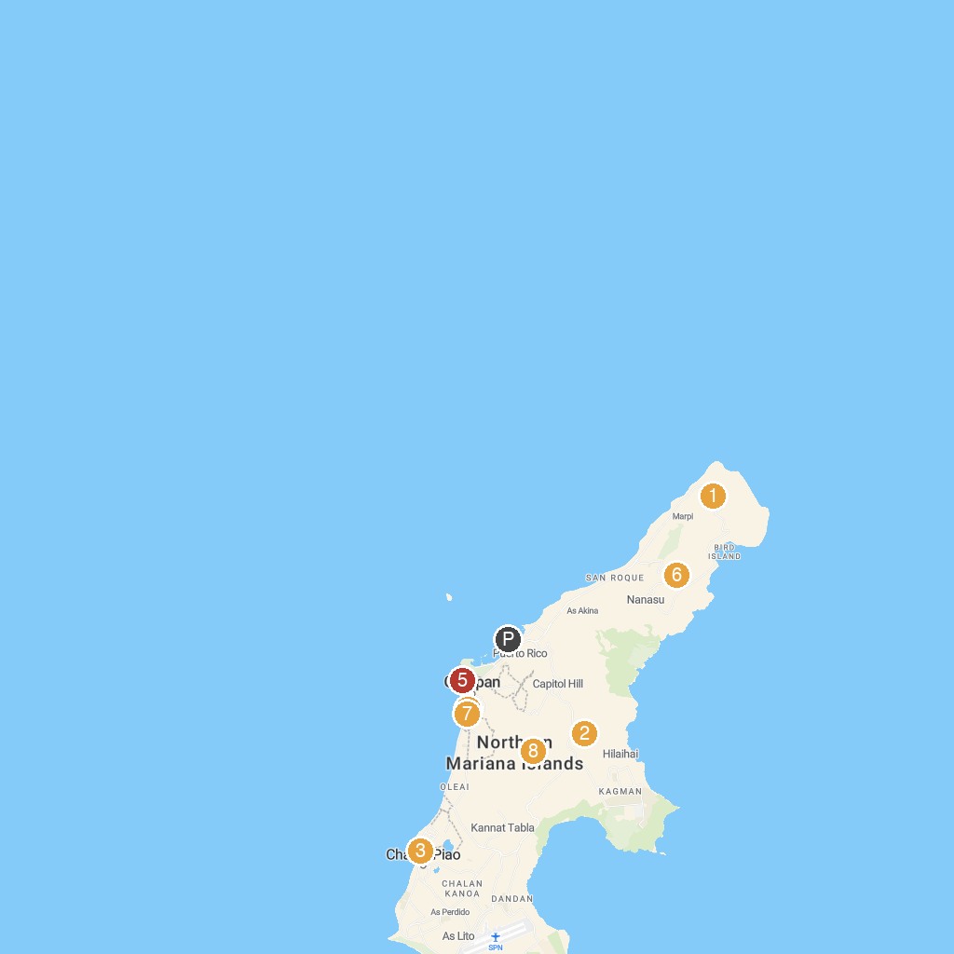
MAP KEY
1. Suicide Cliff | 5. Imperial Pacific Resort Hotel · Saipan
2. Santa Lourdes Shrine | 6. Abandoned Pacific Barrier Radar III
3. Mount Carmel Cathedral | 7. Old Japanese Jail
4. NMI Museum of History and Culture | 8. Concrete Jesus at Mt. Tapochao
P. Cruise port / terminal
Map © MapTiler © OpenStreetMap contributors · cruiseports.org

