Sainte Anne Island, Seychelles
The Seychelles' oldest marine sanctuary wraps six pristine islands in crystalline water. Giant tortoises roam a neighboring isle, manta rays glide through the channel, and white-sand beaches framed by granite boulders look exactly like the postcards.
⚓ Tender / Excursion boat · 🕒 Typical call: 6-8 hrs · 💵 SCR / USD & EUR accepted · 🗣️ Seychellois Creole, French, English · 🐢 Marine National Park
✍️ MY DAY IN PORT (FILL IN)
Ship / Date
In port | arrive ______ · all aboard ______
Booked excursion
Notes / meeting point
GETTING ASHORE
- Docking: Tender or catamaran from Mahé (Port Victoria); small ships may anchor directly
- Walk to Beach: No walking from ship — 15-20 min boat transfer from Victoria to island beaches
- Best For: Snorkeling, sea turtles, glass-bottom boat tours, Club Med day pass
- Don't Miss: Sainte Anne Channel snorkeling (150+ species) and Moyenne Island giant tortoises
GETTING AROUND
- 🚕 Taxi: ~$35–50 per trip — Taxis at Port Victoria on Mahé operate on fixed rates. Useful if combining a Sainte Anne excursion with time in Victoria
- 📱 Rideshare: ❌ not available
TOP THINGS TO DO
- Marine Park Catamaran & Snorkel — The classic Sainte Anne day: cruise the marine park on a catamaran with multiple snorkel stops in the Sainte Anne Channel, where…
- Moyenne Island Tortoises & Nature Trail — A 10-minute boat hop from Sainte Anne, Moyenne Island is a national park with free-roaming Aldabra giant tortoises, pirate grave…
- Club Med Seychelles Day Pass — The entire island is privately run by Club Med.
- Scuba Diving the Granite Reefs — Dive sites in the marine park range from 10–30 m over dramatic granite reef formations.
- Semi-Submersible Reef Safari — Prefer to stay dry? Board a semi-submersible or glass-bottom boat for an eye-level view of the reef gardens and seagrass meadows.
BEST WALKS
- Anse Cabot Beach Stroll: Easy · ~30 min · Free (public beach to high-water mark) — The western shore beaches — Anse Cabot and Anse Cimetière — are gentle walks along white sand…
WEATHER · DAYLIGHT · MONEY
Month | High °F | Low °F | Rainy days
May | 83 | 80 | 22
Jul | 78 | 76 | 14
Sep | 79 | 77 | 18
Daylight: May 6:17AM–6:11PM · Jul 6:27AM–6:20PM · Sep 6:11AM–6:15PM
cruiseports.org/sainte-anne-island-seychelles · Confirm terminal & all-aboard time with your ship

Sainte Anne Island, Seychelles — Port Map
Red = walkable sights · Amber = excursions farther out · P = cruise terminal
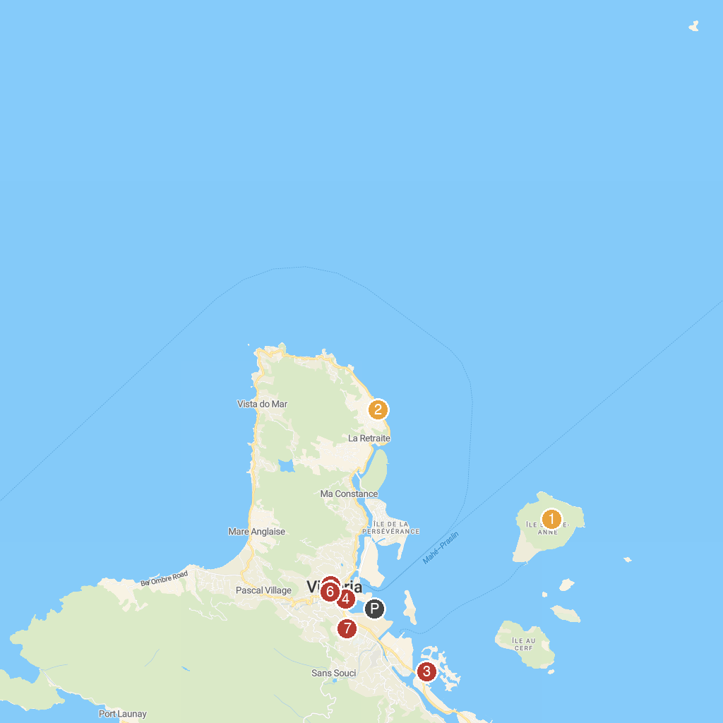
MAP KEY
1. Saint-Anne Marine National Park | 5. Immaculate Conception
2. Anse Etoile Beach | 6. Sir Selwyn Selwyn-Clarke Market
3. Semi-Submarine Seychelles | 7. Victoria Botanical Gardens
4. Bicentenary Monument Seychelles
P. Cruise port / terminal
Map © MapTiler © OpenStreetMap contributors · cruiseports.org

