Saint-Tropez, Provence, France
Once a quiet fishing village discovered by Brigitte Bardot and the jet set, Saint-Tropez balances Mediterranean glamour with cobblestone Provençal charm — and you step off the tender directly into the heart of it all.
⚓ Tender (no pier) · 🕒 Typical call: 6-8 hrs · 💶 Euro (€) · 🗣️ French (English widely spoken) · 🌊 French Riviera
✍️ MY DAY IN PORT (FILL IN)
Ship / Date
In port | arrive ______ · all aboard ______
Booked excursion
Notes / meeting point
GETTING ASHORE
- Docking: Tender — ships anchor in the Gulf of Saint-Tropez; tenders land at the Vieux Port
- Walk to Center: 0 min — you step off the tender directly onto the Old Port quay
- Best For: Strolling the old quarter, art museums, market days (Tue/Sat), beach clubs
- Don't Miss: La Tarte Tropézienne from the original Place des Lices shop
GETTING AROUND
- 🚕 Taxi: €5–7 base + €2.20/km; local rides typically €30–40 — Taxis queue near the port and in the town center. Confirm the fare before departure; surcharges apply at night, on holid
- 📱 Rideshare: ✅ Uber, Bolt
TOP THINGS TO DO
- Pampelonne Beach & the Famous Beach Clubs — The legendary 3-mile sandy stretch — home to Club 55, Nikki Beach, and dozens of other iconic clubs — is 6 km south of town.
- Citadelle de Saint-Tropez & Maritime Museum — A 17th-century fortress crowning the hill above town.
- Musée de l'Annonciade — A stunning collection of Modernist paintings — Signac, Matisse, Derain, Dufy — housed in a 16th-century chapel just off the Vieux…
- Sentier du Littoral Coastal Walk — A hiking path that begins beyond the Citadel and follows the rocky coastline south, offering wild Mediterranean scenery and far…
- Place des Lices Market (Tue & Sat) — Saint-Tropez's legendary twice-weekly open-air market fills the town square with lavender, local cheeses, olives, Provençal…
BEST WALKS
- Vieux Port to La Ponche Old Quarter: Easy · 30–45 min · 1 km — The classic Saint-Tropez loop.
- Up to the Citadel: Moderate · 30 min up · 1.2 km — From Place des Lices, follow Rue de la Citadelle uphill to the 17th-century fortress.
- To Plage des Graniers: Easy · 20 min · 1.5 km — Walk past the Citadel and down the other side to reach Plage des Graniers — a wild, sandy cove with…
WEATHER · DAYLIGHT · MONEY
Month | High °F | Low °F | Rainy days
May | 71 | 56 | 7
Jul | 86 | 70 | 2
Sep | 78 | 64 | 6
Daylight: May 6:09AM–8:50PM · Jul 6:07AM–9:11PM · Sep 7:13AM–7:43PM
cruiseports.org/saint-tropez · Confirm terminal & all-aboard time with your ship

Saint-Tropez, Provence, France — Port Map
Red = walkable sights · Amber = excursions farther out · P = cruise terminal
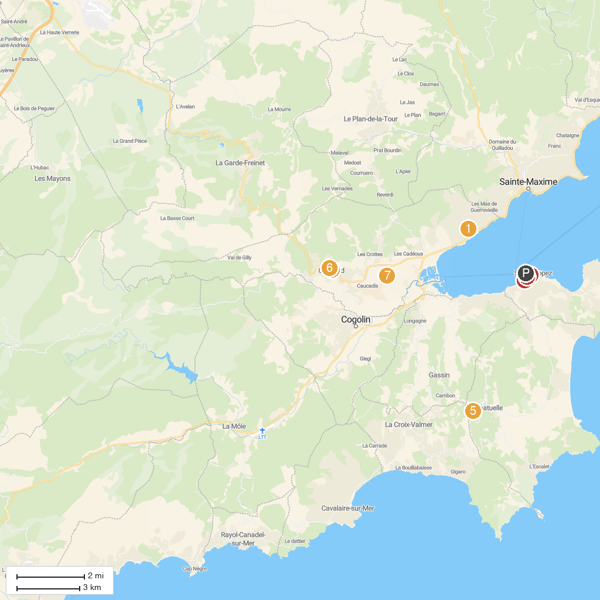
MAP KEY
1. Beauvallon Golf Club | 5. Les Moulins de Paillas
2. Église Saint-Michel | 6. Chateau de Grimaud
3. Gendarmerie Nationale | 7. Grimaud Karting Loisir
4. Promenade en bateau St.Tropez Le Brigantin 2 | 8. Annonciade Museum
P. Cruise port / terminal
Map © MapTiler © OpenStreetMap contributors · cruiseports.org

