Saint-Raphaël, Var, France
Where the rust-red Esterel mountains tumble into the turquoise Mediterranean, Saint-Raphaël delivers a classic French Riviera day — Belle Époque promenades, sandy beaches, and Roman history next door in Fréjus, all reachable on foot or by train.
⚓ Tender port (no pier) · 🕒 Typical call: 8–10 hrs · 💶 Euro · 🗣️ French
✍️ MY DAY IN PORT (FILL IN)
Ship / Date
In port | arrive ______ · all aboard ______
Booked excursion
Notes / meeting point
GETTING ASHORE
- Docking: Tender — ships anchor offshore; boats land at the Vieux Port quayside, steps from the town centre
- Walk to centre: Immediate — tender lands in the heart of Saint-Raphaël
- Best For: Beach days, Esterel scenery, DIY rail trips to Cannes or Nice
- Don't Miss: Ferry to Saint-Tropez from the Vieux Port (seasonal, ~1 hr each way)
GETTING AROUND
- 🚕 Taxi: €8–15 — Taxis are available at the port with a base pick-up fee of ~€3.50 plus ~€1–1.30/km. Useful for reaching Fréjus (5 km) or
- 📱 Rideshare: ✅ Uber, Bolt
TOP THINGS TO DO
- Saint-Tropez by Ferry — Les Bateaux de Saint-Raphaël runs a seasonal direct ferry from the Vieux Port to Saint-Tropez — about 1 hour each way.
- Fréjus Roman Ruins — Saint-Raphaël's twin city Fréjus is a 5-minute train ride away and packed with Roman history: an amphitheatre, aqueduct remains…
- Esterel Massif Hike or Drive — The blood-red volcanic rocks of the Esterel Massif rise just west of town.
- Plage du Veillat Beach Day — Saint-Raphaël's main sandy beach stretches right from the town centre — sunbeds, clear water, and Esterel views.
- DIY Rail Trip to Cannes or Nice — The station is 10 minutes' walk from the tender landing.
BEST WALKS
- Old Port & Town Centre Stroll: 1–1.5 hrs · Flat · Free — From the Vieux Port landing, explore the Jardin Bonaparte, wander to the Basilica of Notre-Dame de…
- Promenade to Plage du Veillat: 20 min each way · Flat · Free — A leisurely walk west along the seafront from the Vieux Port to Saint-Raphaël's main sandy beach…
WEATHER · DAYLIGHT · MONEY
Month | High °F | Low °F | Rainy days
May | 70 | 56 | 8
Jul | 84 | 69 | 3
Sep | 77 | 63 | 7
Daylight: May 6:08AM–8:50PM · Jul 6:06AM–9:11PM · Sep 7:12AM–7:42PM
cruiseports.org/saint-raphael · Confirm terminal & all-aboard time with your ship

Saint-Raphaël, Var, France — Port Map
Red = walkable sights · Amber = excursions farther out · P = cruise terminal
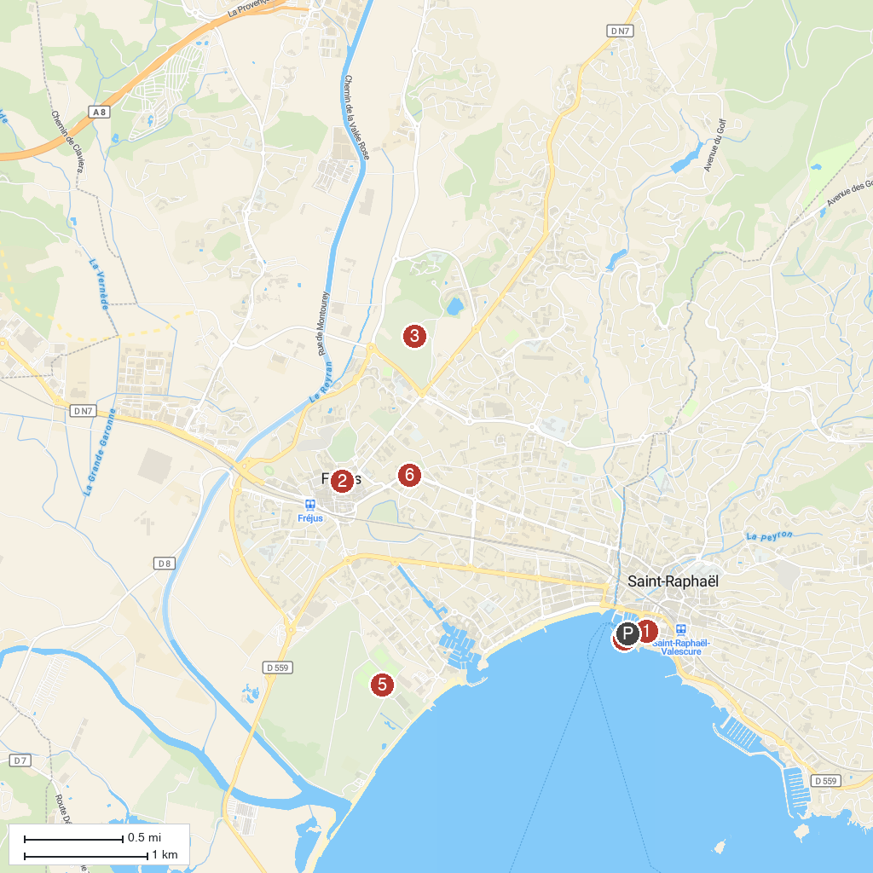
MAP KEY
1. Basilique Notre-Dame-de-la-Victoire | 4. Bonaparte Garden
2. Musée d'Histoire Locale | 5. Base Nature François Léotard
3. Parc Aurélien | 6. Médiathèque Villa Marie
P. Cruise port / terminal
Map © MapTiler © OpenStreetMap contributors · cruiseports.org

