Saint-Pierre, Saint Pierre and Miquelon, France
Step off the ship and onto European soil — Saint Pierre and Miquelon is genuinely French territory a stone's throw from Newfoundland. Baguettes, Euros, and Bordeaux await, alongside one of North America's wildest Prohibition stories.
⚓ Mostly tender; larger ships anchor · 🕒 Typical call: 6–8 hrs · 💶 Currency: Euro (€) · 🗣️ Language: French · 🇫🇷 French overseas territory
✍️ MY DAY IN PORT (FILL IN)
Ship / Date
In port | arrive ______ · all aboard ______
Booked excursion
Notes / meeting point
GETTING ASHORE
- Docking: Small/expedition ships dock at Quai de la Reine; most larger ships tender to town pier
- Walk to center: 1–5 min from pier to Place du Général de Gaulle
- Best For: French culture, history, Prohibition stories, authentic bistro dining
- Don't Miss: Île-aux-Marins ghost island and the guillotine at Musée de l'Arche
GETTING AROUND
- 🚕 Taxi: €5–€15 — Taxis wait at the wharf on arrival with fixed, zone-based fares (not metered). Supply is limited — confirm your return p
TOP THINGS TO DO
- Île-aux-Marins Ghost Island — A 10-minute water taxi ride takes you to this uninhabited former fishing village — a church, schoolhouse, lighthouse, and…
- Prohibition Walking Tour — During the 1920s, Saint-Pierre was a major rum-running hub funneling whisky into the U.S.
- Miquelon Island & The Isthmus — A ferry or ship excursion to the larger Miquelon island reveals a dramatic 12-km sand dune connecting Miquelon and Langlade, wild…
- Musée de l'Arche — Saint-Pierre's premier museum covers local history, Basque fishing heritage, Prohibition relics, and houses the actual guillotine…
- French Bistro & Wine Tasting — French wines and champagne arrive here with minimal import tax — a glass of Bordeaux at a waterfront cafe costs a fraction of…
BEST WALKS
- Town Centre Stroll: 1–2 hrs · Easy · Flat near waterfront — From the cruise pier, walk to Place du Général de Gaulle, then up to the Cathédrale de Saint-Pierre…
- Cemetery & Coastal Edge: 45 min · Easy — Walk to the unique above-ground cemetery at the edge of town — the rocky soil forced above-ground…
WEATHER · DAYLIGHT · MONEY
Month | High °F | Low °F | Rainy days
May | 41 | 38 | 12
Jul | 57 | 54 | 12
Sep | 60 | 56 | 10
Daylight: May 6:10AM–9:12PM · Jul 6:06AM–9:34PM · Sep 7:23AM–7:55PM
cruiseports.org/saint-pierre-and-miquelon-islands · Confirm terminal & all-aboard time with your ship

Saint-Pierre, Saint Pierre and Miquelon, France — Port Map
Red = walkable sights · Amber = excursions farther out · P = cruise terminal
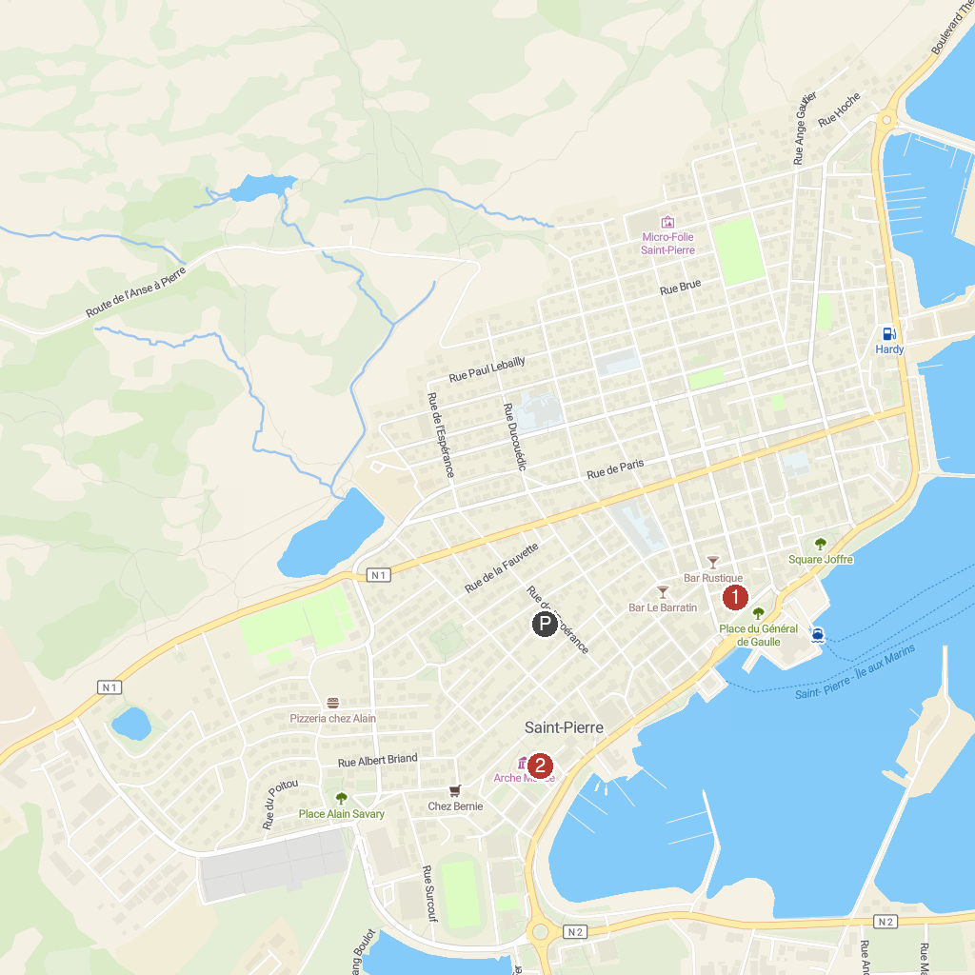
MAP KEY
1. Heritage Museum | 2. Ark Museum
P. Cruise port / terminal
Map © MapTiler © OpenStreetMap contributors · cruiseports.org

