Saint Petersburg, Russia
Russia's 'Window to Europe' — a city of gilded palaces, mosaic-encrusted churches, and labyrinthine canals that once seduced tsars and still stuns every traveler who sees it.
⚓ Pier (Marine Facade terminal) · 🕒 Typical call: 2 days (overnight) · 💵 Russian Ruble (RUB) — cash only · 🗣️ Russian · ⚠️ Calls suspended since 2022
✍️ MY DAY IN PORT (FILL IN)
Ship / Date
In port | arrive ______ · all aboard ______
Booked excursion
Notes / meeting point
GETTING ASHORE
- Docking: Pier — Marine Facade, Vasilyevsky Island (~9 km from city center)
- Walk to center: Not walkable — transfer by bus, metro, or tour required
- Best For: Art & history lovers, palace enthusiasts, White Nights in summer
- Don't Miss: Hermitage (Winter Palace) and the drawbridge opening on the Neva at night
GETTING AROUND
- 🚕 Taxi: ₽300–₽600 (~€3–€6) — Yandex Taxi (accessible via Yandex Go app) is the dominant ride-hailing service. Very affordable by European standards,
- 📱 Rideshare: ✅ Yandex Taxi
- 🚌 Hop-on hop-off: ✅
TOP THINGS TO DO
- The State Hermitage Museum — One of the world's great art museums, housed in the green-and-white Winter Palace on the Neva.
- Peterhof Palace & Grand Cascade — The 'Russian Versailles' sits 45 minutes outside the city.
- Church of the Savior on Spilled Blood — Built on the site where Tsar Alexander II was assassinated, this riot of colorful onion domes conceals 7,500 sq m of intricate…
- Catherine Palace & the Amber Room — The baroque blue-and-gold palace at Tsarskoye Selo holds the reconstructed Amber Room — a chamber panelled in amber, gold leaf…
- White Nights Canal Cruise — In late May through mid-July the sky never fully darkens.
BEST WALKS
- Nevsky Prospekt & Palace Square: 3 km · Easy · 1-2 hrs — Walk St Petersburg's grand main boulevard from Kazan Cathedral past the Singer House to Palace…
- Summer Garden & Bronze Horseman: 2 km · Easy · 1 hr — Peter the Great's oldest park leads to Senate Square and the famous equestrian statue of the tsar…
WEATHER · DAYLIGHT · MONEY
Month | High °F | Low °F | Rainy days
May | 59 | 44 | 11
Jul | 71 | 59 | 15
Sep | 60 | 49 | 12
Daylight: May 4:21AM–9:30PM · Jul 4:03AM–10:04PM · Sep 6:27AM–7:19PM
cruiseports.org/saint-petersburg · Confirm terminal & all-aboard time with your ship

Saint Petersburg, Russia — Port Map
Red = walkable sights · Amber = excursions farther out · P = cruise terminal
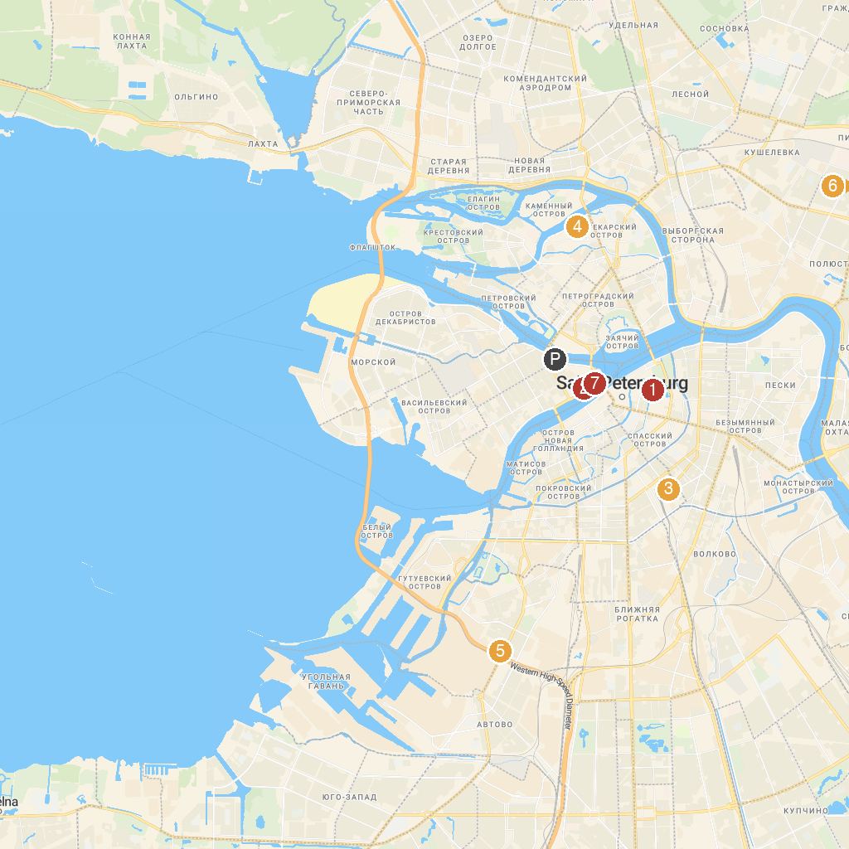
MAP KEY
1. Savior on the Spilled Blood | 5. Narvskaya Zastava
2. Zdaniye Dvenadtsati Kollegiy | 6. Pionerskiy Park
3. Pionerskaya Square Garden | 7. Sad Ivana Fomina
4. Вяземский сад | 8. Kunstkamera
P. Cruise port / terminal
Map © MapTiler © OpenStreetMap contributors · cruiseports.org

