Saint-Nazaire, Pays de la Loire, France
Heavily bombed in WWII and rebuilt from scratch, Saint-Nazaire wears its industrial soul proudly — massive concrete sub pens, a shipyard where floating cities are born, and a breezy Atlantic waterfront that surprises most visitors who expected quaint France.
⚓ Docked (pier) · 🕒 Typical call: 8-10 hrs · 💶 Euro (€) · 🗣️ French · 🚢 Birthplace of the world's largest cruise ships
✍️ MY DAY IN PORT (FILL IN)
Ship / Date
In port | arrive ______ · all aboard ______
Booked excursion
Notes / meeting point
GETTING ASHORE
- Docking: Pier — no tender. Smaller ships dock at Quai de Commerce (5-min walk to attractions); larger ships at Montoir terminal (~10 km, shuttle provided).
- Walk to center: 5-10 min from Quai de Commerce dock; not walkable from Montoir terminal.
- Best For: History buffs, WWII sites, industrial architecture, unique museum experiences, shipyard fans.
- Don't Miss: Escal'Atlantic inside the submarine pens — a surreal ocean-liner museum inside a WWII bunker.
GETTING AROUND
- 🚕 Taxi: €10–15 — Metered taxis are available at the cruise terminal. The city center is roughly 2 km away; fares start at €5 base plus €1
- 📱 Rideshare: ✅ Uber, Bolt
TOP THINGS TO DO
- Escal'Atlantic — Ocean Liner Museum — Inside one of the largest WWII German submarine bunkers in the world, this immersive museum recreates life aboard historic…
- Espadon Submarine Tour — Board the Espadon, the only submarine open to the public in France.
- Chantiers de l'Atlantique Shipyard Tour — A guided bus tour of the legendary shipyard where Oasis of the Seas, MSC World America, and countless ocean liners were built.
- Brière Regional Natural Park — France's second-largest marshland sits just outside Saint-Nazaire.
- Airbus Factory Tour — Visit the Saint-Nazaire Airbus facility where cockpits and fuselage sections for A320 and A380 families are assembled before…
BEST WALKS
- Submarine Base & Waterfront Loop: 2-3 hrs | Easy | Flat — From the Quai de Commerce dock, walk directly into the La Base district surrounding the WWII…
- La Havane Heritage Quarter: 45 min | Easy | Stroll — A short walk inland from the waterfront takes you to La Havane, a rare surviving pocket of…
WEATHER · DAYLIGHT · MONEY
Month | High °F | Low °F | Rainy days
May | 65 | 52 | 10
Jul | 75 | 61 | 8
Sep | 71 | 58 | 9
Daylight: May 6:32AM–9:38PM · Jul 6:28AM–10:00PM · Sep 7:46AM–8:20PM
cruiseports.org/saint-nazaire · Confirm terminal & all-aboard time with your ship

Saint-Nazaire, Pays de la Loire, France — Port Map
Red = walkable sights · Amber = excursions farther out · P = cruise terminal
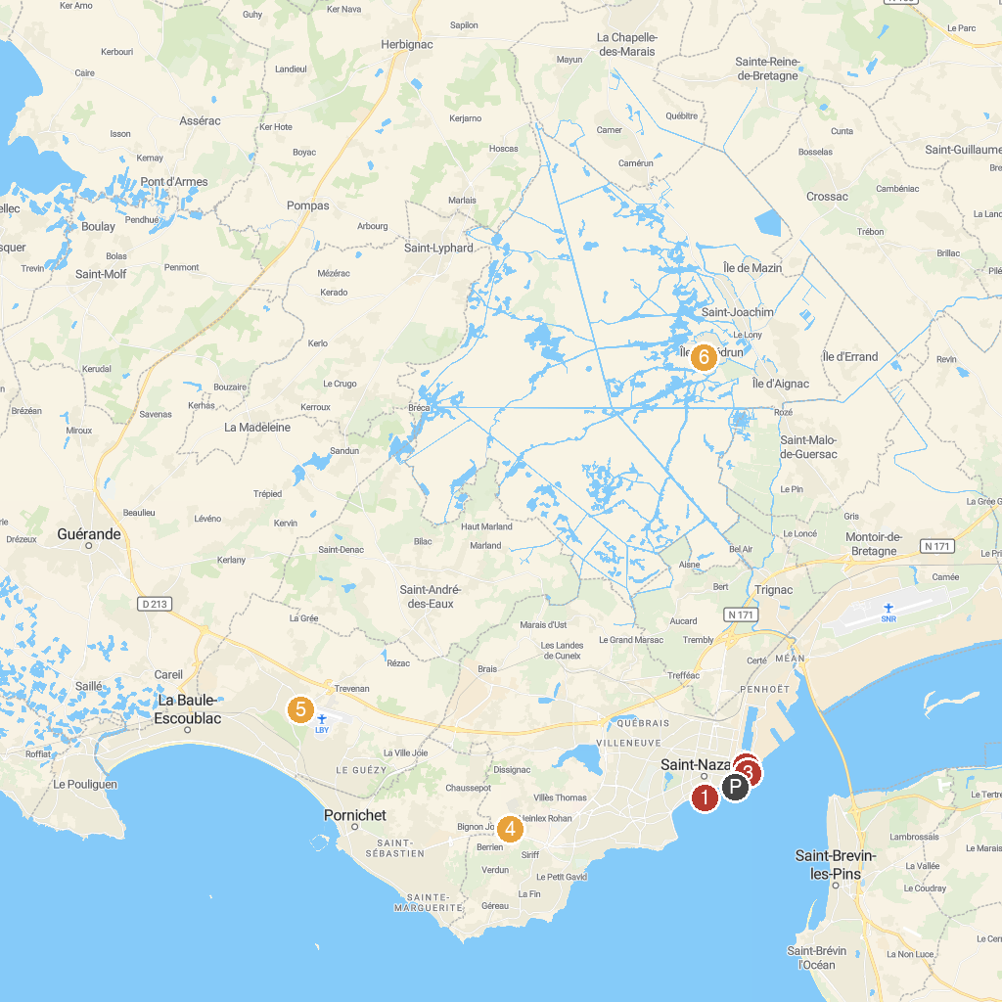
MAP KEY
1. Kerbourg dolmens | 5. Laser Game Evolution
2. Monument du soldat américain | 6. Aerospace Museum Peninsula Coast of Love
3. Sous-marin Espadon | 7. Valérie AOUSTIN BRIERE
4. Ecomusée de Saint Nazaire | 8. Faune Brièronne : Découverte de la brière en barque ou calèche
P. Cruise port / terminal
Map © MapTiler © OpenStreetMap contributors · cruiseports.org

