Saint-Jean-de-Luz, Basque Country, France
A jewel of the French Basque coast where King Louis XIV married Maria Theresa in 1660 — today a picture-perfect fishing town with a protected crescent beach, gilded baroque church, and some of the best food in France.
⚓ Tender port · 🕒 Typical call: 7-9 hrs · 💶 Euro (€) · 🗣️ French & Basque
✍️ MY DAY IN PORT (FILL IN)
Ship / Date
In port | arrive ______ · all aboard ______
Booked excursion
Notes / meeting point
GETTING ASHORE
- Docking: Tender — ships anchor in the bay; tenders land at the fishing port in town
- Walk to center: 0 min — you step off the tender and you're there
- Best For: Basque food, royal history, beach, day trips to Spain or Biarritz
- Don't Miss: Église Saint-Jean-Baptiste and a macaron from Maison Adam
GETTING AROUND
- 🚕 Taxi: €3–€6 — Local taxis charge a €2.50 pick-up fee plus €0.97–€2.58/km depending on time of day. The short distance to center keeps
- 📱 Rideshare: ✅ Uber
TOP THINGS TO DO
- Église Saint-Jean-Baptiste & Royal Wedding Trail — France's grandest Basque church and site of Louis XIV's 1660 wedding.
- Basque Food & Market Morning — Hit Les Halles covered market for local cheeses, jambon de Bayonne, and fresh seafood, then walk Rue Gambetta for a Gâteau Basque…
- Grande Plage Beach — The crescent-shaped town beach is sheltered by three stone dykes, making it one of the calmest swimming beaches on the entire…
- Day Trip to San Sebastián, Spain — A 30-minute train ride crosses the border to one of Europe's great food cities.
- Biarritz by Train — The glamorous surfing resort 15 minutes north by train.
BEST WALKS
- Town Centre Loop: 1.5 km · 40 min · flat — From the tender pier, walk to Place Louis XIV, into Église Saint-Jean-Baptiste, down pedestrian Rue…
- Promenade & Grande Plage: 2 km · 50 min · flat — Head south from the tender pier along the Promenade de Jacques Thibaud hugging the beach.
WEATHER · DAYLIGHT · MONEY
Month | High °F | Low °F | Rainy days
May | 66 | 54 | 14
Jul | 74 | 64 | 11
Sep | 73 | 61 | 12
Daylight: May 6:42AM–9:24PM · Jul 6:40AM–9:44PM · Sep 7:46AM–8:16PM
cruiseports.org/saint-jean-de-luz · Confirm terminal & all-aboard time with your ship

Saint-Jean-de-Luz, Basque Country, France — Port Map
Red = walkable sights · Amber = excursions farther out · P = cruise terminal
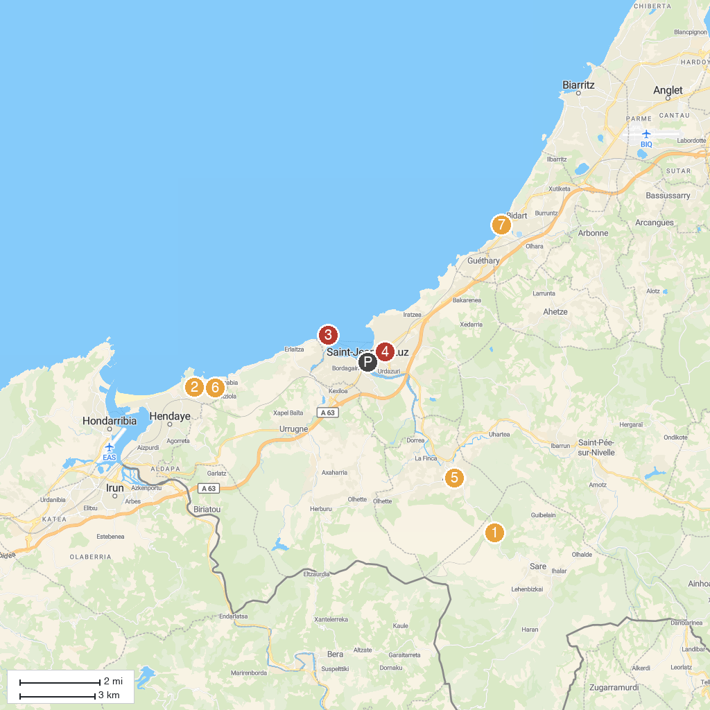
MAP KEY
1. Le Train de La Rhune | 5. Parc Ducontenia
2. Château d'Abbadie | 6. Église Notre-Dame-de-l'Assomption de Ascain
3. Biarritz Aquarium | 7. Maison de la Corniche - Asporotsttipi
4. Socoa Fort | 8. Plage de Bidart
P. Cruise port / terminal
Map © MapTiler © OpenStreetMap contributors · cruiseports.org

