Saint-Jean-de-Losne, Burgundy, France
At the crossroads of the Saône, the Burgundy Canal, and the Rhine-Rhône Canal, this tiny town of 1,100 is France's undisputed capital of inland waterways — and a deeply authentic slice of Burgundy.
⚓ Docked (riverside quay) · 🕒 Typical call: 6–8 hrs · 💶 Currency: Euro (€) · 🗣️ Language: French
✍️ MY DAY IN PORT (FILL IN)
Ship / Date
In port | arrive ______ · all aboard ______
Booked excursion
Notes / meeting point
GETTING ASHORE
- Docking: Docked alongside Quai National or Quai de la Hutte — no tender
- Walk to center: 2–5 min from gangway to cafes and church
- Best For: Burgundy wine, canal culture, cycling, day trips to Dijon/Beaune
- Don't Miss: Pochouse stew and a stroll around the canal basin
GETTING AROUND
- 🚕 Taxi: €10–€20 (short local trips) — Local taxi services (Taxi Jonathan, Elo'taxi) are available for mobility-impaired passengers or trips to nearby villages
- 📱 Rideshare: ✅ Uber
TOP THINGS TO DO
- Dijon Day Trip — The Burgundy capital is 40 km away — reachable by ship excursion or independent train in 25 minutes.
- Beaune Wine Country — Beaune, about 42 km away, is the wine capital of Burgundy.
- Voie Bleue Cycling — The Voie Bleue is a flat, paved riverside bike path that runs along the Saône and canals.
- Town Historic Walk — Explore Saint-Jean-de-Losne on foot: the brick Gothic church of Saint-Jean-Baptiste, the 17th-century Hôtel de Ville with its…
- Musée de la Batellerie — Housed in one of the oldest timber-framed buildings in town (15th century), this small museum traces the history of inland water…
BEST WALKS
- Old Town & Canal Basin Loop: 1.5 km · 30–40 min · flat — From the Saône quay, walk into the old town to the Église Saint-Jean-Baptiste, then north past the…
- Riverside Path to Losne: 2 km round trip · 40 min · flat — Cross the bridge over the Saône to the adjacent commune of Losne, where the train station is located.
WEATHER · DAYLIGHT · MONEY
Month | High °F | Low °F | Rainy days
May | 67 | 50 | 12
Jul | 81 | 62 | 9
Sep | 73 | 55 | 8
Daylight: May 6:03AM–9:07PM · Jul 5:59AM–9:30PM · Sep 7:16AM–7:50PM
cruiseports.org/saint-jean-de-losne · Confirm terminal & all-aboard time with your ship

Saint-Jean-de-Losne, Burgundy, France — Port Map
Red = walkable sights · Amber = excursions farther out · P = cruise terminal
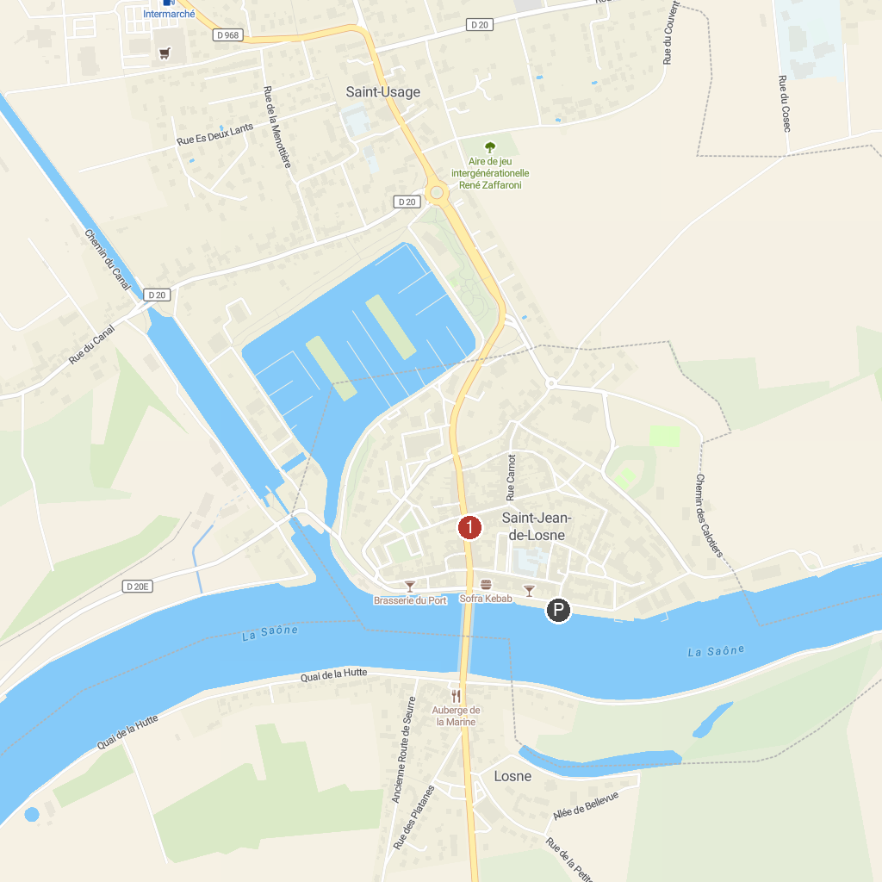
MAP KEY
1. Musee De La Batellerie | 3. Abbaye Notre-Dame de Cîteaux
2. Auxonne Castle
P. Cruise port / terminal
Map © MapTiler © OpenStreetMap contributors · cruiseports.org

