Jamestown, Saint Helena, South Atlantic
Napoleon spent his final six years on this lonely volcanic outcrop, 1,200 miles from the nearest continent. Today it's one of the most unusual — and unhurried — port calls in the world.
⚓ Tender port (no cruise pier) · 🕒 Typical call: 7-9 hrs · 💷 Currency: Saint Helena pound / GBP · 🗣️ Language: English
✍️ MY DAY IN PORT (FILL IN)
Ship / Date
In port | arrive ______ · all aboard ______
Booked excursion
Notes / meeting point
GETTING ASHORE
- Docking: Tender only — ships anchor off Jamestown; small boats bring you ashore at the wharf
- Walk to centre: Immediate — the wharf puts you at the foot of Main Street, Jamestown
- Best For: History buffs, slow travellers, unique bucket-list stamps
- Don't Miss: Longwood House (Napoleon's exile) and Jonathan the tortoise at Plantation House
GETTING AROUND
- 🚕 Taxi: £3–8 GBP — Small local taxi fleet; from Rupert's Valley (new tender point from Sept 2025) to Jamestown is ~2.4 km, roughly £3–6 GBP
- 📱 Rideshare: ❌ not available
TOP THINGS TO DO
- Longwood House — Napoleon's Exile — Visit the country house where Napoleon Bonaparte lived from 1815 until his death in 1821.
- Jacob's Ladder — 699 steep steps cut into the cliff face above Jamestown — a lung-busting climb rewarded with sweeping views over James Bay and…
- Jonathan the Tortoise at Plantation House — The Governor's residence is home to Jonathan, a Seychelles giant tortoise born around 1832 — recognized by Guinness World Records…
- Diana's Peak National Park — The island's highest point (2,684 ft) is laced with cloud forest trails through endemic tree ferns and black cabbage trees.
- Jamestown Walking Tour — The capital's Georgian main street is lined with 18th-century buildings, a castle, and the old museum in the former public library.
BEST WALKS
- Main Street to Jacob's Ladder: 1 mile · easy flat then steep climb · 45-60 min — Walk the length of Main Street from the wharf, pass the castle and gardens, then tackle the 699…
- Jamestown Historic Core: 0.5 mile · easy · 45 min — From the wharf, stroll up Main Street past the East India Company castle, the Supreme Court, St…
WEATHER · DAYLIGHT · MONEY
Month | High °F | Low °F | Rainy days
May | 66 | 45 | 10
Jul | 80 | 62 | 8
Sep | 71 | 53 | 7
Daylight: May 5:59AM–9:03PM · Jul 5:56AM–9:25PM · Sep 7:13AM–7:45PM
cruiseports.org/saint-helena · Confirm terminal & all-aboard time with your ship

Jamestown, Saint Helena, South Atlantic — Port Map
Red = walkable sights · Amber = excursions farther out · P = cruise terminal
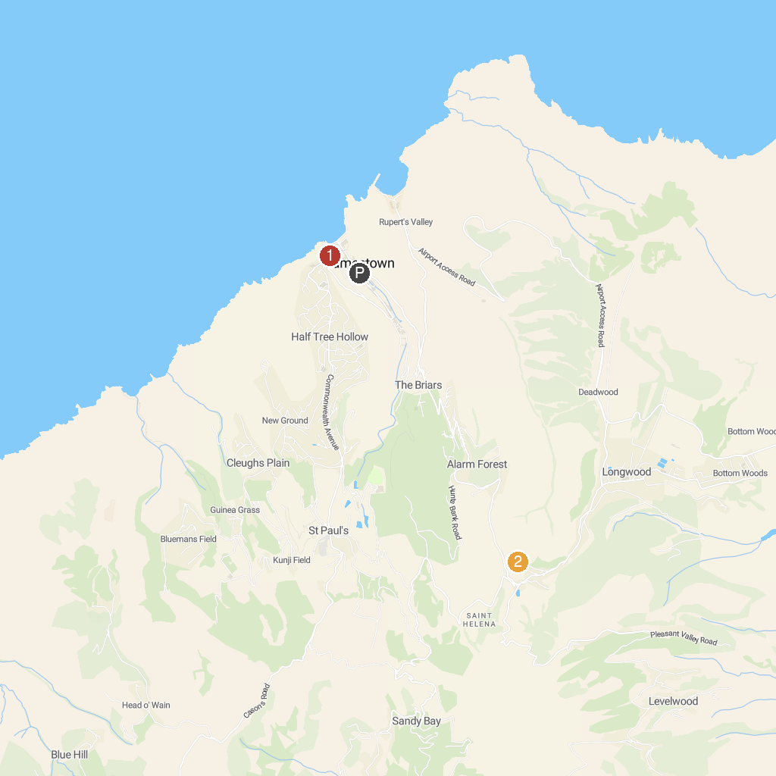
MAP KEY
1. Jacob's Ladder | 2. Napoleon's Grave
P. Cruise port / terminal
Map © MapTiler © OpenStreetMap contributors · cruiseports.org

