Saint Helena Island, South Atlantic, British Overseas Territory
One of the most remote inhabited islands on Earth, Saint Helena earned its place in history as Napoleon Bonaparte's final exile — and today rewards intrepid cruisers with a living land animal who was already old when Queen Victoria was crowned.
⚓ Tender port (no pier) · 🕒 Typical call: 7-9 hrs · 💷 GBP / SHP (cash only — no international ATMs) · 🗣️ English · 📅 Season: Oct–Apr
✍️ MY DAY IN PORT (FILL IN)
Ship / Date
In port | arrive ______ · all aboard ______
Booked excursion
Notes / meeting point
GETTING ASHORE
- Docking: Tender from James Bay anchorage to Jamestown Wharf
- Walk to center: 2 min from tender landing into Jamestown; all outside sites require a taxi
- Best For: History buffs, bucket-list travelers, Napoleon fans
- Don't Miss: Jonathan the tortoise at Plantation House — born c.1832, world's oldest known land animal
GETTING AROUND
- 🚕 Taxi: Negotiated (no meters) — Local taxis are available for trips to attractions outside Jamestown. Fares are not metered — agree on a price before de
- 📱 Rideshare: ❌ not available
TOP THINGS TO DO
- Longwood House — Napoleon's Exile — Tour the villa where Napoleon lived from 1815 until his death in 1821, preserved by the French government with original furniture…
- Jonathan the Tortoise at Plantation House — Meet Jonathan, a Seychelles giant tortoise born around 1832 and officially the world's oldest known living land animal, on the…
- Jacob's Ladder Climb — Tackle 699 steps up a 41-degree staircase built in 1829, rising straight out of Jamestown to Ladder Hill Fort.
- Diana's Peak National Park — Hike to the island's highest point (818 m) through lush tree-fern cloud forest.
- Napoleon's Tomb & Valley of the Tomb — Visit the peaceful wooded glade where Napoleon was buried before his remains were returned to France in 1840.
BEST WALKS
- Jamestown Town Walk: 1-2 hrs · Easy · Free — From the wharf, walk through the historic fortified gate into Main Street.
- Jacob's Ladder Challenge: 30-45 min up · Strenuous · Free — Start at the foot of Jacob's Ladder in Jamestown and climb all 699 steps to Ladder Hill Fort for…
WEATHER · DAYLIGHT · MONEY
Month | High °F | Low °F | Rainy days
May | 73 | 71 | 6
Jul | 69 | 66 | 8
Sep | 67 | 65 | 6
Daylight: May 6:38AM–6:00PM · Jul 6:51AM–6:06PM · Sep 6:18AM–6:18PM
cruiseports.org/saint-helena-island · Confirm terminal & all-aboard time with your ship

Saint Helena Island, South Atlantic, British Overseas Territory — Port Map
Red = walkable sights · Amber = excursions farther out · P = cruise terminal
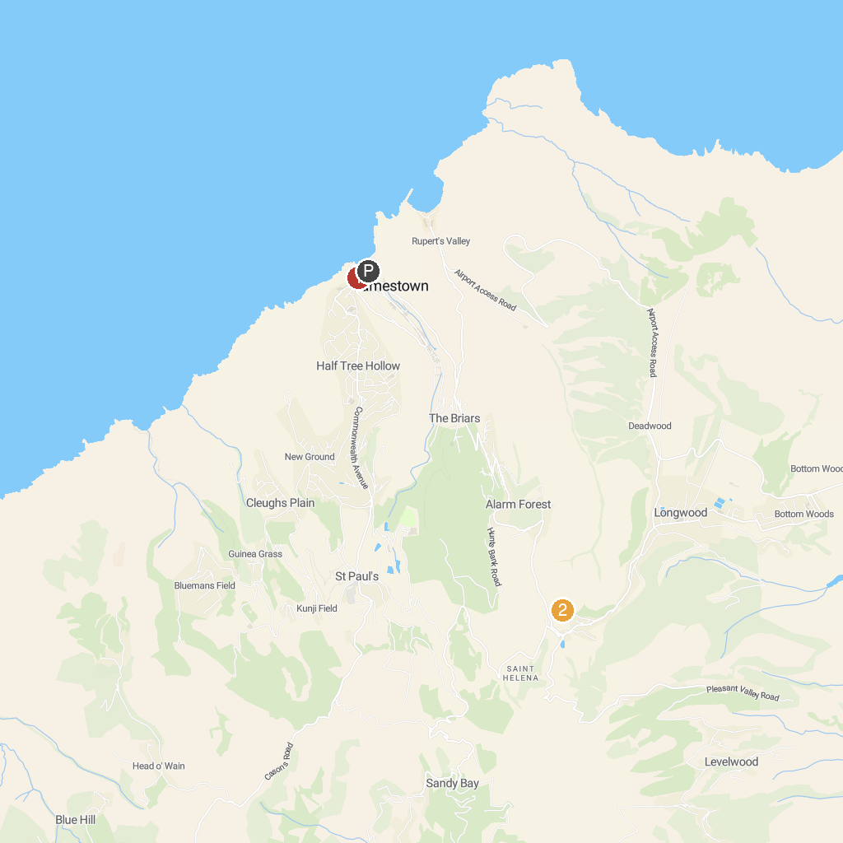
MAP KEY
1. Jacob's Ladder | 2. Napoleon's Grave
P. Cruise port / terminal
Map © MapTiler © OpenStreetMap contributors · cruiseports.org

