Saint-Emilion, Nouvelle-Aquitaine, France
Carved from limestone and steeped in Merlot, Saint-Emilion is one of France's most captivating medieval villages — an underground church beneath cobblestone streets, centuries-old châteaux, and wine poured with pride on every corner.
🚌 Bus transfer from dock (no ship pier) · 🕒 Typical call: 4-6 hrs in village · 💶 Currency: Euro (€) · 🗣️ Language: French · 🍷 UNESCO Wine Landscape
✍️ MY DAY IN PORT (FILL IN)
Ship / Date
In port | arrive ______ · all aboard ______
Booked excursion
Notes / meeting point
GETTING ASHORE
- Docking: River cruise ships dock at Libourne (8 km / 15 min by bus). Ocean ships dock at Bordeaux, Bassens, or Pauillac.
- Walk to center: Village is compact (~1 km across) but steeply cobbled. Arrive by bus at top or bottom of town.
- Best For: Wine lovers, history buffs, UNESCO sightseers, underground heritage
- Don't Miss: The Monolithic Church — Europe's largest underground church, carved by monks in the 12th century
GETTING AROUND
- 🚕 Taxi: €60–€80 — Taxis from Bordeaux cruise dock to Saint-Emilion village take roughly 40–50 minutes. Fares vary by operator; confirm pri
- 📱 Rideshare: ✅ Uber
TOP THINGS TO DO
- Monolithic Church & Underground Tour — Europe's largest underground monolithic church, carved by Benedictine monks in the 12th century from a single limestone cliff.
- Grand Cru Wine Tasting at a Château — Visit a Saint-Emilion Grand Cru Classé estate — Château Villemaurine (underground quarries + tasting) or Château Soutard are…
- Medieval Village Walking Tour — Wander the cobbled calades past the Collegiate Church and its Gothic cloister, the ruins of Les Cordeliers Franciscan monastery…
- Bell Tower Climb — Climb 196 steps above the Monolithic Church for the best panoramic view of the village rooftops and the vine-quilted Bordeaux…
- Vineyard Bike Tour — Pedal through the UNESCO-listed vineyard landscape surrounding Saint-Emilion, passing limestone walls, grand châteaux, and the…
BEST WALKS
- The Village Loop: 1.5 km | ~45 min | Moderate (steep cobbles) — Start at Place du Marché at the foot of the Monolithic Church cliff face, walk up through the…
- Vineyard Walk to the Grande Muraille: 2 km round-trip | ~45 min | Easy (flat vineyard path) — Walk out of the village through the vineyard lanes to the Grande Muraille — the isolated ruins of a…
WEATHER · DAYLIGHT · MONEY
Month | High °F | Low °F | Rainy days
May | 70 | 52 | 11
Jul | 81 | 62 | 8
Sep | 77 | 58 | 8
Daylight: May 6:32AM–9:22PM · Jul 6:29AM–9:43PM · Sep 7:39AM–8:10PM
cruiseports.org/saint-emilion · Confirm terminal & all-aboard time with your ship

Saint-Emilion, Nouvelle-Aquitaine, France — Port Map
Red = walkable sights · Amber = excursions farther out · P = cruise terminal
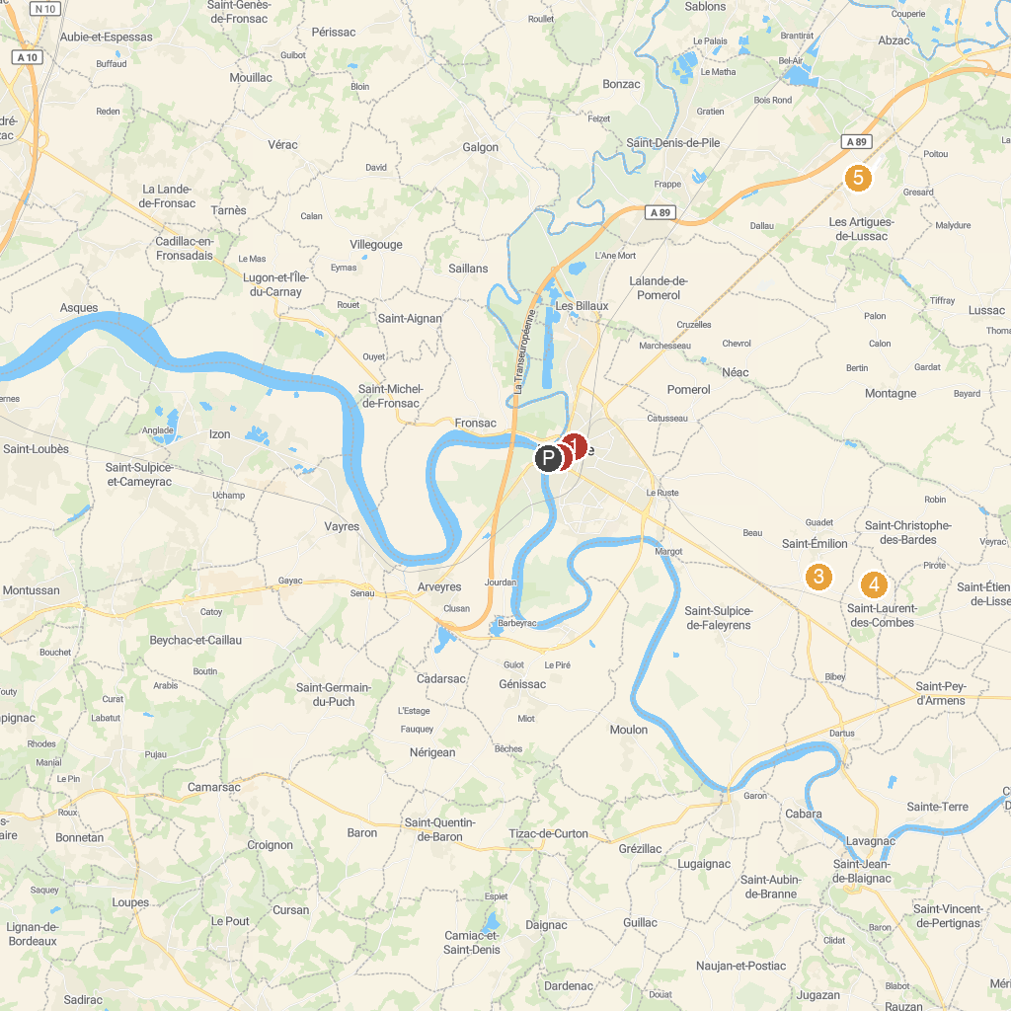
MAP KEY
1. Chapelle du Carmel | 5. Appy Ulm Baptême De L'air Et Initiation Au Vol En Ulm Près De Bordeaux
2. Museum of Fine Arts and Archeology of Libourne | 6. Grotte Célestine
3. Château Saint Georges Côte Pavie | 7. Château Rauzan
4. Château Rochebelle Saint-Émilion Grand Cru Classé
P. Cruise port / terminal
Map © MapTiler © OpenStreetMap contributors · cruiseports.org

