Sado Island, Niigata, Japan
Japan's storied island of exile and gold — where taiko drums echo through cedar forests, rare crested ibis wade in rice paddies, and historic gold mines sprawl across misty mountains.
⚓ Pier (Ryotsu Port) · 🕒 Typical call: 7-10 hrs · 💴 Japanese Yen (cash essential) · 🗣️ Japanese (limited English) · 🏝️ Island — all-day excursion
✍️ MY DAY IN PORT (FILL IN)
Ship / Date
In port | arrive ______ · all aboard ______
Booked excursion
Notes / meeting point
GETTING ASHORE
- Docking: Pier at Ryotsu Port (east coast) — large ships dock directly
- Walk to Center: Ryotsu town center is 5-10 min walk from the pier; major sights are 45-60 min by bus/taxi
- Best For: Cultural history, unique wildlife, sake tasting, coastal scenery
- Don't Miss: Sado Gold Mine (Sado Kinzan) and a tarai-bune tub boat ride at Ogi
GETTING AROUND
- 🚕 Taxi: Metered; charter rates vary — Standard metered taxis are available at Ryotsu Port. Chartered sightseeing taxis can be arranged for customized island t
- 📱 Rideshare: ❌ not available
TOP THINGS TO DO
- Sado Kinzan Gold Mine — Japan's largest pre-modern gold mine and a UNESCO World Heritage Site (inscribed 2024), mined for nearly 400 years under the…
- Toki Forest Park — Japanese Crested Ibis — The toki (Nipponia nippon) was declared extinct in Japan in 2003 before a captive breeding program brought it back.
- Ogi Tarai-bune Tub Boat Ride — At Ogi Port on the southern coast, local women paddle visitors through rocky inlets in traditional oval wooden tub boats — a…
- Noh Theater Performance — Sado has over a third of all active Noh stages in Japan, a legacy of exiled courtiers and artists who brought the art form here…
- Ogi Coast Cycling Route — Rent an e-bike at Marine Plaza Ogi and loop the dramatic volcanic coastline via Yajima and Kyojima sea stacks and Chojagabashi…
BEST WALKS
- Ryotsu Waterfront & Hot Spring Stroll: 1-2 km · 20-30 min · Easy — From the pier, walk the Ryotsu waterfront along Kamo Lake — a lagoon connected to the sea — toward…
- Shukunegi Historic Village Walk (Ogi): 1 km loop · 30 min · Easy — If calling at Ogi Port or on a south-Sado tour, walk the narrow lanes of Shukunegi — a beautifully…
WEATHER · DAYLIGHT · MONEY
Month | High °F | Low °F | Rainy days
May | 69 | 54 | 11
Jul | 83 | 72 | 16
Sep | 77 | 68 | 15
Daylight: May 4:36AM–6:49PM · Jul 4:35AM–7:08PM · Sep 5:27AM–5:54PM
cruiseports.org/sadoshima-island-japan · Confirm terminal & all-aboard time with your ship

Sado Island, Niigata, Japan — Port Map
Red = walkable sights · Amber = excursions farther out · P = cruise terminal
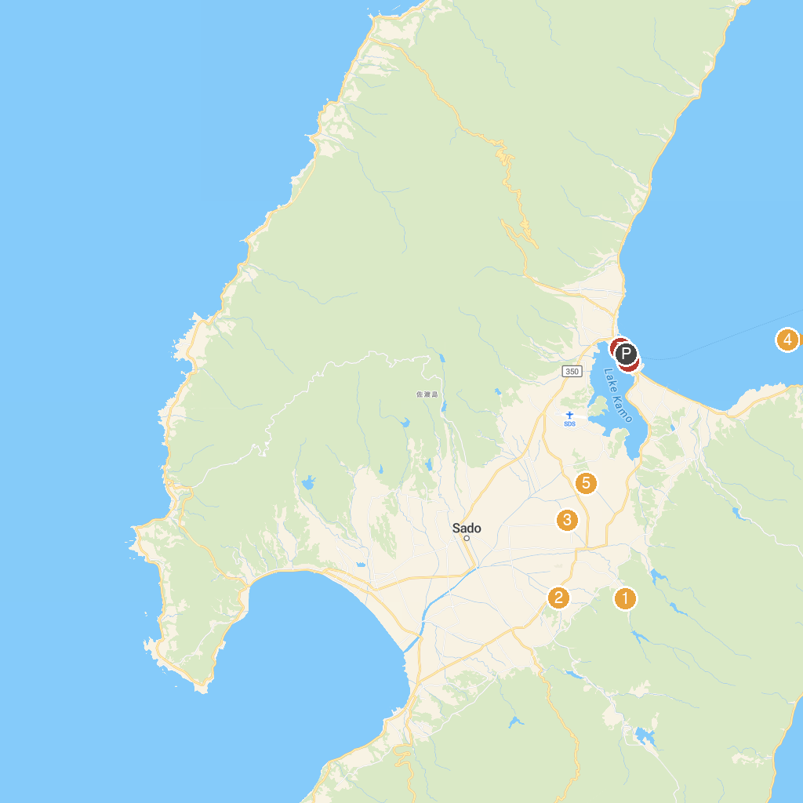
MAP KEY
1. Seisuiji Temple | 5. Tokinomori Park
2. Sendoonsen Yurinso | 6. Daizen Shrine
3. 朱鷺と暮らす郷 田んぼアート | 7. Minatochuo Park
4. Himezaki Lighthouse | 8. みなとオアシス佐渡両津
P. Cruise port / terminal
Map © MapTiler © OpenStreetMap contributors · cruiseports.org

