Sacramento, California, USA
California's capital city blends Gold Rush cobblestones with farm-fresh cuisine — and river cruise ships dock right at the heart of it all.
⚓ River pier dock (no tender) · 🕒 Typical call: 6-8 hrs · 💵 USD · 🗣️ English · 🌿 River cruise specialist port
✍️ MY DAY IN PORT (FILL IN)
Ship / Date
In port | arrive ______ · all aboard ______
Booked excursion
Notes / meeting point
GETTING ASHORE
- Docking: Pier — Old Sacramento Waterfront (L Street area); walk straight ashore
- Walk to center: 0 min to Old Sacramento; 20 min to State Capitol
- Best For: Gold Rush history, farm-to-fork dining, California history
- Don't Miss: California State Railroad Museum & the Underground Sacramento tour
GETTING AROUND
- 🚕 Taxi: $10–$20 — Metered taxis are available near the waterfront. Rates are roughly $4 base + $3/mile, placing most downtown trips in the
- 📱 Rideshare: ✅ Uber, Lyft
TOP THINGS TO DO
- California State Railroad Museum — One of the finest railroad museums in North America, with massive restored steam locomotives and vintage passenger cars you can…
- Underground Sacramento Tour — After catastrophic floods in the 1860s, Sacramento literally raised its streets by up to 15 feet.
- California State Capitol — Modeled on the US Capitol in Washington D.C., Sacramento's gold-domed Capitol sits inside a stunning 40-acre park with roses and…
- Old Sacramento Historic District — Step back into the 1850s Gold Rush era on wooden boardwalk streets lined with original 19th-century buildings, the Pony Express…
- Farm-to-Fork Sacramento — Sacramento is surrounded by 1.5 million acres of active farmland and earned the title 'Farm-to-Fork Capital of America.' Try the…
BEST WALKS
- Old Sacramento Waterfront to State Capitol: 2 miles round-trip | Easy | 45-60 min — Walk the wooden boardwalks of Old Sacramento, cross the Tower Bridge for views, then head up…
- Old Sacramento Historic Loop: 0.5 miles | Easy | 30-45 min — A short loop around the Gold Rush district: Railroad Museum, California History Museum, the Delta…
WEATHER · DAYLIGHT · MONEY
Month | High °F | Low °F | Rainy days
May | 82 | 54 | 3
Jul | 96 | 62 | 0
Sep | 90 | 60 | 1
Daylight: May 5:54AM–8:11PM · Jul 5:54AM–8:29PM · Sep 6:48AM–7:13PM
cruiseports.org/sacramento-ca · Confirm terminal & all-aboard time with your ship

Sacramento, California, USA — Port Map
Red = walkable sights · Amber = excursions farther out · P = cruise terminal
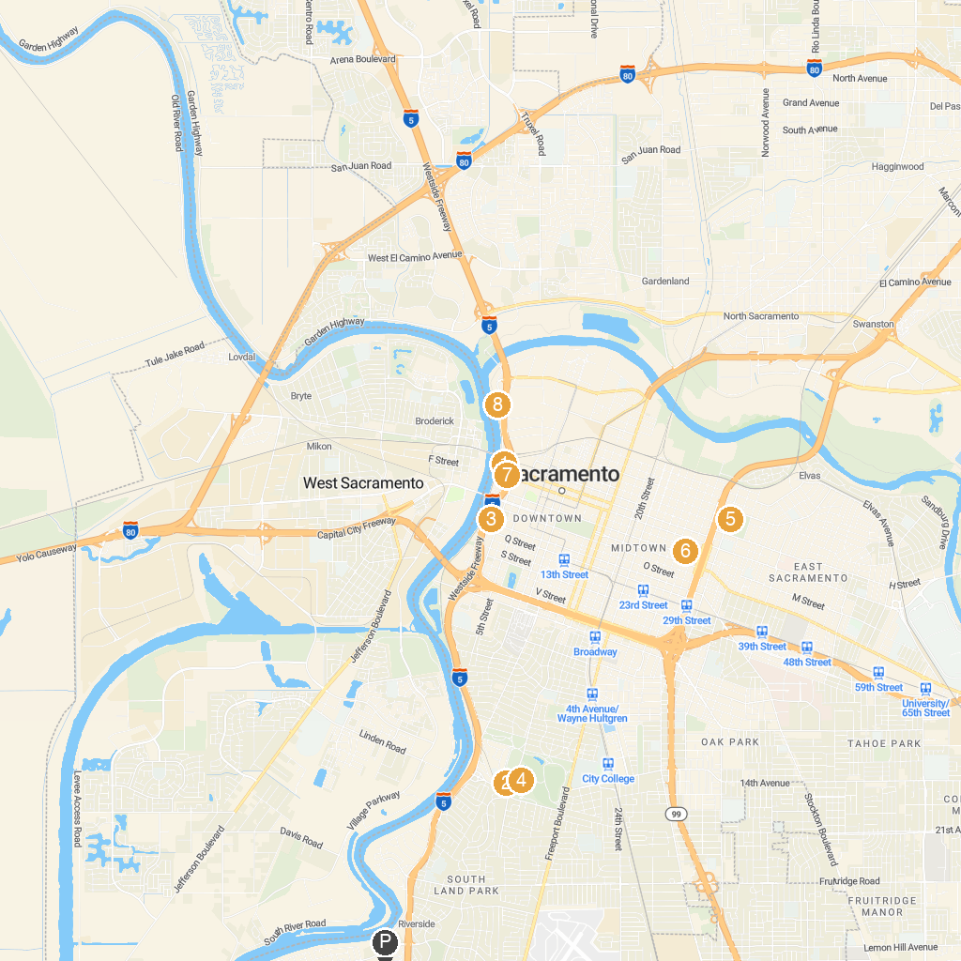
MAP KEY
1. California State Railroad Museum | 5. McKinley Park
2. Sacramento Zoo | 6. Sutter's Fort State Historic Park
3. Crocker Art Museum | 7. Pony Express Statue
4. Fairytale Town | 8. SMUD Museum of Science and Curiosity
P. Cruise port / terminal
Map © MapTiler © OpenStreetMap contributors · cruiseports.org

