Saarlouis, Saarland, Germany
Founded in 1680 by Louis XIV and engineered by military genius Vauban, Saarlouis wears its French heritage proudly — cobblestone parade squares, stone-vaulted casemate bars, and some of the finest Riesling in Germany just up the river.
⚓ River pier (docked) · 🕒 Typical call: 6–8 hrs · 💶 Euro (€) · 🗣️ German / French
✍️ MY DAY IN PORT (FILL IN)
Ship / Date
In port | arrive ______ · all aboard ______
Booked excursion
Notes / meeting point
GETTING ASHORE
- Docking: River quay at Saarlouis/Dillingen port — no tender required
- Walk to center: 10–15 min through Stadtgarten to Großer Markt
- Best For: History buffs, foodies, easy walkers
- Don't Miss: Lunch in the Kasematten vaults; Saar Riesling at a terrace cafe
GETTING AROUND
- 🚕 Taxi: €10–€15 — Taxis are readily available at the port area. The city center (Großer Markt) is a short ride; metered fares use the Saar
- 📱 Rideshare: ✅ Uber
TOP THINGS TO DO
- Vauban Fortifications & Kasematten — The star-shaped fortress, laid out from 1680 to Vauban's design, is the town's defining feature.
- Großer Markt & Town Exploration — The immense central square — designed by Vauban for military parades — today hosts a lively market scene.
- Völklinger Hütte — UNESCO Ironworks — The world's only fully preserved ironworks from the era of industrialization, a hulking cathedral of industrial heritage about 15…
- Saarschleife (The Saar Loop) — The iconic hairpin bend of the Saar River, surrounded by dense oak and beech forest.
- Kasematten Dining & Saar Riesling — Saarlouis punches well above its size in restaurants.
BEST WALKS
- Fortress & Markt Loop: 2–3 km · ~1.5 hrs · Easy · Flat — From the quay, walk through Stadtgarten to the Vauban Kasematten, continue to Großer Markt, cross…
WEATHER · DAYLIGHT · MONEY
Month | High °F | Low °F | Rainy days
May | 65 | 48 | 11
Jul | 77 | 59 | 10
Sep | 69 | 52 | 8
Daylight: May 5:49AM–9:09PM · Jul 5:44AM–9:33PM · Sep 7:09AM–7:45PM
cruiseports.org/saarlouis · Confirm terminal & all-aboard time with your ship

Saarlouis, Saarland, Germany — Port Map
Red = walkable sights · Amber = excursions farther out · P = cruise terminal
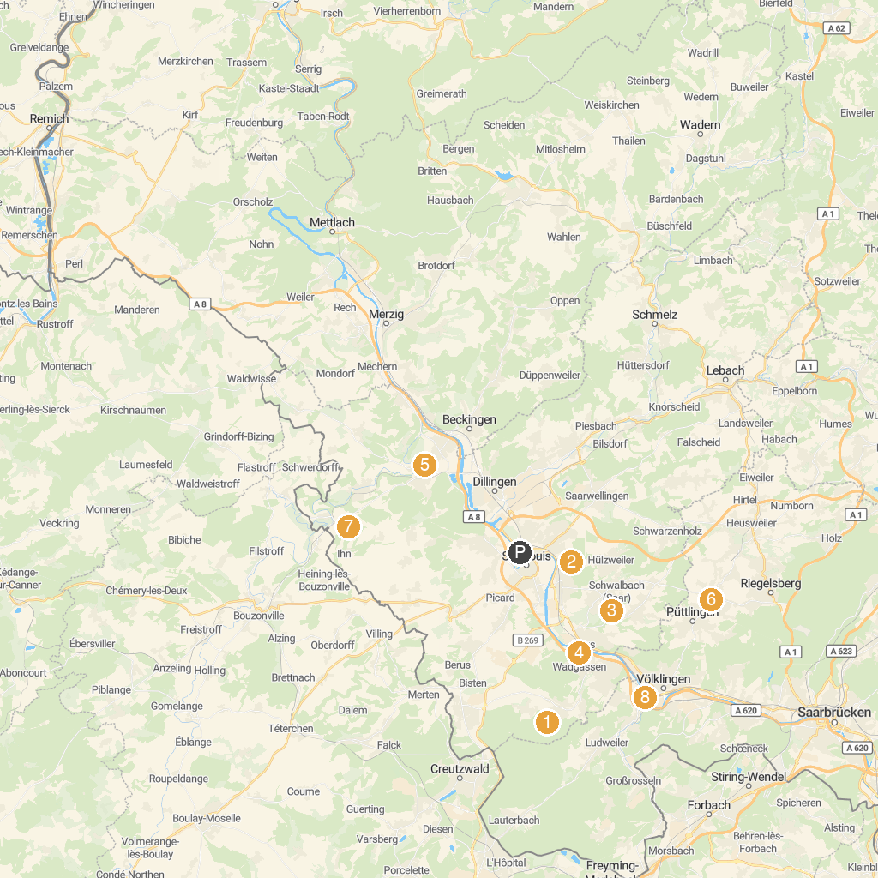
MAP KEY
1. Wildpark Wadgassen-Differten | 5. Siersburg Burg
2. Saarpolygon | 6. Uhrmachers Haus
3. Jahnhütte Schwalbach | 7. Sudelfels
4. Deutsches Zeitungsmuseum | 8. Völklingen Ironworks
P. Cruise port / terminal
Map © MapTiler © OpenStreetMap contributors · cruiseports.org

