Saarburg, Rhineland-Palatinate, Germany
A medieval waterfall town on the Saar — where a 20-metre cascade plunges through half-timbered streets, hilltop castle ruins crown the skyline, and slate-slope Rieslings are poured on the riverbank.
⚓ Docked (riverside pier) · 🕒 Typical call: 5–8 hrs · 💶 Currency: Euro (€) · 🗣️ Language: German · 🍷 Wine region: Saar Riesling
✍️ MY DAY IN PORT (FILL IN)
Ship / Date
In port | arrive ______ · all aboard ______
Booked excursion
Notes / meeting point
GETTING ASHORE
- Docking: Riverside quay at the Staden; no tender required
- Walk to center: ~10 min (flat along river, then cobbled hills)
- Best For: Waterfall walks, castle views, local Riesling tastings
- Don't Miss: The Leukbach waterfall and Klein-Venedig canal quarter
GETTING AROUND
- 🚕 Taxi: €5–€10 — Local taxis (Taxi Saarburg / Wendt, Gauer-Dahm) serve the area. The base fare is €4.80 plus ~€3.10/km; a short ride with
TOP THINGS TO DO
- Saarburg Waterfall & Klein-Venedig Walk — The Leukbach stream drops 20 metres over sandstone cliffs right in the town centre.
- Burg Saarburg Castle Ruins — Climb to the hilltop ruins of Saarburg Castle, founded in 964 AD by Count Siegfried of Luxembourg.
- KulturGießerei Mabilon Bell Foundry Museum — The Mabilon foundry cast bells from 1770 until 2002.
- Saar Riesling Wine Tasting — The steep slate slopes around Saarburg yield some of Germany's finest Riesling.
- Warsberg Chairlift & Summer Toboggan — Ride an open-air chairlift from the valley floor up to the Warsberg plateau for views over the Saar River.
BEST WALKS
- Waterfall & Old Town Loop: ~1.5 km · 45–60 min · Moderate (cobbles and steps) — Walk from the Staden quay along the promenade, cross the Saarbrücke, turn into the Altstadt toward…
- Saar Promenade Stroll: ~2 km · 30 min · Easy (flat) — For an easy warm-up, walk the riverside promenade north from the ship dock.
WEATHER · DAYLIGHT · MONEY
Month | High °F | Low °F | Rainy days
May | 65 | 48 | 12
Jul | 78 | 60 | 11
Sep | 70 | 53 | 9
Daylight: May 5:50AM–9:06PM · Jul 5:45AM–9:29PM · Sep 7:08AM–7:44PM
cruiseports.org/saarburg · Confirm terminal & all-aboard time with your ship

Saarburg, Rhineland-Palatinate, Germany — Port Map
Red = walkable sights · Amber = excursions farther out · P = cruise terminal
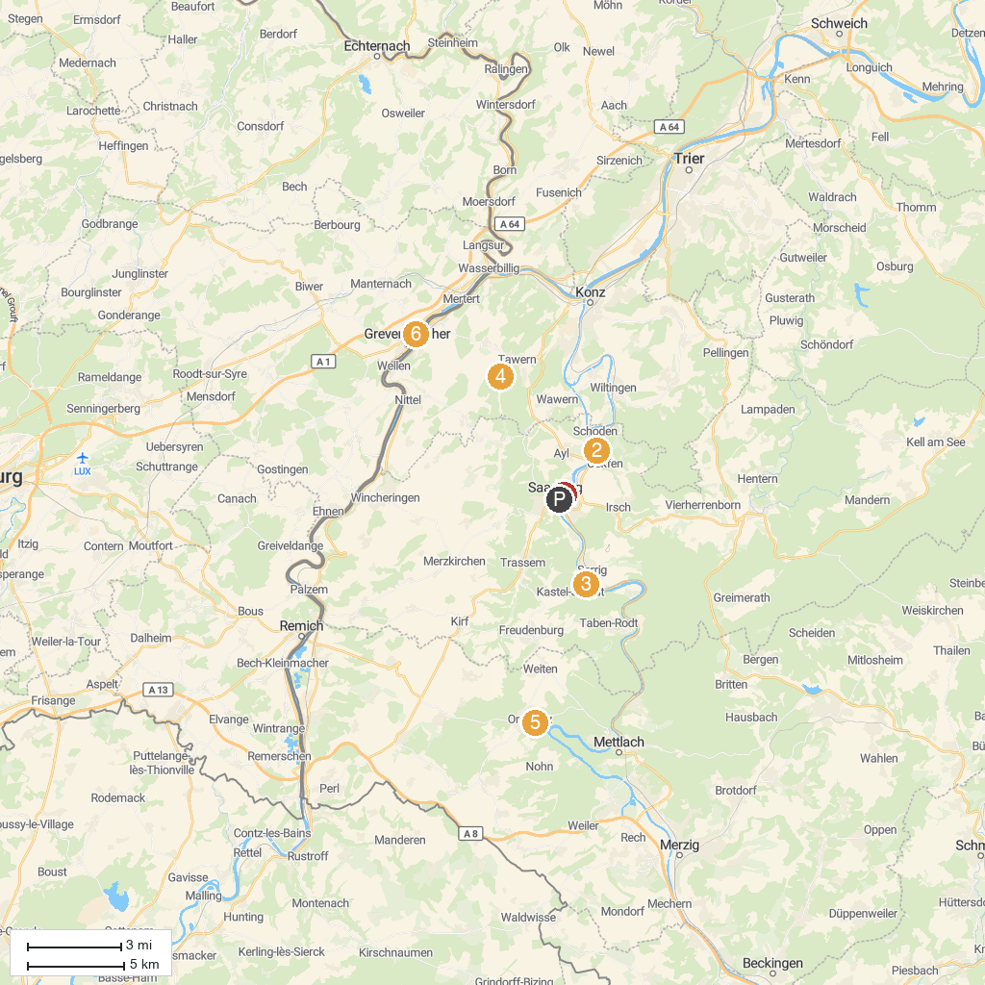
MAP KEY
1. Saarburg | 5. Treetop Walk Saarschleife
2. Bismarck Tower Schoden | 6. Butterfly Garden, Grevenmacher
3. Klause bei Kastel | 7. Wäinhaus - Maison et musée du vin
4. Roman Temple of Tawern | 8. Bulldog- und Landmaschinenmuseum Robert Willkomm
P. Cruise port / terminal
Map © MapTiler © OpenStreetMap contributors · cruiseports.org

