Saarbrücken, Saarland, Germany
Where Germany meets France along the Saar River — a compact, walkable Baroque city with a lively market square, a hilltop castle, and a UNESCO ironworks a short train ride away.
⚓ Docked (river pier) · 🕒 Typical call: 7–9 hrs · 💶 Euro (EUR) · 🗣️ German
✍️ MY DAY IN PORT (FILL IN)
Ship / Date
In port | arrive ______ · all aboard ______
Booked excursion
Notes / meeting point
GETTING ASHORE
- Docking: River moorings at Alte Brücke or Staden; ships dock alongside quay
- Walk to centre: ~5 min to St. Johanner Markt from main moorings
- Best For: History, Baroque architecture, Franco-German culture, day trips
- Don't Miss: Völklingen Ironworks UNESCO site (11 min by train)
GETTING AROUND
- 🚕 Taxi: €10–€20 — Metered taxis are readily available at the cruise terminal and main city stands. Base fare €4.80 plus €3.10/km; most cit
- 📱 Rideshare: ✅ Uber, FREENOW
TOP THINGS TO DO
- Saarbrücken Castle & Historical Museum Saar — The Baroque Saarbrücker Schloss dominates the riverbank skyline.
- St. Johanner Markt Old Town Walk — The heart of Saarbrücken — a cobbled Baroque market square ringed by boutiques, bistros, and the Neo-Gothic Rathaus St.
- Völklingen Ironworks — UNESCO Day Trip — A short 11-minute train ride brings you to the Völklinger Hütte, a remarkably intact 19th-century blast furnace complex now a…
- Ludwigskirche Baroque Church — Considered one of Germany's finest Baroque Protestant churches, the Ludwigskirche was designed by Friedrich Joachim Stengel — the…
- Saar River Promenade Walk — Both banks of the Saar offer tree-lined promenades with cafes, sculptures, and cycle paths.
BEST WALKS
- Old Town Loop: ~2 km · 45 min · Easy — From the river moorings, cross the Alte Brücke into the St.
WEATHER · DAYLIGHT · MONEY
Month | High °F | Low °F | Rainy days
May | 65 | 48 | 11
Jul | 77 | 59 | 10
Sep | 69 | 53 | 8
Daylight: May 5:49AM–9:08PM · Jul 5:43AM–9:31PM · Sep 7:08AM–7:44PM
cruiseports.org/saarbrucken · Confirm terminal & all-aboard time with your ship

Saarbrücken, Saarland, Germany — Port Map
Red = walkable sights · Amber = excursions farther out · P = cruise terminal
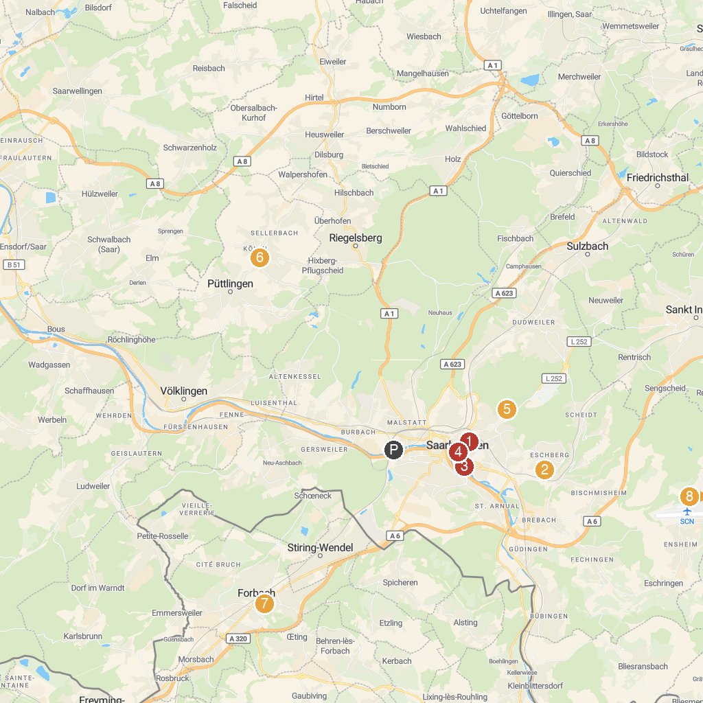
MAP KEY
1. St. Michael Kirche | 5. Adventure Park Saar - climbing park in Saarbrücken
2. Saarbrücken Zoo | 6. Uhrmachers Haus
3. Saarland Museum, Modern Gallery | 7. Église Saint-Rémi
4. Rathaus St. Johann | 8. Gangelbrunnen
P. Cruise port / terminal
Map © MapTiler © OpenStreetMap contributors · cruiseports.org

