Sa Dec, Dong Thap, Vietnam
Drift past boat-tended flower fields and step into the romance of the Mekong Delta — Sa Dec preserves a 1930s riverside world that most of Vietnam has long left behind.
⚓ Docked at riverbank · 🕒 Typical call: 6-8 hrs · 💵 Vietnamese Dong (VND) · 🗣️ Vietnamese · 🌸 Flower Village
✍️ MY DAY IN PORT (FILL IN)
Ship / Date
In port | arrive ______ · all aboard ______
Booked excursion
Notes / meeting point
GETTING ASHORE
- Docking: Riverbank mooring; small gangway to shore
- Walk to center: ~5 min to Sa Dec Market; 15 min to Huynh Thuy Le House
- Best For: Flower village, French colonial history, local market life
- Don't Miss: Huynh Thuy Le Ancient House and Tan Quy Dong Flower Village
GETTING AROUND
- 🚕 Taxi: ~10,000 VND/km (metered) — Metered local taxis are available in Sa Dec. Fares are low by Western standards; ask your cruise staff or hotel to call
TOP THINGS TO DO
- Tan Quy Dong Flower Village — One of Southern Vietnam's largest flower-growing areas, with over 1,000 varieties cultivated on shelves above flooded ground.
- Huynh Thuy Le Ancient House — The 'Lover's House' at 255A Nguyen Hue Street — a beautifully preserved 1895 merchant home blending Chinese, Vietnamese, and…
- Sa Dec Market & Riverside Walk — The riverside market bursts with fresh produce, spices, tropical fruit, and local street food — a genuine working market rather…
- Kien An Cung Temple — A striking Chinese temple (also called Ong Quach Pagoda) built 1924–1927 by Fujian settlers, richly decorated with ceramic…
- Mekong Delta Cooking & Canal Boat Ride — Many ships and local operators offer a combined canal sampan ride through narrow waterways followed by a hands-on cooking class…
BEST WALKS
- Riverside to Lovers House Walk: 1.5 km · 20 min · Easy · Flat — Follow the riverfront from the dock through the market, then turn inland along Nguyen Hue Street to…
- Temple & Town Loop: 2 km · 30 min · Easy · Flat — From the dock, walk north along the river to Kien An Cung Temple, then loop back through the old…
WEATHER · DAYLIGHT · MONEY
Month | High °F | Low °F | Rainy days
May | 91 | 78 | 25
Jul | 86 | 77 | 29
Sep | 87 | 76 | 28
Daylight: May 5:35AM–6:11PM · Jul 5:43AM–6:22PM · Sep 5:46AM–5:57PM
cruiseports.org/sa-dec · Confirm terminal & all-aboard time with your ship

Sa Dec, Dong Thap, Vietnam — Port Map
Red = walkable sights · Amber = excursions farther out · P = cruise terminal
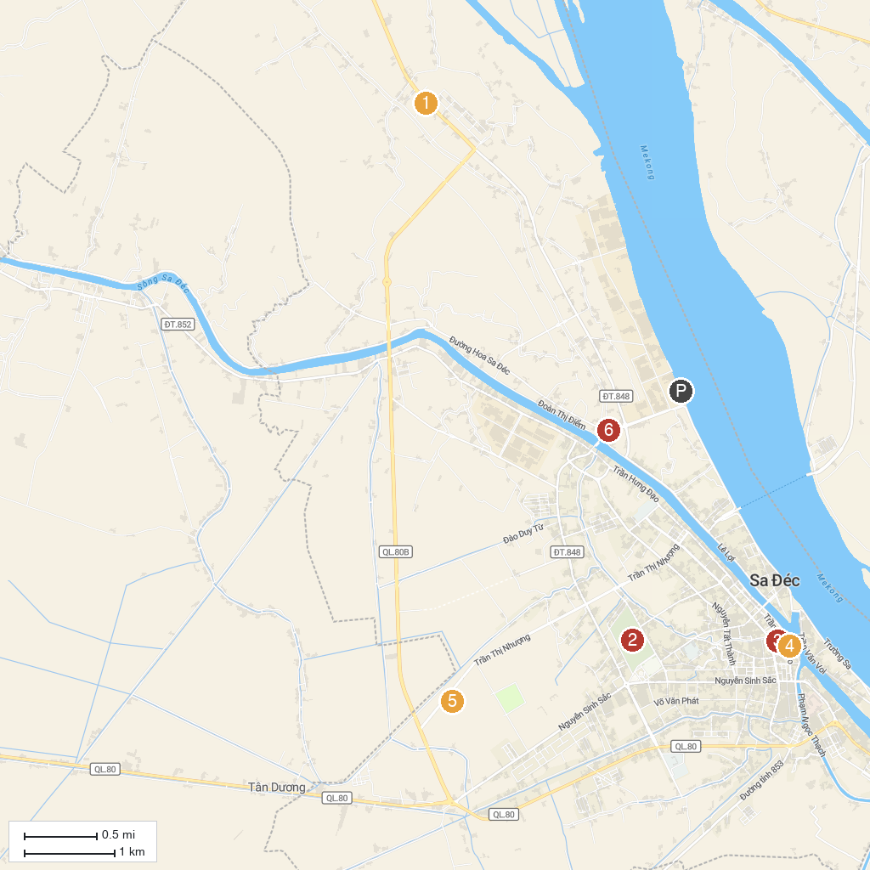
MAP KEY
1. Sa Dec Ornamental Flower Tourist Area | 5. Nhà cổ Huỳnh Thuỷ Lê
2. Lotus Pagoda | 6. Khu Du lịch Sinh thái MIỀN TÂY Lodge
3. Sa Dec Park | 7. Làng hoa Sa Đéc
4. Sa Dec Hokkien Assembly Hall
P. Cruise port / terminal
Map © MapTiler © OpenStreetMap contributors · cruiseports.org

