Ruse, Northern Bulgaria, Bulgaria
Called 'Little Vienna' for its grand 19th-century facades, Ruse sits on the Danube with a walkable city centre just minutes from the pontoon — plus UNESCO rock churches a short drive inland.
⚓ Pier (docked) · 🕒 Typical call: 8-10 hrs · 💵 Bulgarian Lev (BGN) · 🗣️ Bulgarian (Cyrillic) · 🏛️ History & architecture
✍️ MY DAY IN PORT (FILL IN)
Ship / Date
In port | arrive ______ · all aboard ______
Booked excursion
Notes / meeting point
GETTING ASHORE
- Docking: Direct pier at central passenger quay — no tender required
- Walk to centre: 10-15 min (~800 m) from quay to Freedom Square
- Best For: Architecture lovers, history buffs, UNESCO day trips
- Don't Miss: Ivanovo Rock-Hewn Churches UNESCO site, 20 km south
GETTING AROUND
- 🚕 Taxi: ~8–12 BGN (~€4–6) — Licensed taxis are readily available at the port. Base fare is 2.90 BGN plus 1.20 BGN/km; short city-center trips run un
- 📱 Rideshare: ❌ not available
TOP THINGS TO DO
- Ivanovo Rock-Hewn Churches (UNESCO) — Chapels and monasteries carved into the cliffs of Rusenski Lom Nature Park, featuring vivid 14th-century frescoes.
- Sexaginta Prista Roman Fortress — Open-air ruins of a Roman naval fortress ('Sixty Ships') just a 5-minute walk from the ship.
- Freedom Square & Old Town Walk — Self-guided stroll through Ruse's finest Neo-Baroque streetscapes — the Monument of Liberty, Dohodno Zdanie theatre building, and…
- Regional Historical Museum — Housed in the former Battenberg Palace, this museum holds the Borovo Treasure — a stunning Thracian silver feast set — along with…
- Basarbovo Cave Monastery — The only active cave monastery in Bulgaria, built directly into the limestone cliffs of the Rusenski Lom river valley, just 10 km…
BEST WALKS
- Quay to Freedom Square Stroll: 1.5 km · 20 min · Easy · Mostly flat — The essential Ruse introduction: follow the riverside promenade north through Pridunavski Park…
- Old Town Architecture Loop: 2.5 km · 35 min · Easy — From Freedom Square, loop through the backstreets past the Regional Historical Museum on Alexander…
WEATHER · DAYLIGHT · MONEY
Month | High °F | Low °F | Rainy days
May | 73 | 55 | 11
Jul | 86 | 67 | 8
Sep | 78 | 59 | 6
Daylight: May 5:50AM–8:34PM · Jul 5:48AM–8:55PM · Sep 6:55AM–7:26PM
cruiseports.org/ruse · Confirm terminal & all-aboard time with your ship

Ruse, Northern Bulgaria, Bulgaria — Port Map
Red = walkable sights · Amber = excursions farther out · P = cruise terminal
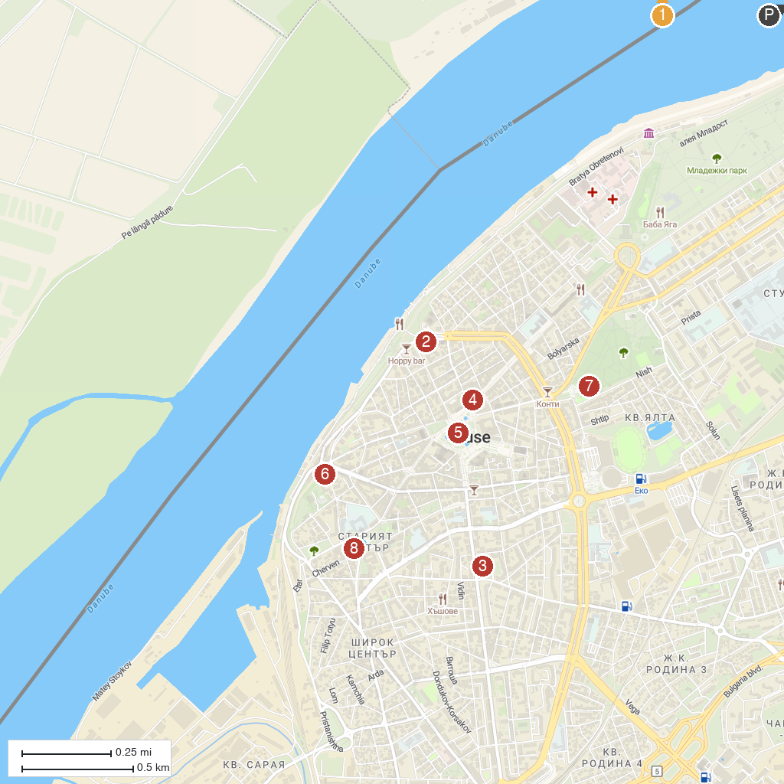
MAP KEY
1. Giurgiu Port | 5. Monument of Liberty
2. Museum of urban life Kaliopa House | 6. “Sexaginta Prista” Port of the sixty ships fortress
3. Art Gallery | 7. Pantheon of National Revival Heroes
4. Municipal Tourist Information Center | 8. Regional Historical Museum
P. Cruise port / terminal
Map © MapTiler © OpenStreetMap contributors · cruiseports.org

