Runavík, Eysturoy, Faroe Islands
Stretched along the shore of Skálafjørður — the longest fjord in the Faroe Islands — Runavík is the islands' most welcoming cruise port: ships dock pier-side and passengers walk straight into a living Faroese town with zero tourist-trap energy.
⚓ Pier (King's Harbour) · 🕒 Typical call: 6-8 hrs · 💵 Danish Krone (DKK) — cards accepted everywhere · 🗣️ Faroese & Danish; English widely spoken · 🌦️ Layers required year-round
✍️ MY DAY IN PORT (FILL IN)
Ship / Date
In port | arrive ______ · all aboard ______
Booked excursion
Notes / meeting point
GETTING ASHORE
- Docking: Pier — King's Harbour, walk off gangway directly into town
- Walk to center: 5–15 min flat walk along the fjord to main street
- Best For: Scenic fjord hikes, Faroese village culture, authentic wool shopping
- Don't Miss: Lake Toftavatn heather walk and the world's first underwater roundabout
GETTING AROUND
- 🚕 Taxi: 75–400 DKK — Local taxis are available but limited and often based in Tórshavn. Expect a minimum fare around 400 DKK (~$58 USD) for o
- 📱 Rideshare: ❌ not available
TOP THINGS TO DO
- Lake Toftavatn Heather Walk — A 30-minute walk from port leads to the largest continuous heather area in the Faroe Islands, wrapped around a still freshwater…
- Gjógv Village & Sea Gorge — The most photographed village in the Faroes sits at the northern tip of Eysturoy.
- Underwater Roundabout Drive — The 11.2 km Eysturoy Tunnel connects Runavík to Tórshavn via the world's first underwater roundabout, illuminated with art by…
- Heimablídni Home Dining — Faroese 'home hospitality' — sit down with a local family for coffee, homemade waffles, and traditional fermented lamb or dried…
- Nes Church & Fjord Walk — A scenic 40-minute walk (or short bus ride) along the fjord shore brings you to the 1843 wooden church at Nes, one of the most…
BEST WALKS
- King's Harbour to Heiðavegur (Town Stroll): 0.8 km · 10 min · Easy — Walk the flat fjord-front promenade from the pier into the town centre.
- Toftavatn Heather Lake Loop: 4 km · 1.5 hrs · Easy-Moderate — Head south from the town centre on the marked footpath to Lake Toftavatn, the Faroes' largest…
WEATHER · DAYLIGHT · MONEY
Month | High °F | Low °F | Rainy days
May | 48 | 41 | 17
Jul | 56 | 49 | 18
Sep | 53 | 47 | 18
Daylight: May 4:32AM–10:16PM · Jul 4:09AM–10:54PM · Sep 6:53AM–7:49PM
cruiseports.org/runavik · Confirm terminal & all-aboard time with your ship

Runavík, Eysturoy, Faroe Islands — Port Map
Red = walkable sights · Amber = excursions farther out · P = cruise terminal
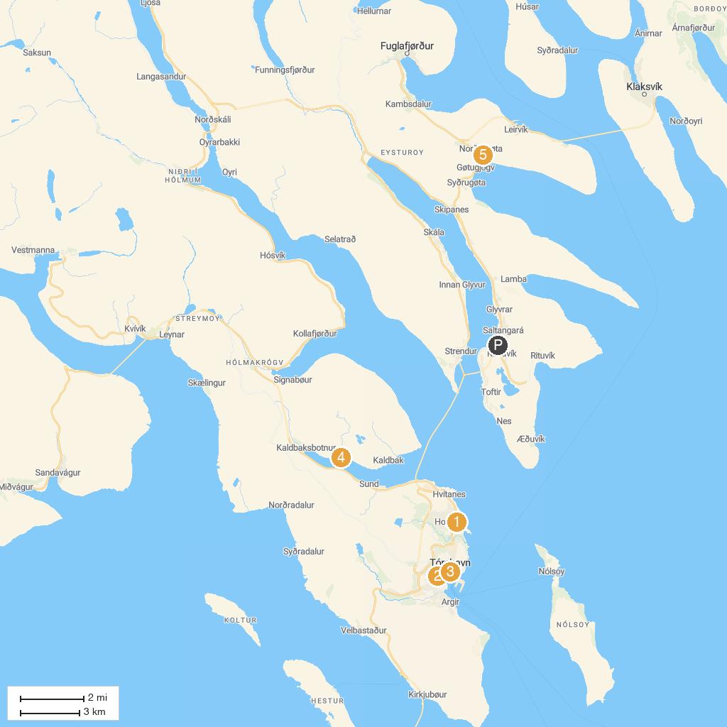
MAP KEY
1. Tjóðsavnið (Faroe Islands National Museum) | 4. Tórshavn Cathedral
2. Vesturkirkjan | 5. Tyggjara falls
3. Christianskirkjan | 6. Gøta Museum
P. Cruise port / terminal
Map © MapTiler © OpenStreetMap contributors · cruiseports.org

