Royan, Charente-Maritime, France
Destroyed in WWII and rebuilt in bold 1950s concrete modernism, Royan is a seaside resort unlike any other in France — think futuristic church, shell-shaped market, and oysters by the dozen.
⚓ River cruise pier / ocean ships may tender · 🕒 Typical call: 6–8 hrs · 💶 Euro (€) · 🗣️ French
✍️ MY DAY IN PORT (FILL IN)
Ship / Date
In port | arrive ______ · all aboard ______
Booked excursion
Notes / meeting point
GETTING ASHORE
- Docking: River cruise ships dock at Sabliers pier in the marina; larger ocean vessels may anchor and tender
- Walk to Center: 5 min from pier to main beach; 12 min to Notre-Dame Church
- Best For: Architecture lovers, beach days, seafood & wine, Atlantic France
- Don't Miss: Notre-Dame de Royan church, the shell-shaped Marché Central, and Marennes-Oléron oysters
GETTING AROUND
- 🚕 Taxi: €6–€10 — Short taxi rides within central Royan are affordable, typically €6–€10 for trips under 3 km. Taxis may not always be wai
- 📱 Rideshare: ✅ Uber
TOP THINGS TO DO
- Cordouan Lighthouse — The 'Versailles of the Sea' — a UNESCO World Heritage lighthouse built in the 16th century and still operational.
- 1950s Architecture Walk — Royan's post-war rebuild produced one of Europe's finest collections of modernist architecture.
- Oyster & Pineau Tasting — The Marennes-Oléron oyster is world-famous — finished in shallow claire ponds to develop a green hue and nutty flavour.
- La Grande Conche Beach — A 2 km crescent of golden Atlantic sand starting just steps from the harbour.
- Planet Exotica — A tropical botanical garden and reptile park a short walk from the harbour.
BEST WALKS
- Modernist Royan Circuit: 2 km · 45 min · Easy — From the marina, head up to Notre-Dame de Royan — the dramatic concrete church whose bell tower…
- Coastal Path to Pontaillac: 3.5 km · 1 hr · Easy — Follow the rocky coastal path west from the harbour past Plage de Foncillon to the trendy…
WEATHER · DAYLIGHT · MONEY
Month | High °F | Low °F | Rainy days
May | 67 | 53 | 11
Jul | 77 | 63 | 8
Sep | 74 | 59 | 9
Daylight: May 6:33AM–9:28PM · Jul 6:29AM–9:49PM · Sep 7:42AM–8:14PM
cruiseports.org/royan · Confirm terminal & all-aboard time with your ship

Royan, Charente-Maritime, France — Port Map
Red = walkable sights · Amber = excursions farther out · P = cruise terminal
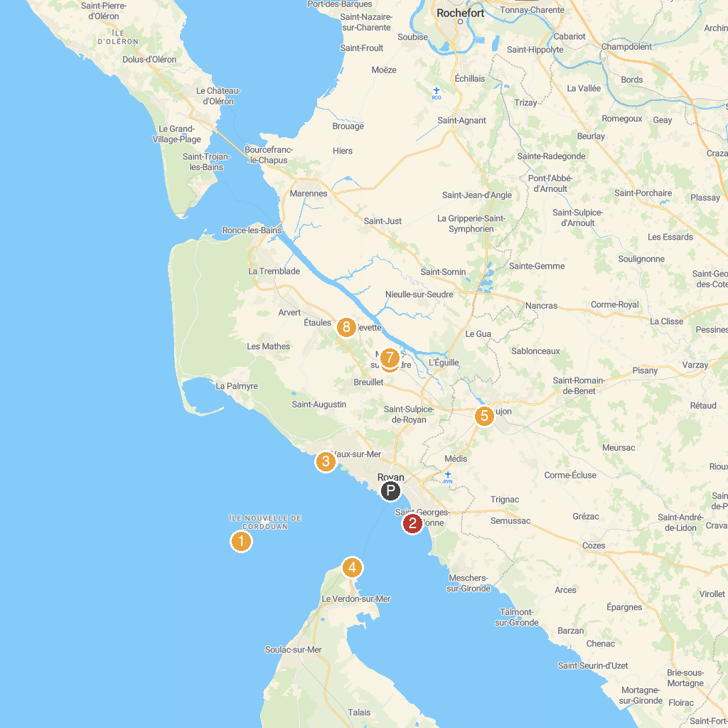
MAP KEY
1. Cordouan Lighthouse | 5. Le Train des Mouettes
2. Phare de Saint-Georges-de-Didonne | 6. Le Train des Mouettes-Gare de Mornac.
3. Maison des Douanes | 7. Mornac Sur Seudre
4. Phare de Grave | 8. Gare de Chaillevette
P. Cruise port / terminal
Map © MapTiler © OpenStreetMap contributors · cruiseports.org

