Rovinj, Istria, Croatia
Rovinj tumbles down a hillside into the Adriatic like a Venetian painting come to life — pastel houses stacked to a soaring baroque bell tower, cobblestone lanes polished to a mirror shine, and truffle pasta around every corner.
⚓ Tender (most ships) / Pier (small ships) · 🕒 Typical call: 7-9 hrs · 💶 Currency: Euro (€) · 🗣️ Languages: Croatian, Italian, English
✍️ MY DAY IN PORT (FILL IN)
Ship / Date
In port | arrive ______ · all aboard ______
Booked excursion
Notes / meeting point
GETTING ASHORE
- Docking: Tender for most ships; small vessels may dock at Molo Grande in the harbor
- Walk to center: 0 min — tender drops at the Old Town harbor
- Best For: Wandering medieval lanes, Istrian cuisine, seaside swimming
- Don't Miss: Climbing St. Euphemia Bell Tower for panoramic Adriatic views
GETTING AROUND
- 🚕 Taxi: €6–10 — Local taxis are available near the harbor. The base fare is around €1.95 with ~€1.80/km; the minimum fare is approximate
- 📱 Rideshare: ✅ Uber, Cammeo
TOP THINGS TO DO
- Old Town Walk & St. Euphemia Tower — Wander Grisia Street's open-air galleries, pass through Balbi's Arch, and climb the 60 m baroque bell tower for panoramic views…
- Istrian Truffle Hunt & Lunch — Head inland to the Motovun forest for a guided truffle hunt with dogs, then sit down to a farm lunch of local pasta, truffle…
- Hilltop Villages of Istria (Motovun & Grožnjan) — Two medieval hilltop towns in the Istrian interior — Motovun for its walls and truffles, Grožnjan for its artists' colony and…
- Golden Cape Forest Park & Beach — A 20-min walk south along the coastal promenade brings you to Zlatni Rt, a forested cape with pebble coves, calm water, sunbed…
- Batana Eco-Museum — A small but engaging museum celebrating the batana — the flat-bottomed wooden fishing boat unique to Rovinj — with exhibits on…
BEST WALKS
- Old Town Loop: 1.2 km · 45–60 min · Easy (some hills) — From the harbor, pass through Balbi's Arch into the old town, climb Grisia Street past galleries…
- Harbourfront to Golden Cape: 2.5 km one-way · 25 min · Flat — Follow the coastal promenade south past Mulini Beach and the Hotel Monte Mulini to Zlatni Rt…
WEATHER · DAYLIGHT · MONEY
Month | High °F | Low °F | Rainy days
May | 70 | 59 | 13
Jul | 84 | 72 | 9
Sep | 76 | 64 | 10
Daylight: May 5:36AM–8:27PM · Jul 5:33AM–8:49PM · Sep 6:44AM–7:15PM
cruiseports.org/rovinj · Confirm terminal & all-aboard time with your ship

Rovinj, Istria, Croatia — Port Map
Red = walkable sights · Amber = excursions farther out · P = cruise terminal
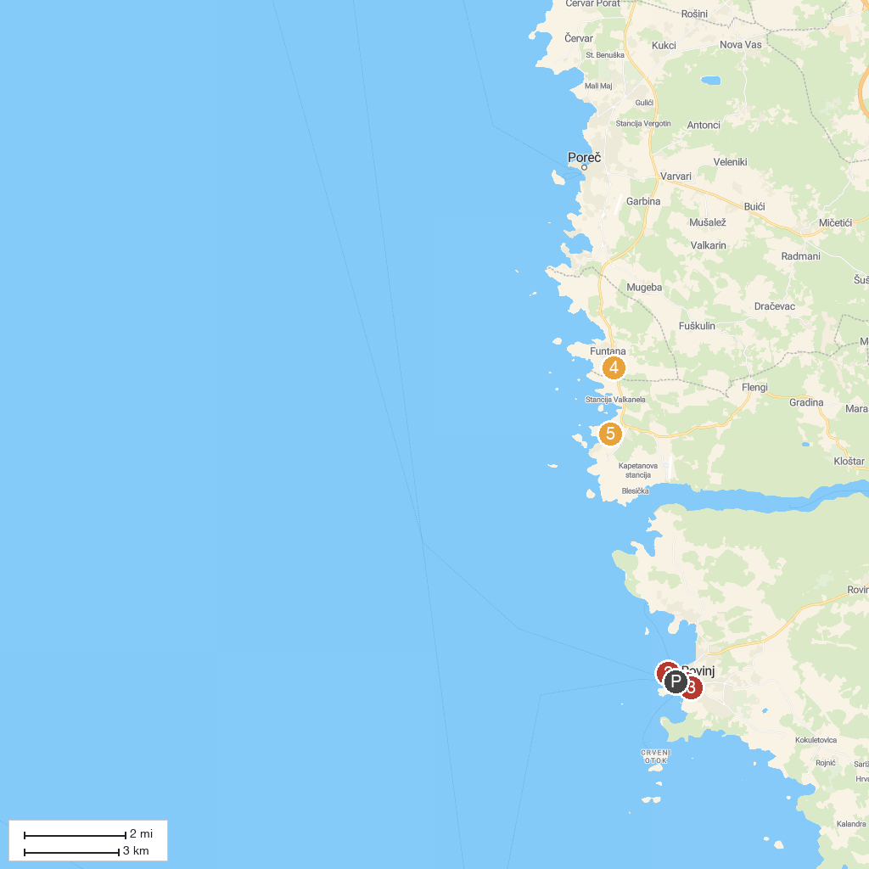
MAP KEY
1. Admiral Automat Club Rovinj | 5. Soardo-Bembo Palace
2. Plaža Balota | 6. Aquapark Aquacolors
3. Galerija Adris | 7. Church of St. Martin
4. Dinopark Funtana
P. Cruise port / terminal
Map © MapTiler © OpenStreetMap contributors · cruiseports.org

