Rouen, Normandy, France
Victor Hugo's 'City of a Hundred Spires' delivers one of Europe's most intact medieval city centers — cobbled lanes, soaring Gothic spires, and the square where Joan of Arc was burned — all within a short walk of the pier on the Seine.
⚓ Pier (docked on the Seine) · 🕒 Typical call: 8–12 hrs · 💶 Currency: Euro (€) · 🗣️ Language: French · 🏛️ History & Culture
✍️ MY DAY IN PORT (FILL IN)
Ship / Date
In port | arrive ______ · all aboard ______
Booked excursion
Notes / meeting point
GETTING ASHORE
- Docking: Pier — ships berth alongside the Seine quays; no tender required
- Walk to center: 15–25 min (1.2–1.8 km) along flat riverside promenade
- Best For: Medieval architecture, Joan of Arc history, Monet art, Normandy cuisine
- Don't Miss: Rouen Cathedral (Monet's muse), Place du Vieux-Marché, Gros-Horloge clock
GETTING AROUND
- 🚕 Taxi: €10–€18 — Taxis wait at both cruise terminals and reach the city center in about 10–15 minutes. Metered fares; no pre-booking need
- 📱 Rideshare: ✅ Uber, Bolt
TOP THINGS TO DO
- Joan of Arc Trail — Visit the Old Market Square where she was executed in 1431, the striking modern Church of Saint Joan of Arc, and the Historial…
- Rouen Cathedral & Monet's Muse — Explore the magnificent Gothic cathedral Monet painted over 30 times, housing the tomb of Richard the Lionheart's heart.
- D-Day Beaches (Normandy) — The WWII landing beaches — Omaha, Utah, Gold, Juno, Sword — are about 2 hours by road.
- Monet's Garden at Giverny — Claude Monet's legendary home and water-lily garden (inspiration for his famous series) is about an hour (≈45 min–1 hr 15)…
- Honfleur & the Normandy Coast — The postcard-perfect harbor town of Honfleur — tall slate houses, art galleries, and fresh seafood — is about 50 minutes west.
BEST WALKS
- Medieval Heart Walk: 2–3 km · Flat · 90 min — The essential Rouen circuit: from the quays, walk to the Gros-Horloge, continue to Rouen Cathedral…
- Rue Eau-de-Robec Stroll: 1 km · Flat · 30 min — A picturesque pedestrian lane with a small stream running through it, lined with colorful…
WEATHER · DAYLIGHT · MONEY
Month | High °F | Low °F | Rainy days
May | 64 | 48 | 13
Jul | 74 | 58 | 10
Sep | 69 | 54 | 10
Daylight: May 6:11AM–9:32PM · Jul 6:06AM–9:56PM · Sep 7:32AM–8:08PM
cruiseports.org/rouen · Confirm terminal & all-aboard time with your ship

Rouen, Normandy, France — Port Map
Red = walkable sights · Amber = excursions farther out · P = cruise terminal
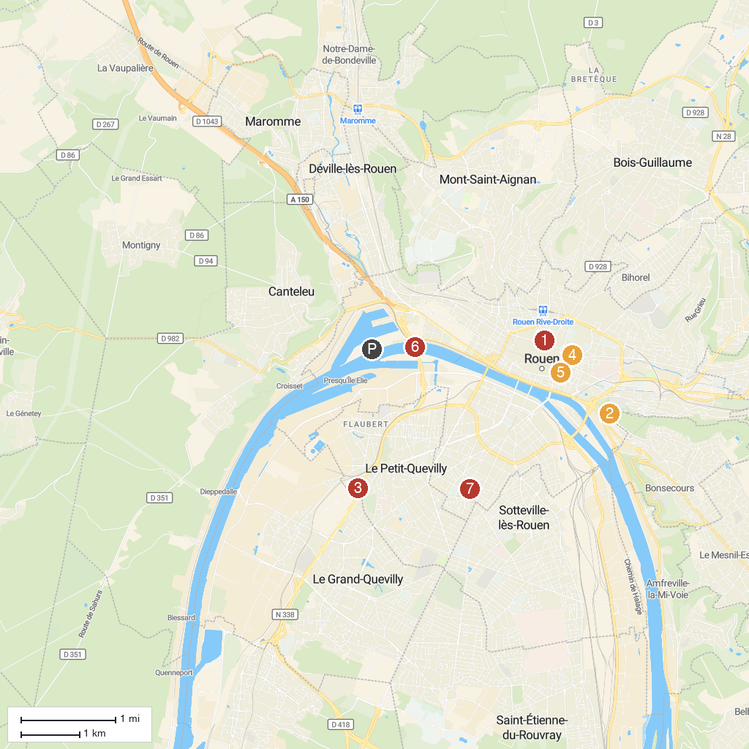
MAP KEY
1. Musée des Beaux-Arts de Rouen | 5. Eglise Saint-Maclou
2. Rouen Panorama De La Côte Sainte Catherine | 6. Pont Gustave-Flaubert
3. Woupi Rouen - Grand Quevilly | 7. Jardin des Plantes de Rouen
4. l'Hôtel-de-Ville Garden
P. Cruise port / terminal
Map © MapTiler © OpenStreetMap contributors · cruiseports.org

