Rothenburg ob der Tauber, Bavaria, Germany
Step through a stone gate into a perfectly frozen medieval fairy tale. Rothenburg ob der Tauber is Germany's most spectacularly preserved walled town — cobblestone lanes, half-timbered houses, and rooftop panoramas that look unchanged since the 14th century.
🚌 Shore excursion (bus from river port) · ⚓ No direct ship docking — landlocked · 🕒 Typical excursion: 4–6 hrs · 💶 Currency: Euro (cash useful) · 🗣️ Language: German
✍️ MY DAY IN PORT (FILL IN)
Ship / Date
In port | arrive ______ · all aboard ______
Booked excursion
Notes / meeting point
GETTING ASHORE
- Access: Bus transfer from Würzburg (~50 min) or Nuremberg (~75 min)
- Walk to center: 5–10 min from bus parking to Marktplatz
- Best For: Medieval history, photography, Christmas shopping year-round
- Don't Miss: Plönlein photo stop, St. Jakob's Riemenschneider altarpiece, city wall walk
GETTING AROUND
- 🚕 Taxi: €8–€15 — Local taxis (Citytaxi Rothenburg, Taxi Kersten, Taxi Ebert) wait at the train station and can drive into the pedestrian
TOP THINGS TO DO
- Plönlein & City Wall Walk — Start at the famous Plönlein — a crooked yellow half-timbered house at a cobblestone fork framed by two medieval towers.
- St. Jakob's Church & Holy Blood Altarpiece — This soaring Gothic church houses Tilman Riemenschneider's masterpiece — the 15th-century Altar of the Holy Blood, considered one…
- Medieval Crime & Justice Museum — Europe's leading museum of legal history occupies a sprawling complex near the walls.
- Käthe Wohlfahrt Christmas Village — Year-round Christmas in a massive, beautifully decorated shop stocked floor-to-ceiling with traditional German ornaments…
- Town Hall Tower Climb — Climb 220 steps up the Rathausturm for the best 360-degree aerial view of Rothenburg's red-tiled rooftops and the Tauber Valley.
BEST WALKS
- Old Town Highlights Loop: 2–3 km · 1.5–2 hrs · Easy–Moderate · Free — The essential Rothenburg circuit from the bus parking to all major sights and back.
- Tauber Valley Descent: 1.5 km one way · 45–60 min · Moderate · Free — From the Castle Garden, a wooded path zigzags steeply down to the valley floor.
WEATHER · DAYLIGHT · MONEY
Month | High °F | Low °F | Rainy days
May | 63 | 47 | 13
Jul | 75 | 58 | 12
Sep | 67 | 52 | 10
Daylight: May 5:35AM–8:56PM · Jul 5:30AM–9:19PM · Sep 6:55AM–7:31PM
cruiseports.org/rothenburg-ob-der-tauber · Confirm terminal & all-aboard time with your ship

Rothenburg ob der Tauber, Bavaria, Germany — Port Map
Red = walkable sights · Amber = excursions farther out · P = cruise terminal
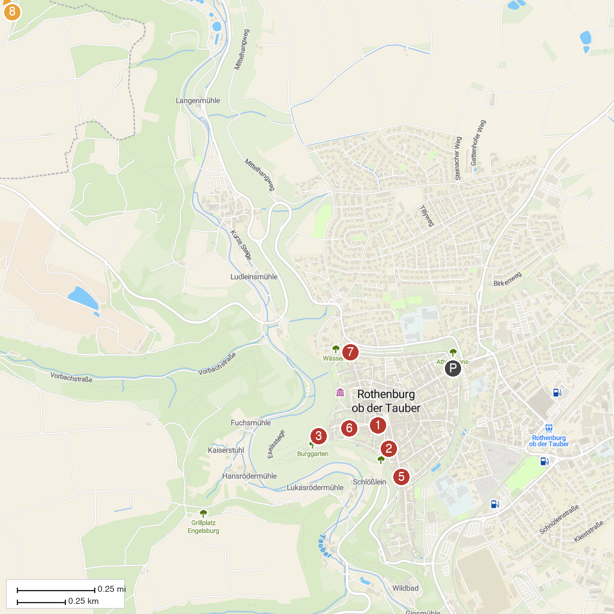
MAP KEY
1. German Christmas Museum | 5. Plönlein
2. Medieval Crime Museum | 6. Franziskanerkirche
3. Castle Garden | 7. Blade Gate
4. Gallows Gate | 8. Keltenwall
P. Cruise port / terminal
Map © MapTiler © OpenStreetMap contributors · cruiseports.org

