Rosslare Europort, County Wexford, Ireland
Ireland's busiest ferry port doubles as a cruise gateway to the 'Sunny Southeast' — explore Viking towns, Norman castles, world-class beaches, and one of the oldest working lighthouses on Earth.
⚓ Pier (docked, shuttle to terminal) · 🕒 Typical call: 8-10 hrs · 💶 Currency: Euro (€) · 🗣️ Language: English · ☀️ Sunniest county in Ireland
✍️ MY DAY IN PORT (FILL IN)
Ship / Date
In port | arrive ______ · all aboard ______
Booked excursion
Notes / meeting point
GETTING ASHORE
- Docking: Pier — shuttle bus from ship to passenger terminal (walking through the working port is not permitted)
- Walk to centre: Rosslare Harbour village is a 5–10 min walk uphill from the terminal; Wexford Town is 25 min by train
- Best For: History lovers, beach walkers, and those craving authentic small-town Ireland
- Don't Miss: Hook Lighthouse — over 800 years old and still operational, one of the oldest in the world
GETTING AROUND
- 🚕 Taxi: €30–€40 — Taxis to Wexford Town (the nearest city center) take about 17–18 minutes and cost roughly €30–€40 each way. A free port
- 📱 Rideshare: ✅ Uber, Bolt
TOP THINGS TO DO
- Wexford Town Viking Heritage Walk — Founded by the Vikings in the 9th century, Wexford is a maze of narrow medieval streets.
- Hook Lighthouse & Peninsula — Built by the Normans over 800 years ago, Hook Lighthouse is one of the oldest operational lighthouses in the world.
- Irish National Heritage Park — A 40-acre outdoor museum near Ferrycarrig depicting 9,000 years of Irish history — from Stone Age huts and Celtic ring forts to…
- Dunbrody Famine Ship, New Ross — A full-scale replica of an 1840s emigrant vessel, this moving interactive experience tells the story of the Irish who fled the…
- Rosslare Strand Beach Day — A Blue Flag sandy beach stretching for miles, backed by dunes — officially in Ireland's sunniest county.
BEST WALKS
- Terminal to Rosslare Harbour Village: 0.5 km · 10 min · Easy (uphill path with ramps) — From the passenger terminal, follow the paved path up the hill to Rosslare Harbour village.
- Rosslare Strand Seafront Walk: 2-4 km · 45-60 min · Easy · Access by train (6 min) — Take the train one stop to Rosslare Strand, then walk the length of this gorgeous Blue Flag beach.
cruiseports.org/rosslare-europort · Confirm terminal & all-aboard time with your ship

Rosslare Europort, County Wexford, Ireland — Port Map
Red = walkable sights · Amber = excursions farther out · P = cruise terminal
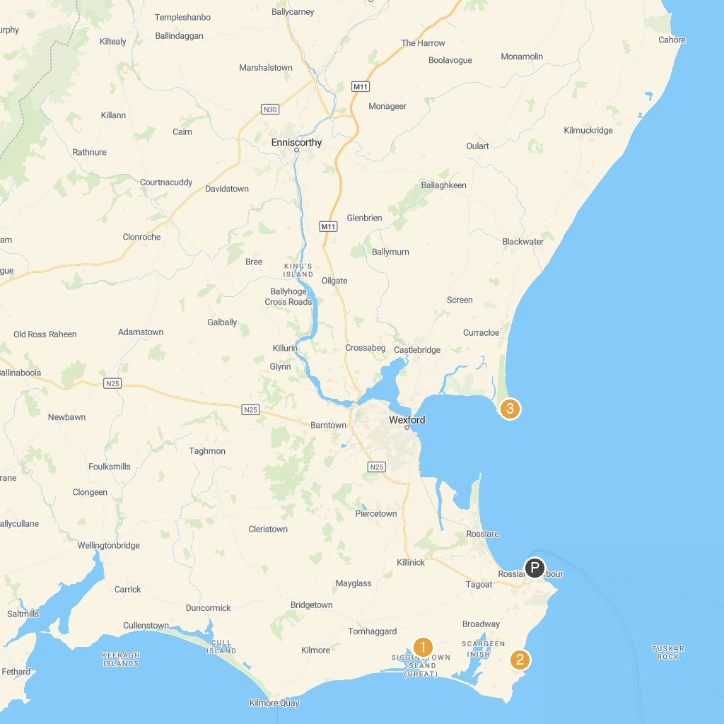
MAP KEY
1. Sigginstown Castle | 5. Church of the Assumption - Bride Street Church.
2. Carne Beach | 6. Wexford Harbour
3. Raven Point | 7. The Raven Nature Reserve
4. Johnstown Castle Estate, Museum & Gardens | 8. WexWalks
P. Cruise port / terminal
Map © MapTiler © OpenStreetMap contributors · cruiseports.org

