Roses, Costa Brava, Spain
Where the Pyrenees meet the Mediterranean — Roses faces the most beautiful bay in Spain, fringed by ancient ruins, wild capes, and the legacy of Salvador Dalí.
⚓ Pier (small ships) / Tender (large ships) · 🕒 Typical call: 7–9 hrs · 💶 Euro (€) · 🗣️ Catalan & Spanish
✍️ MY DAY IN PORT (FILL IN)
Ship / Date
In port | arrive ______ · all aboard ______
Booked excursion
Notes / meeting point
GETTING ASHORE
- Docking: Small/luxury ships dock at marina pier; large vessels tender from the Gulf of Roses
- Walk to centre: 5–10 min along the flat seafront promenade from pier or tender dock
- Best For: History, beaches, Dalí excursions, seafood, coastal hiking
- Don't Miss: Ciutadella de Roses, the Camí de Ronda coastal path, and a bowl of Suquet de Peix
GETTING AROUND
- 🚕 Taxi: €4–€9 — Taxis wait at the pier. The base fare is ~€3.50 plus €1.10/km; given the short distance to town it is barely worth ridin
TOP THINGS TO DO
- Ciutadella de Roses — A 17th-century star fortress enclosing 2,500 years of history: the Greek colony of Rhode (4th c.
- Figueres — Dalí Theatre-Museum — Salvador Dalí's hometown, about 20 km inland.
- Cadaqués & Dalí House-Museum — A whitewashed fishing village over the mountains from Roses, and the most photographed town on the Costa Brava.
- Cap de Creus Natural Park — The easternmost point of the Spanish mainland, where the Pyrenees plunge into the sea.
- Empuriabrava Canals — One of the world's largest residential marinas, 15 min south of Roses — over 24 km of navigable canals lined with villas.
BEST WALKS
- Promenade to Ciutadella Loop: 2.5 km · 45 min · Easy · Flat — Head south from the pier along the palm-lined Passeig Marítim, browsing sculptures and seafood…
- Camí de Ronda — Roses to Canyelles Petites: 3 km one way · 40 min · Easy–Moderate · Coastal cliffs — Pick up the Camí de Ronda coastal path near the Far de Roses (lighthouse) and follow it east along…
WEATHER · DAYLIGHT · MONEY
Month | High °F | Low °F | Rainy days
May | 70 | 58 | 8
Jul | 83 | 71 | 2
Sep | 76 | 66 | 6
Daylight: May 6:26AM–9:01PM · Jul 6:24AM–9:21PM · Sep 7:27AM–7:56PM
cruiseports.org/roses · Confirm terminal & all-aboard time with your ship

Roses, Costa Brava, Spain — Port Map
Red = walkable sights · Amber = excursions farther out · P = cruise terminal
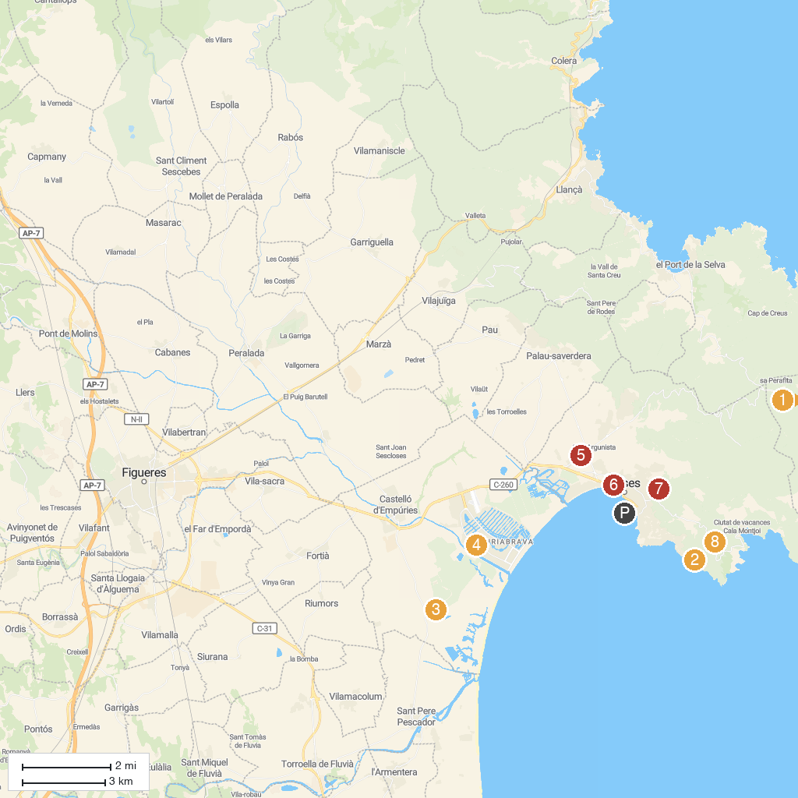
MAP KEY
1. Salvador Dalí House Museum | 5. Aquatic Park Aquabrava
2. Platja de l'Almadrava | 6. Museu de la Ciutadella de Roses
3. Aiguamolls de l'Empordà | 7. Dolmen Llit de la Generala
4. Canals i Mar - Location bateau Empuriabrava | 8. Torre del Sastre
P. Cruise port / terminal
Map © MapTiler © OpenStreetMap contributors · cruiseports.org

