Rosendal, Vestland, Norway
A village of 800 souls tucked between snow-capped peaks and Norway's second-largest fjord, Rosendal delivers a 17th-century barony, 300-year-old rose gardens, and a glacier-fed turquoise lake — all within easy reach of the tender dock.
⚓ Tender (large ships) / Pier (small ships) · 🕒 Typical call: 6-8 hrs · 💳 Norwegian Krone (NOK) — virtually cashless · 🗣️ Norwegian (English widely spoken) · 🌿 Eco-destination: max 1,000 pax/ship
✍️ MY DAY IN PORT (FILL IN)
Ship / Date
In port | arrive ______ · all aboard ______
Booked excursion
Notes / meeting point
GETTING ASHORE
- Docking: Tender to harbor for large ships; small/expedition ships dock at Rosendal Hamn quay
- Walk to center: 1-5 min from tender dock to village; Baroniet Rosendal 15-20 min walk
- Best For: History lovers, garden fans, fjord hikers, and those seeking an authentic, uncrowded Norway experience
- Don't Miss: Baroniet Rosendal castle & rose garden, Hattebergsfossen waterfall, and Bondhusvatnet glacier lake
GETTING AROUND
- 🚕 Taxi: Metered (varies) — Local taxis available on request through Kvinnherad Taxi (+47 917 81 000). Useful for reaching Folgefonna National Park
TOP THINGS TO DO
- Baroniet Rosendal — Norway's Only Barony — Built in 1665, this is Norway's sole barony and its smallest castle.
- Bondhusvatnet Glacier Lake — A roughly 30-40 minute drive from Rosendal to the Sundal trailhead, then an easy, near-flat 45-60 minute walk (about 2.5 km each…
- Hattebergsfossen Waterfall Walk — A scenic, well-marked path from Baroniet Rosendal leads to the Hattebergsfossen waterfall.
- Sjethaug Viewpoint Hike — An easy-to-moderate 1-1.5 hour round-trip hike above the village rewarding you with panoramic views over Rosendal and the…
- Folgefonn Centre & Folgefonna National Park — Right at the harbor, this interactive visitor centre covers the Folgefonna glacier, national park ecology, and climate.
BEST WALKS
- Village Center to Baroniet Rosendal & Hattebergsfossen: 3-4 km round trip | Easy | 1.5-2.5 hrs — From the harbor, walk through the village past cafes and the Steinparken stone park, continuing…
- Sjethaug Viewpoint Hike: 2-3 km round trip | Easy-moderate | 1.5 hrs — From the village center, follow the marked trail uphill to the Sjethaug viewpoint for sweeping…
WEATHER · DAYLIGHT · MONEY
Month | High °F | Low °F | Rainy days
May | 56 | 43 | 16
Jul | 65 | 53 | 19
Sep | 60 | 49 | 17
Daylight: May 4:58AM–10:07PM · Jul 4:40AM–10:42PM · Sep 7:04AM–7:56PM
cruiseports.org/rosendal · Confirm terminal & all-aboard time with your ship

Rosendal, Vestland, Norway — Port Map
Red = walkable sights · Amber = excursions farther out · P = cruise terminal
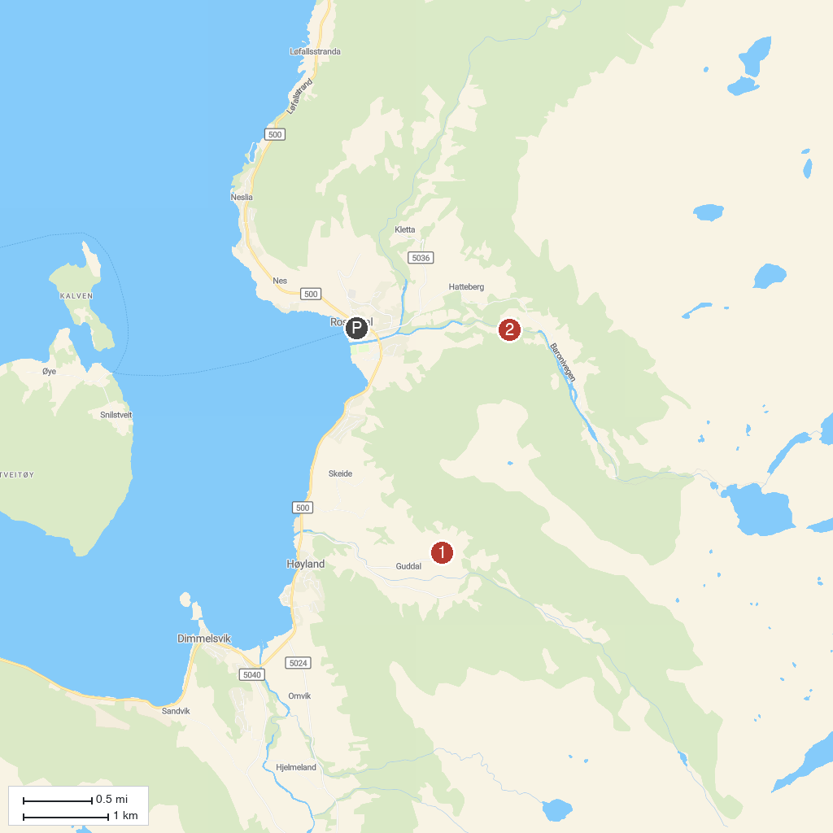
MAP KEY
1. Gallery G Guddal | 3. Fjellhaugvatn foss
2. Hattebergfossen
P. Cruise port / terminal
Map © MapTiler © OpenStreetMap contributors · cruiseports.org

