Roseau, Dominica, Caribbean
Dominica is the Caribbean's wild child — no sprawling white-sand beaches, no duty-free malls, just 365 rivers, volcanic peaks, twin waterfalls, and the world's second-largest boiling lake. Arrive ready to get muddy.
⚓ Pier (downtown berth) · 🕒 Typical call: 7-9 hrs · 💵 USD widely accepted / EC Dollar · 🗣️ English (Creole patois) · 🌿 Nature Island
✍️ MY DAY IN PORT (FILL IN)
Ship / Date
In port | arrive ______ · all aboard ______
Booked excursion
Notes / meeting point
GETTING ASHORE
- Docking: Roseau Cruise Berth — steps from downtown; Woodbridge Bay (overflow, 1.5 mi north)
- Walk to center: Immediate from main berth; 20-30 min walk (or $3-5 taxi) from Woodbridge Bay
- Best For: Rainforest hikes, waterfalls, hot springs, snorkeling, wildlife
- Don't Miss: Trafalgar Falls (20 min), Titou Gorge swim, Champagne Reef snorkeling
GETTING AROUND
- 🚕 Taxi: $5–$10 USD — Government-regulated taxis wait at the pier. Fare to downtown is $5–10 USD; longer island trips cost more. Confirm the f
- 📱 Rideshare: ❌ not available
- 🚌 Hop-on hop-off: ✅
TOP THINGS TO DO
- Trafalgar Falls — Twin 'Mother and Father' waterfalls cascade into cool pools.
- Titou Gorge Swim — Swim through a narrow volcanic-rock gorge between towering canyon walls to a hidden waterfall cave.
- Boiling Lake Hike — The world's second-largest flooded fumarole sits at 2,600 ft elevation inside Morne Trois Pitons National Park.
- Wotten Waven Hot Springs — Natural sulphur hot springs in the rainforest, about 25 minutes from port.
- Champagne Reef Snorkel — Volcanic vents on the seafloor release continuous streams of warm bubbles, making you feel like you're swimming inside a…
BEST WALKS
- Bayfront & Old Market Stroll: 30-45 min · Easy · Free — From the cruise pier, walk the Dame Eugenia Charles Boulevard bayfront to the Old Market Plaza…
- Botanic Gardens & Morne Bruce View: 1.5-2 hrs · Easy-Moderate · Free — Walk 10-15 min from the pier to the free Dominica Botanic Gardens.
WEATHER · DAYLIGHT · MONEY
Month | High °F | Low °F | Rainy days
May | 83 | 77 | 15
Jul | 83 | 78 | 21
Sep | 85 | 79 | 18
Daylight: May 5:36AM–6:26PM · Jul 5:42AM–6:39PM · Sep 5:53AM–6:07PM
cruiseports.org/roseau · Confirm terminal & all-aboard time with your ship

Roseau, Dominica, Caribbean — Port Map
Red = walkable sights · Amber = excursions farther out · P = cruise terminal
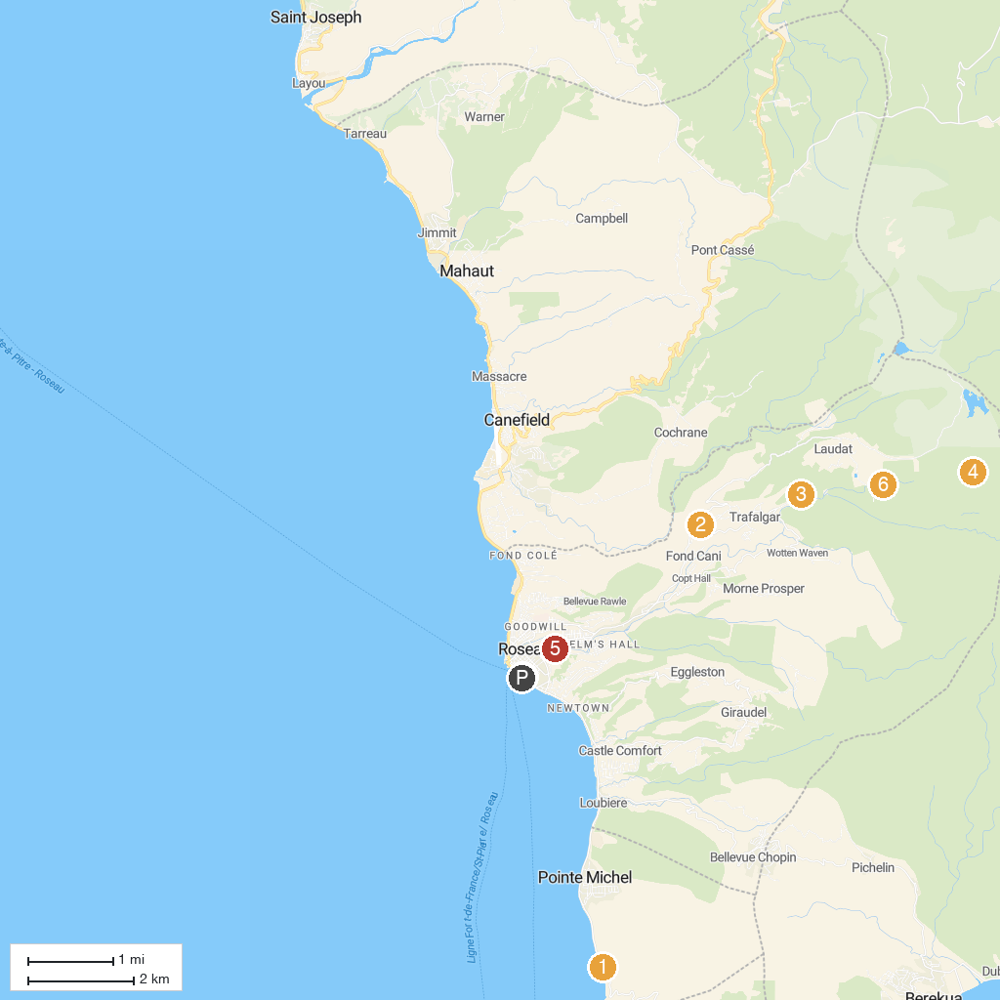
MAP KEY
1. Champagne Reef | 5. Dominica Botanic Gardens
2. Extreme Dominica - Canyon Experience | 6. Titou Gorge
3. Papillote Tropical Gardens | 7. The Dominica Museum
4. Morne Trois Pitons National Park
P. Cruise port / terminal
Map © MapTiler © OpenStreetMap contributors · cruiseports.org

