Rose Island, New Providence, Bahamas
Three miles east of Nassau, Rose Island feels like a world away — no roads, no crowds, just pink-hued sand, swimming pigs, and some of the Bahamas' clearest reef water.
⚓ Shore excursion from Nassau (tender for small ships) · 🕒 Typical call: 7-9 hrs (Nassau port day) · 💵 USD / BSD (1:1) · 🗣️ English · 🐷 Famous for swimming pigs
✍️ MY DAY IN PORT (FILL IN)
Ship / Date
In port | arrive ______ · all aboard ______
Booked excursion
Notes / meeting point
GETTING ASHORE
- Docking: Cruise ships berth at Nassau (Prince George Wharf); Rose Island reached by excursion boat (~25 min)
- Walk to center: Everything on Rose Island is within 5 min of the Sandy Toes dock
- Best For: Beach escape, snorkeling, swimming pigs, Caribbean rum drinks
- Don't Miss: Sandy Toes swimming pigs & the hillside beach bar with 360° views
GETTING AROUND
- 🚕 Taxi: $79–$89/person — The primary way to reach Rose Island. Water taxis and group tour boats depart from the Nassau Cruise Port or Paradise Is
TOP THINGS TO DO
- Sandy Toes Full-Day Beach Excursion — The signature Rose Island experience: boat transfer from Nassau, private beach access, hammock garden, swimming pigs encounter…
- Swimming Pigs Experience — Wade into the shallows and hand-feed Rose Island's resident swimming pigs — farm-saved animals that are genuinely habituated to…
- Rose Island Reef Snorkeling — Guided snorkel over fringing reefs surrounding Rose Island — tropical fish, sea fans, stingrays, and occasional sea turtles in…
- Catamaran Cruise from Nassau — Half-day catamaran tours depart Nassau for Rose Island, combining a harbor scenic cruise with snorkeling, beach time, and an open…
BEST WALKS
- Dock to Sandy Toes Beach Bar & Pigs: 5 min · Easy · Flat — From the excursion dock, a short path leads over a gentle ridge to the main north-shore beach, the…
- Beach Walk — Snorkeling Cove to Hammock Garden: 15 min · Easy · Sand & light brush — Stroll the north-shore beach east to the rocky snorkeling cove, then loop back through the shaded…
WEATHER · DAYLIGHT · MONEY
Month | High °F | Low °F | Rainy days
May | 82 | 76 | 16
Jul | 87 | 81 | 17
Sep | 86 | 80 | 18
Daylight: May 6:25AM–7:47PM · Jul 6:29AM–8:02PM · Sep 6:55AM–7:14PM
cruiseports.org/rose-island-bahamas · Confirm terminal & all-aboard time with your ship

Rose Island, New Providence, Bahamas — Port Map
Red = walkable sights · Amber = excursions farther out · P = cruise terminal
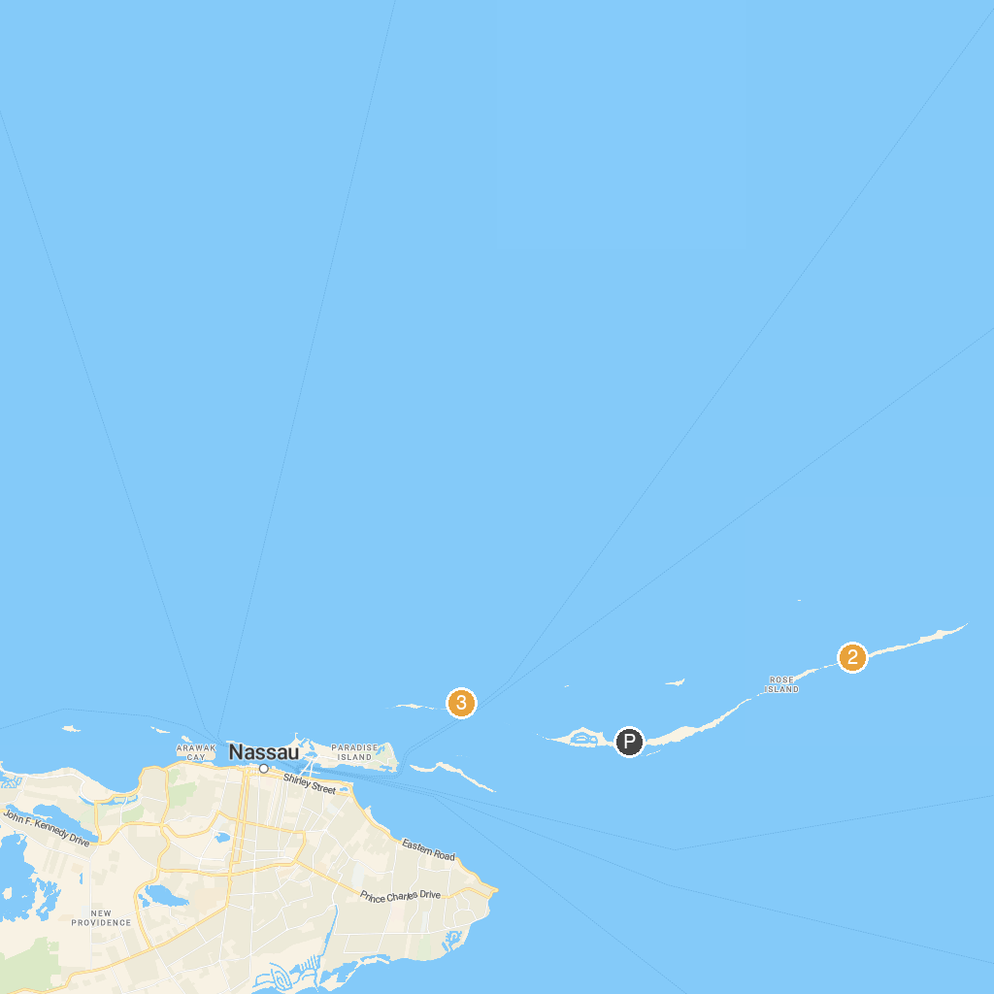
MAP KEY
1. Yamacraw Beach | 4. Blue Lagoon Island Bahamas
2. Sandy Toes, Bahamas | 5. Pigs Beach
3. Da'Pig Beach
P. Cruise port / terminal
Map © MapTiler © OpenStreetMap contributors · cruiseports.org

