Roscoff, Brittany, France
A Petite Cité de Caractère on Brittany's wild north coast — corsair history, Gothic churches, seaweed spas, and the world's only AOC pink onion, all within a compact, walkable granite town.
⚓ Dock at Port de Bloscon (or tender to Vieux Port) · 🕒 Typical call: 7–9 hrs · 💶 Euro (€) · 🗣️ French (English widely spoken) · 🧅 Known for: Roscoff pink onion AOC
✍️ MY DAY IN PORT (FILL IN)
Ship / Date
In port | arrive ______ · all aboard ______
Booked excursion
Notes / meeting point
GETTING ASHORE
- Docking: Most cruise ships dock at Port de Bloscon (deep-water terminal, ~2 km from center); some smaller ships tender to the Vieux Port
- Walk to center: 15–25 min on foot or shuttle (Bloscon pier) · 0 min if tendered to Vieux Port
- Best For: History, coastal walks, local food, day trip to Île de Batz
- Don't Miss: Notre-Dame-de-Croaz-Batz church, Jardin Exotique, Île de Batz ferry
GETTING AROUND
- 🚕 Taxi: €5–€8 — Taxis meet ships on arrival but there is no formal rank — call ahead to book. The short ride to town center costs approx
- 📱 Rideshare: ❌ not available
TOP THINGS TO DO
- Île de Batz Day Trip — Hop a 15-minute ferry from the Vieux Port footbridge to this car-free island.
- Roscoff Old Town Walking Tour — Wander 16th-century granite merchants' houses with turrets and gargoyles, visit the Notre-Dame-de-Croaz-Batz church (ship models…
- Jardin Exotique et Botanique de Roscoff — Thanks to the Gulf Stream microclimate, this garden grows over 3,000 subtropical species from New Zealand, South Africa, and…
- Maison des Johnnies & Onion Museum — Roscoff's most quirky attraction tells the story of the 'Onion Johnnies' — Breton farmers who crossed the Channel by bicycle from…
- Morlaix Half-Day Excursion — 30 minutes by road, Morlaix is a medieval town spanning a dramatic viaduct, with half-timbered houses (Maison de Pondalez…
BEST WALKS
- Vieux Port to Chapelle Sainte-Barbe: 30 min · Easy · Free · Panoramic views — From the Vieux Port, walk east along the coast to the small white Chapelle Sainte-Barbe perched on…
- Old Town Loop & Exotic Garden: 1.5 hrs · Easy · Mostly flat — From the Vieux Port, explore the old town streets and the church of Notre-Dame-de-Croaz-Batz, then…
- West to Plage de Roch'Roum: 30–40 min one way · Easy · Sandy beach — Walk west from the old port along the coastal path (part of the GR34 Customs Trail) to Plage de…
WEATHER · DAYLIGHT · MONEY
Month | High °F | Low °F | Rainy days
May | 60 | 51 | 12
Jul | 68 | 59 | 11
Sep | 66 | 57 | 11
Daylight: May 6:34AM–9:50PM · Jul 6:29AM–10:13PM · Sep 7:53AM–8:28PM
cruiseports.org/roscoff · Confirm terminal & all-aboard time with your ship

Roscoff, Brittany, France — Port Map
Red = walkable sights · Amber = excursions farther out · P = cruise terminal
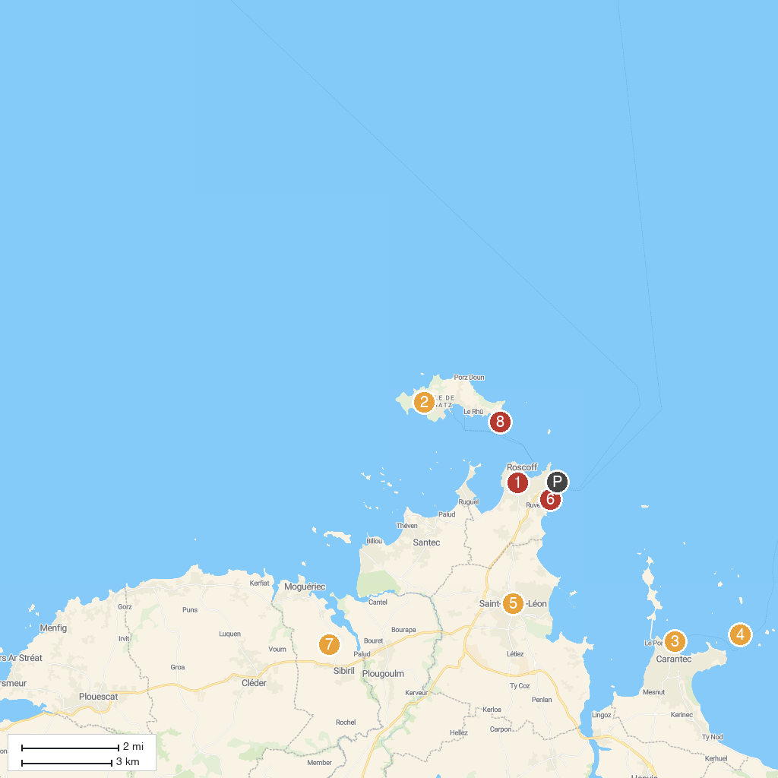
MAP KEY
1. Maison des Johnnies et de l'Oignon de Roscoff | 5. Saint-Pol-de-Léon Cathedral
2. Creach Guy - Bateau Roscoff - Ile de Batz | 6. The Exotic Garden of Roscoff
3. The chair of the Priest | 7. Château de Kérouzéré
4. Taureau Fort | 8. Georges Delaselle Garden
P. Cruise port / terminal
Map © MapTiler © OpenStreetMap contributors · cruiseports.org

