Civitavecchia (Rome), Lazio, Italy
Rome is 80 km away and absolutely worth the trip — catch the regional train from Civitavecchia station and you're at Roma Termini in 70 minutes for under €10.
⚓ Docked (cruise pier) · 🕒 Typical call: 9–11 hrs · 💶 Euro (EUR) · 🗣️ Italian · English at tourist sites
✍️ MY DAY IN PORT (FILL IN)
Ship / Date
In port | arrive ______ · all aboard ______
Booked excursion
Notes / meeting point
GETTING ASHORE
- Docking: Civitavecchia cruise terminal
- To Rome: ~70 min by Trenitalia train · €8–10
- Best For: Vatican · Colosseum · Ancient history
- Don't Miss: St. Peter's Basilica (free entry)
GETTING AROUND
- 🚕 Taxi: €130–€180 (up to 4 passengers) — Metered taxis available at the port. Agree on a fare before departure; prices can be higher on weekends or at night. Tak
- 📱 Rideshare: ✅ Uber
- 🚌 Hop-on hop-off: ✅
TOP THINGS TO DO
- Vatican & St. Peter's Basilica — The Vatican Museums, Sistine Chapel, and St.
- Colosseum, Roman Forum & Palatine Hill — The Roman Empire's greatest amphitheatre and the forum below it are covered on a single combo ticket.
- Trevi Fountain, Pantheon & Piazzas — A walking loop through central Rome: Trevi Fountain, the perfectly preserved Pantheon (now ticketed), Piazza Navona, and Campo…
- Trastevere food & neighbourhood walk — Rome's most atmospheric medieval neighbourhood across the Tiber — cobblestone lanes, trattorias, and the beautiful Basilica di…
- Stay in Civitavecchia — If Rome fatigue is real, Civitavecchia has a pleasant old town, the Forte Michelangelo (a Bramante-designed fortress on the…
BEST WALKS
- Vatican to Trastevere: ~3.5 km · 2–3 hrs · mostly flat — From St.
- Colosseum to Trevi Fountain: ~4 km · 2–3 hrs · mostly flat — From the Colosseum, walk north past the Imperial Fora, through the neighbourhood of Monti, up to…
WEATHER · DAYLIGHT · MONEY
Month | High °F | Low °F | Rainy days
May | 71 | 58 | 9
Jul | 85 | 71 | 3
Sep | 78 | 66 | 8
Daylight: May 5:52AM–8:26PM · Jul 5:50AM–8:46PM · Sep 6:53AM–7:22PM
cruiseports.org/rome-civitavecchia · Confirm terminal & all-aboard time with your ship

Civitavecchia (Rome), Lazio, Italy — Port Map
Red = walkable sights · Amber = excursions farther out · P = cruise terminal
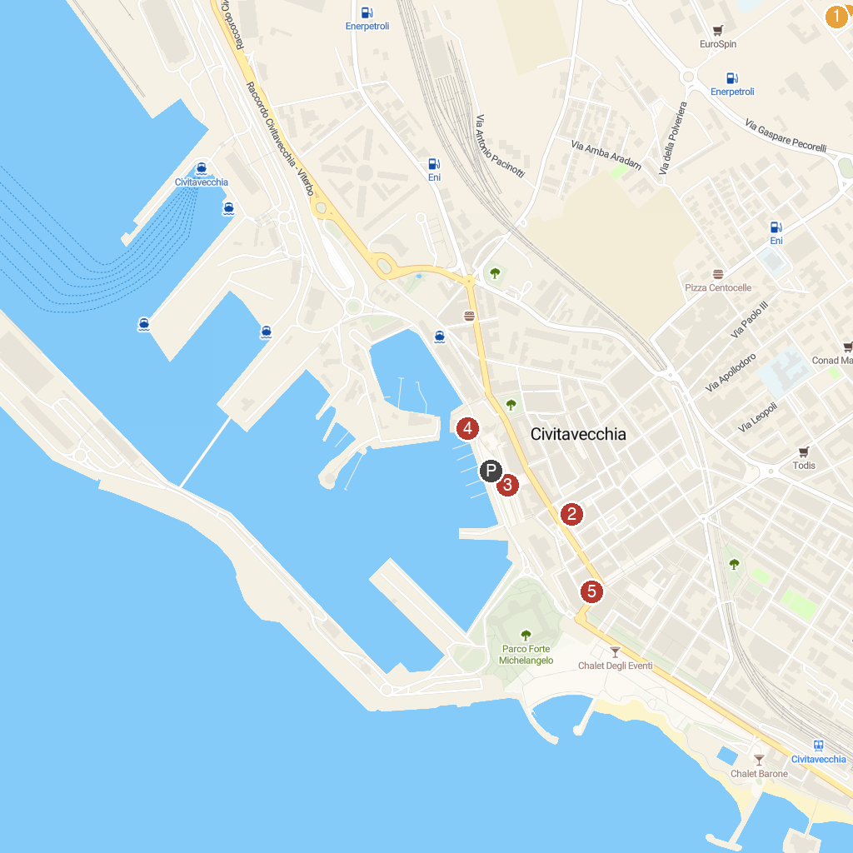
MAP KEY
1. Museo Civico di Tolfa | 4. Fontana del Vanvitelli
2. Aquafelix | 5. Ancient Fortress of Civitavecchia
3. Cattedrale di S. Francesco d’Assisi | 6. Museo Archeologico Nazionale di Civitavecchia
P. Cruise port / terminal
Map © MapTiler © OpenStreetMap contributors · cruiseports.org

