Rodrigues Island, Rodrigues, Mauritius
Rodrigues is Mauritius as it was 50 years ago — no traffic lights, no high-rises, just a turquoise lagoon twice the size of the island itself, giant tortoises roaming a restored valley, and women wading at low tide to spear octopus.
⚓ Tender (most ships) · 🕒 Typical call: 7-9 hrs · 💵 Mauritian Rupee (MUR) · 🗣️ Creole, French, English
✍️ MY DAY IN PORT (FILL IN)
Ship / Date
In port | arrive ______ · all aboard ______
Booked excursion
Notes / meeting point
GETTING ASHORE
- Docking: Tender to Port Mathurin jetty (most cruise ships); small expedition vessels may dock at the quay
- Walk to Centre: 2-5 min flat walk from jetty to market & shops
- Best For: Giant tortoises, unspoiled beaches, Creole seafood, eco-tourism
- Don't Miss: François Leguat Giant Tortoise Reserve & octopus curry at Chez Robert et Solange
GETTING AROUND
- 🚕 Taxi: MUR 100–200 (~$2–5 USD) within Port Mathurin; day hire ~MUR 1,500–2,500 — Taxis wait at the port and around Port Mathurin. Fares are negotiable — agree on a price before you depart. Hiring a tax
- 📱 Rideshare: ❌ not available
TOP THINGS TO DO
- François Leguat Giant Tortoise & Cave Reserve — Walk among hundreds of free-roaming Aldabra giant tortoises in a beautifully restored valley at Anse Quitor, then take a guided…
- Caverne Patate (Cave Tour) — An extensive limestone cave (over 1 km of passages) filled with stalactites and stalagmites; guided tours cover roughly 700 metres.
- Trou d'Argent & Saint François Beach — Saint François is the most accessible white-sand beach on the east coast and the start of a 30-45 minute coastal hike to Trou…
- Île aux Cocos Bird Sanctuary — A protected flat sandy island in the lagoon packed with thousands of noddy and fairy terns.
- Port Mathurin Market & Town Walk — The island's bazar is a short walk from the jetty and sells hand-woven leaf baskets, chili pastes, and jarred Rodrigues lemons.
BEST WALKS
- Port Mathurin Town Loop: ⏱ 45 min · 🚶 Easy · 📍 Starts at jetty — From the jetty, walk to the Port Mathurin market (5 min), browse the colonial main street with its…
WEATHER · DAYLIGHT · MONEY
Month | High °F | Low °F | Rainy days
May | 78 | 75 | 12
Jul | 74 | 71 | 14
Sep | 73 | 71 | 6
Daylight: May 6:07AM–5:17PM · Jul 6:21AM–5:23PM · Sep 5:42AM–5:40PM
cruiseports.org/rodrigues-island · Confirm terminal & all-aboard time with your ship

Rodrigues Island, Rodrigues, Mauritius — Port Map
Red = walkable sights · Amber = excursions farther out · P = cruise terminal
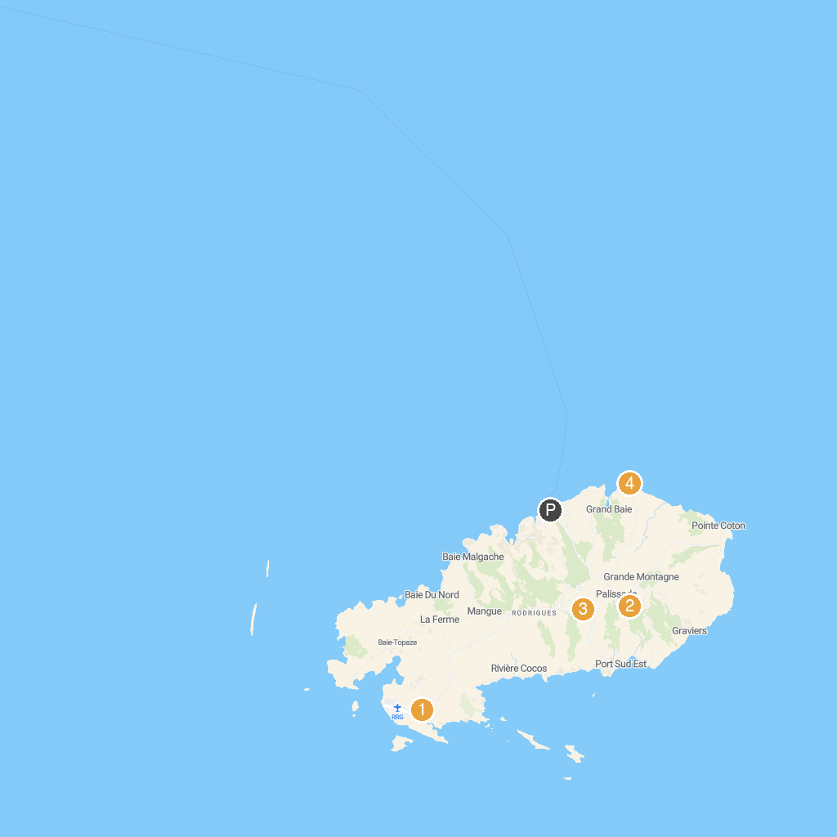
MAP KEY
1. Francois Leguat Reserve Rodrigues | 3. Cathédrale St Gabriel
2. Jardin des Cinq Sens | 4. Baladirou Beach
P. Cruise port / terminal
Map © MapTiler © OpenStreetMap contributors · cruiseports.org

