Rochester, New York, USA
Where the Genesee River meets Lake Ontario, Rochester's Charlotte neighborhood offers a sandy beach, a rare 1905 carousel, and the oldest active lighthouse on the lake — plus an Eastman Kodak legacy that shaped modern photography.
⚓ Pier docked · 🕒 Typical call: 7-9 hrs · 💵 USD · 🗣️ English · 🌊 Lake Ontario
✍️ MY DAY IN PORT (FILL IN)
Ship / Date
In port | arrive ______ · all aboard ______
Booked excursion
Notes / meeting point
GETTING ASHORE
- Docking: Pier — direct dockage at Port of Rochester Terminal, Charlotte
- Walk to center: Charlotte beach & lighthouse 5-10 min; downtown Rochester 9 miles (rideshare)
- Best For: History, photography, beaches, local food culture
- Don't Miss: Abbott's Frozen Custard — a Rochester institution since 1926
GETTING AROUND
- 🚕 Taxi: $18–$25 — Metered taxis serve the Port of Rochester, located ~9 miles north of downtown on Lake Ontario. Expect about $18–$25 to t
- 📱 Rideshare: ✅ Uber, Lyft
TOP THINGS TO DO
- Charlotte-Genesee Lighthouse — Built in 1822, this is the oldest active lighthouse on Lake Ontario.
- George Eastman Museum — The world's oldest photography museum, set in the magnificent estate of Kodak's founder.
- The Strong National Museum of Play — A world-class interactive museum housing the National Toy Hall of Fame and the World Video Game Hall of Fame.
- Susan B. Anthony Museum & House — The actual home where the suffragist leader lived and was arrested for voting in 1872.
- Ontario Beach Park & Charlotte Pier — Wide sandy Lake Ontario beach right next to the terminal.
BEST WALKS
- Charlotte Waterfront Loop: 1.5 miles · 30-45 min · flat — From the port terminal, walk north to Ontario Beach Park, stroll the Charlotte Pier over Lake…
- Genesee Riverway Stroll: 1-3 miles · 30-60 min · flat paved — Head south from the terminal along the Genesee Riverway Trail through Turning Point Park.
WEATHER · DAYLIGHT · MONEY
Month | High °F | Low °F | Rainy days
May | 65 | 48 | 12
Jul | 80 | 64 | 12
Sep | 73 | 58 | 10
Daylight: May 5:46AM–8:27PM · Jul 5:45AM–8:47PM · Sep 6:50AM–7:19PM
cruiseports.org/rochester-ny · Confirm terminal & all-aboard time with your ship

Rochester, New York, USA — Port Map
Red = walkable sights · Amber = excursions farther out · P = cruise terminal
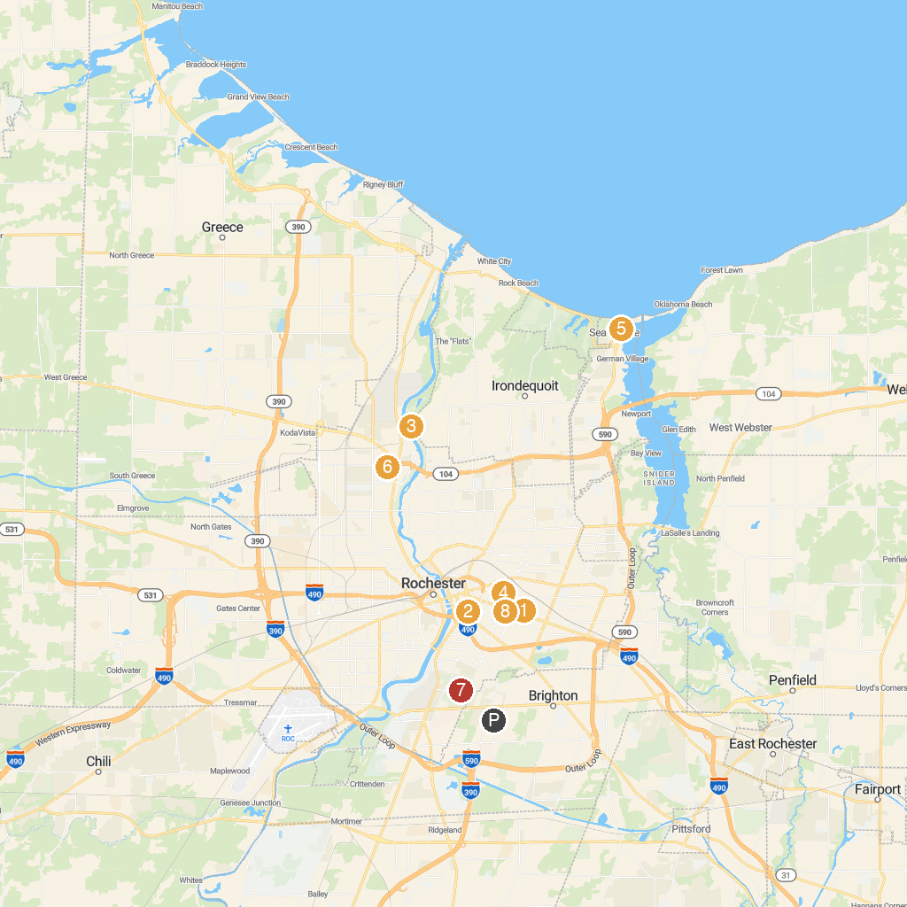
MAP KEY
1. George Eastman Museum | 5. Seabreeze Amusement Park
2. The Strong National Museum of Play | 6. Sacred Heart Cathedral
3. Seneca Park Zoo | 7. Highland Park
4. Memorial Art Gallery | 8. RMSC (Rochester Museum & Science Center)
P. Cruise port / terminal
Map © MapTiler © OpenStreetMap contributors · cruiseports.org

