Rio Grande, Tierra del Fuego, Argentina
One of the world's most remote cruise stops, Rio Grande sits on Tierra del Fuego's windswept Atlantic coast — an authentic Patagonian city famous for Malvinas War history, enormous sea-run brown trout, and the vast silence of the steppe.
⚓ Tender / Zodiac (no pier) · 🕒 Typical call: 6-8 hrs · 💵 Argentine Pesos (USD cash welcomed) · 🗣️ Spanish (very little English) · 🌬️ Extremely windy year-round
✍️ MY DAY IN PORT (FILL IN)
Ship / Date
In port | arrive ______ · all aboard ______
Booked excursion
Notes / meeting point
GETTING ASHORE
- Docking: Expedition ships anchor offshore; Zodiac landing on beach — no cruise pier exists
- Walk to Center: ~1 km from landing beach to town center along Costanera
- Best For: History buffs, fly-fishing enthusiasts, off-the-beaten-path Patagonia explorers
- Don't Miss: Malvinas War Memorial on the Costanera and the flag-shaped wind-bent trees
GETTING AROUND
- 🚕 Taxi: ARS 2,000–6,000 per trip — Local taxis and remis (private hire cars) are available for trips to the Salesian Mission (~4 km) or Estancia María Behe
TOP THINGS TO DO
- Malvinas War Memorial & Costanera Walk — Rio Grande was a key military air base during the 1982 Falklands/Malvinas War.
- Misión Salesiana — Founded in 1893 by Salesian missionaries to serve the indigenous Selk'nam (Ona) people, this historic mission 4 km from town…
- Estancia María Behety — One of Patagonia's legendary sheep ranches, home to the world's largest shearing shed (capacity: 7,000 sheep).
- World-Class Fly Fishing — The Río Grande river is legendary among anglers — it produces the largest sea-run brown trout on earth, often 20-30 lbs.
- Cabo Domingo & Atlantic Coast — Drive 15 km north to Cabo Domingo, a dramatic 90 m cliff rising from the sea, for panoramic steppe and ocean views.
BEST WALKS
- Costanera & Malvinas Memorial Walk: 1.5 km • Flat • Very windy — Follow the Costanera waterfront promenade from the landing beach into town, stopping at the…
- Town Center Wander: 1 km loop • Flat • Compact grid — Rio Grande's downtown grid is easy to explore on foot.
WEATHER · DAYLIGHT · MONEY
Month | High °F | Low °F | Rainy days
May | 45 | 36 | 10
Jul | 39 | 31 | 8
Sep | 45 | 34 | 7
Daylight: May 9:13AM–5:40PM · Jul 9:39AM–5:34PM · Sep 7:36AM–7:16PM
cruiseports.org/rio-grande · Confirm terminal & all-aboard time with your ship

Rio Grande, Tierra del Fuego, Argentina — Port Map
Red = walkable sights · Amber = excursions farther out · P = cruise terminal
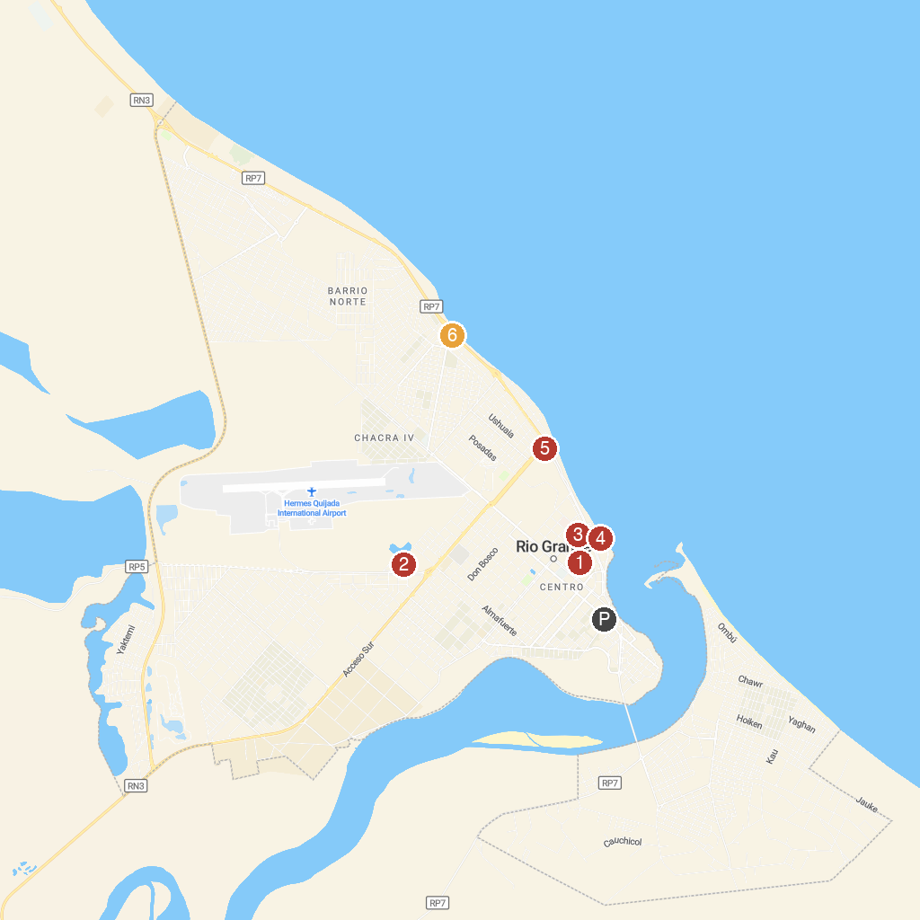
MAP KEY
1. Plaza Almirante Brown | 4. Costanera Rio Grande
2. Reserva Natural Urbana - Laguna de los Patos | 5. Monumento a la Aviación Naval
3. Fuegian Art Museum | 6. Ovejero Fueguino
P. Cruise port / terminal
Map © MapTiler © OpenStreetMap contributors · cruiseports.org

