Riga, Latvia
The grand dame of the Baltics — a UNESCO old town of spires and guild halls wrapped in the world's finest collection of Art Nouveau architecture, right beside your ship.
⚓ Docked (city center) · 🕒 Typical call: 8–10 hrs · 💶 Euro (EUR) · 🗣️ Latvian · English in tourism
✍️ MY DAY IN PORT (FILL IN)
Ship / Date
In port | arrive ______ · all aboard ______
Booked excursion
Notes / meeting point
GETTING ASHORE
- Docking: Riga Passenger Terminal
- Walk to old town: 10 min
- Best For: Architecture · History
- Don't Miss: Art Nouveau district
GETTING AROUND
- 🚕 Taxi: €15–€25 — Metered taxis available at the port. Riga Old Town is roughly a 10–15 min ride; agree on a fare or confirm the meter is
- 📱 Rideshare: ✅ Bolt, Uber
- 🚌 Hop-on hop-off: ✅
TOP THINGS TO DO
- Old Town Walking Tour — The UNESCO core — the House of the Blackheads, Town Hall Square, Dome Cathedral, St.
- Art Nouveau District — The world's greatest concentration of Jugendstil architecture, centered on Alberta iela — a riot of sculpted faces, masks, and…
- Riga Central Market & Soviet History — The vast market in former Zeppelin hangars, plus the Corner House and Occupation Museum telling Latvia's 20th-century story of…
- Rundāle Palace — A baroque 'Versailles of Latvia' with formal French gardens, about an hour south of Riga — a lavish day trip for palace lovers.
BEST WALKS
- Old town highlights loop: ~2.5 km · 1.5 hrs · easy — From the riverfront to Town Hall Square and the House of the Blackheads, past the Dome Cathedral…
- Art Nouveau on Alberta iela: ~2 km · 1 hr · easy — A stroll up Elizabetes and Alberta streets to admire the most spectacular Jugendstil facades…
- Bastion Hill & canal: ~1.5 km · 1 hr · easy — The leafy park and canal ringing the old town, past the Freedom Monument and the Latvian National…
WEATHER · DAYLIGHT · MONEY
Month | High °F | Low °F | Rainy days
May | 62 | 45 | 10
Jul | 72 | 58 | 14
Sep | 63 | 51 | 11
Daylight: May 5:05AM–9:35PM · Jul 4:52AM–10:05PM · Sep 6:54AM–7:41PM
cruiseports.org/riga · Confirm terminal & all-aboard time with your ship

Riga, Latvia — Port Map
Red = walkable sights · Amber = excursions farther out · P = cruise terminal
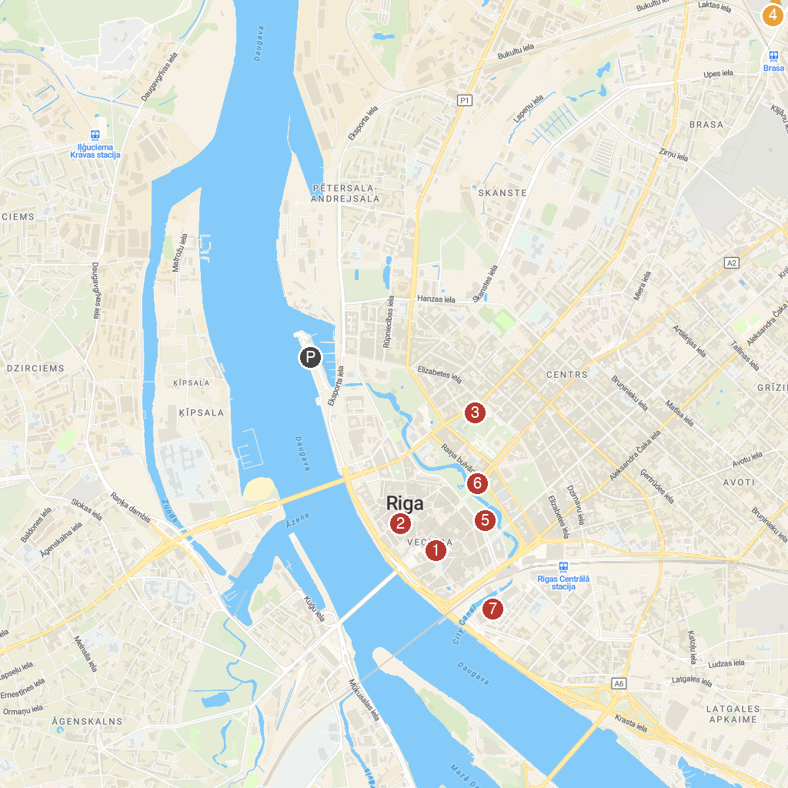
MAP KEY
1. St. Peter's Church | 5. Latvian National Opera
2. Riga Cathedral | 6. The Freedom Monument
3. Latvian National Museum of Art | 7. Riga Central Market
4. Riga National Zoological Garden
P. Cruise port / terminal
Map © MapTiler © OpenStreetMap contributors · cruiseports.org

