Rethymno, Crete, Greece
Rethymno is Crete's most romantic port city — a labyrinth of Venetian stone doorways, Ottoman minarets, and flower-draped alleyways overlooked by a massive 16th-century fortress, all wrapped around a blue-flag sandy beach.
⚓ Pier (direct dock, small–medium ships) · 🕒 Typical call: 7–9 hrs · 💶 Currency: Euro (€) · 🗣️ Language: Greek (English widely spoken) · 🏖️ Beach walkable from ship
✍️ MY DAY IN PORT (FILL IN)
Ship / Date
In port | arrive ______ · all aboard ______
Booked excursion
Notes / meeting point
GETTING ASHORE
- Docking: Pier — small/medium ships dock directly; mega-ships may anchor/tender or dock at Souda Bay (Chania) and bus in
- Walk to Old Town: ~10–12 min (800 m along flat harborfront)
- Best For: History, architecture, beach, Cretan food
- Don't Miss: The Fortezza fortress — panoramic views over city and sea for just €4
GETTING AROUND
- 🚕 Taxi: €5–€10 — Taxis are available at the port and in the city center. Base fare ~€1.30 with ~€0.90/km plus a port surcharge (~€1.07).
- 📱 Rideshare: ❌ not available
TOP THINGS TO DO
- Fortezza & Old Town Walk — Rethymno's 16th-century Venetian citadel crowns a hill above the city with 360° views over the sea and terracotta rooftops.
- Preveli Palm Beach & Kourtaliotiko Gorge — A river lined with Cretan date palms flows through a dramatic gorge and meets the Libyan Sea at Preveli Beach — one of the…
- Monastery of Arkadi — Crete's most revered monastery, site of an 1866 uprising against Ottoman rule in which hundreds of Cretans chose death over…
- Rethymno City Beach — A long Blue Flag sandy beach begins just east of the marina — a 15-minute flat walk from the pier.
- Elafonisi Pink Sand Beach Day Trip — Crete's famous pink-sand island lagoon on the far southwest coast — a 2–2.5 hour drive (~130 km) from Rethymno but worth it for…
BEST WALKS
- Old Town & Venetian Harbor Loop: 2–3 hrs · Flat · Self-guided — From the cruise pier, walk the harborfront to the Venetian Harbor and lighthouse, then weave…
- Fortezza Climb: 1.5–2 hrs · Moderate uphill · €4 entry — From the Venetian Harbor, follow the signs uphill to the Fortezza entrance (~20 min walk).
WEATHER · DAYLIGHT · MONEY
Month | High °F | Low °F | Rainy days
May | 76 | 61 | 6
Jul | 87 | 73 | 2
Sep | 83 | 69 | 8
Daylight: May 6:17AM–8:19PM · Jul 6:18AM–8:37PM · Sep 7:05AM–7:28PM
cruiseports.org/rethymno · Confirm terminal & all-aboard time with your ship

Rethymno, Crete, Greece — Port Map
Red = walkable sights · Amber = excursions farther out · P = cruise terminal
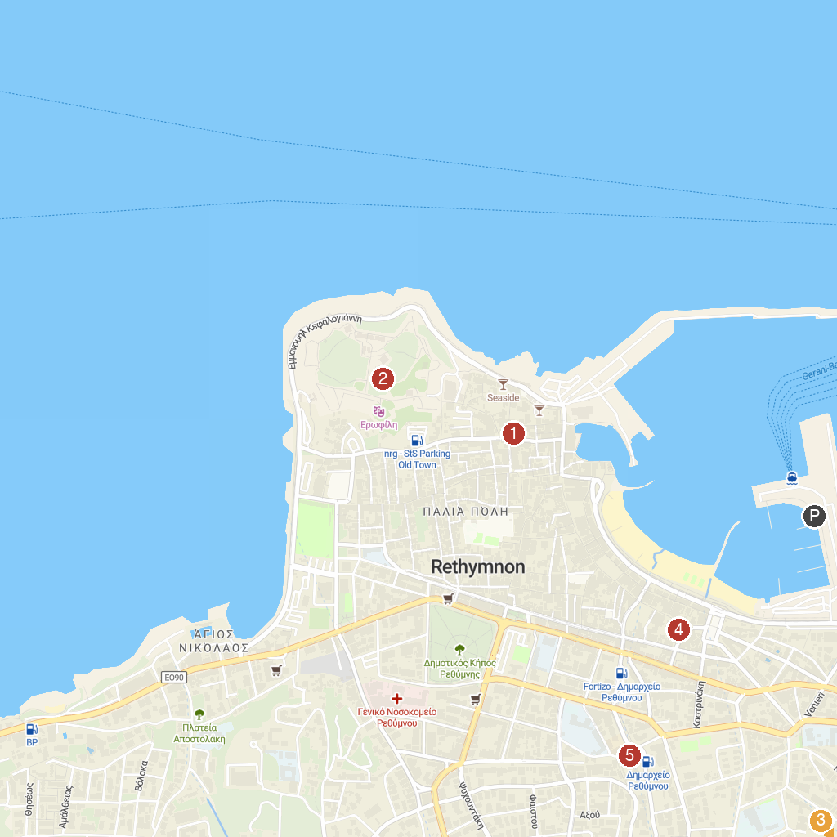
MAP KEY
1. Catholic Church of Saint Anthony of Padua | 4. Kara Musa Pasha Mosque
2. Fortezza of Rethymnon | 5. Paleontological Museum of Rethymno
3. Chromonastirion Military Museum
P. Cruise port / terminal
Map © MapTiler © OpenStreetMap contributors · cruiseports.org

