Rendsburg, Schleswig-Holstein, Germany
Where the world's busiest canal meets a proudly old-fashioned German market town. Watch colossal container ships glide past at eye level, then stroll a bench half a kilometre long.
⚓ Docked (river quay) · 🕒 Typical call: 6–8 hrs · 💶 Euro (€) · 🗣️ German (English widely understood) · 🚲 Excellent cycling
✍️ MY DAY IN PORT (FILL IN)
Ship / Date
In port | arrive ______ · all aboard ______
Booked excursion
Notes / meeting point
GETTING ASHORE
- Docking: River cruise ships berth along the Kiel Canal bank; no tendering required
- Walk to centre: ~5–10 min on foot from the canal quay to the Old Town
- Best For: Canal engineering fans, ship-spotters, cyclists, and history lovers
- Don't Miss: The Ship Welcome Facility — ships are greeted with their nation's anthem as they pass
GETTING AROUND
- 🚕 Taxi: €10–15 — The city center is roughly 2–4 km from the cruise berth. Official Rendsburg taxi rates (base €5 + €2.50/km) put most sho
TOP THINGS TO DO
- Rendsburg High Bridge & Transporter Gondola — The 1913 steel railway bridge soars 42 m above the Kiel Canal — an engineering marvel of its era.
- Kiel Canal Ship-Watching & World's Longest Bench — The Nord-Ostsee-Kanal is the world's busiest artificial waterway.
- Rendsburg Old Town Blue-Line Walk — Follow the painted blue line through the medieval heart of town: the stepped-gable Rathaus (Old Town Hall), Paradeplatz (former…
- Jewish Museum Rendsburg — Housed in Schleswig-Holstein's only preserved synagogue, this thoughtful museum traces the history of Jewish life in northern…
- Kiel Canal Cycle Route — Rent a bike and follow the flat, paved canal towpath in either direction.
BEST WALKS
- Old Town Loop: 2 km · ~30 min · easy — From the canal quay, follow the blue line past the Rathaus, Paradeplatz, St.
- High Bridge & Bench Stroll: 1.5 km · ~20 min · easy — Walk west along the canal bank to the Rendsburg High Bridge viewpoint, passing the world's longest…
WEATHER · DAYLIGHT · MONEY
Month | High °F | Low °F | Rainy days
May | 62 | 47 | 12
Jul | 71 | 57 | 15
Sep | 66 | 53 | 12
Daylight: May 5:17AM–9:19PM · Jul 5:07AM–9:46PM · Sep 6:54AM–7:37PM
cruiseports.org/rendsburg · Confirm terminal & all-aboard time with your ship

Rendsburg, Schleswig-Holstein, Germany — Port Map
Red = walkable sights · Amber = excursions farther out · P = cruise terminal
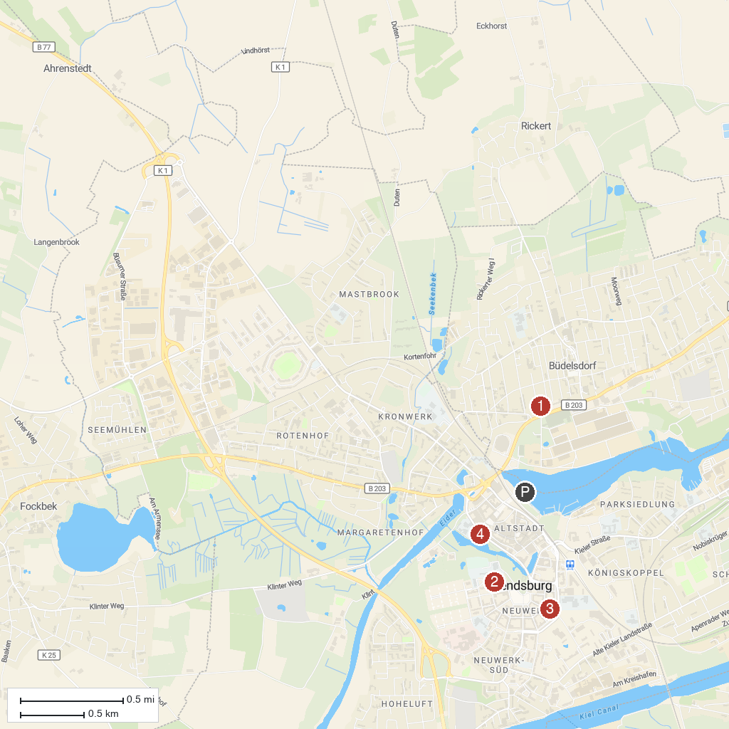
MAP KEY
1. Eisenkunstgussmuseum Büdelsdorf | 3. Jewish Museum Rendsburg
2. Museums in the Cultural Center | 4. Stadt Park
P. Cruise port / terminal
Map © MapTiler © OpenStreetMap contributors · cruiseports.org

