Remich, Moselle Valley, Luxembourg
Known as the Pearl of the Moselle, Remich is Luxembourg's premier wine town — a sun-drenched riverfront where Crémant flows freely, vine-covered hills frame the skyline, and you can walk from your gangway to a wine cellar in minutes.
⚓ River pier (no tender) · 🕒 Typical call: 6-8 hrs · 💶 Euro (€) · 🗣️ Luxembourgish / French / German (English widely spoken) · 🍾 Wine & river excursion port
✍️ MY DAY IN PORT (FILL IN)
Ship / Date
In port | arrive ______ · all aboard ______
Booked excursion
Notes / meeting point
GETTING ASHORE
- Docking: Alongside quay on the Esplanade — walk straight off the gangway into town
- Walk to center: 0-5 min — town is immediately adjacent to the pier
- Best For: Wine tasting, Moselle strolls, day trip to Schengen village
- Don't Miss: Caves St. Martin underground cellars and a glass of local Crémant
GETTING AROUND
- 🚕 Taxi: €40–€55 to Luxembourg City — Local taxis are available for on-demand hire. Unnecessary for the town center given dockside location, but useful for da
- 📱 Rideshare: ✅ Uber, Bolt
TOP THINGS TO DO
- Caves St. Martin Wine Cellar Tour — Descend into nearly a kilometer of underground limestone tunnels where Luxembourg's famous Crémant sparkling wine is aged.
- Day Trip to Schengen Village — The village where the EU's open-border Schengen Agreement was signed in 1985 is just 10 km south.
- Luxembourg City Half-Day — The UNESCO-listed capital is 30 minutes away by free bus.
- Moselle River Panoramic Cruise — Navitours operates panoramic boat excursions from Remich's quay, gliding past vine-terraced hillsides, riverside villages, and…
- Moselle Wine Trail Tasting — Several independent domaines around Remich offer walk-in tastings of Elbling, Auxerrois, Riesling, and Pinot Gris — grape…
BEST WALKS
- Esplanade & Old Town Loop: 2-3 km · 45-60 min · Flat · Free — Start at the pier and head south along the Esplanade, lined with lime trees and benches overlooking…
- Walk to Germany — Cross the Moselle Bridge: 1.5 km round trip · 20-30 min · Flat · Free — A quick and satisfying walk for the 'been to another country' story: cross the Pont de Remich…
WEATHER · DAYLIGHT · MONEY
Month | High °F | Low °F | Rainy days
May | 65 | 47 | 12
Jul | 76 | 58 | 10
Sep | 69 | 52 | 9
Daylight: May 5:50AM–9:12PM · Jul 5:44AM–9:35PM · Sep 7:11AM–7:47PM
cruiseports.org/remich · Confirm terminal & all-aboard time with your ship

Remich, Moselle Valley, Luxembourg — Port Map
Red = walkable sights · Amber = excursions farther out · P = cruise terminal
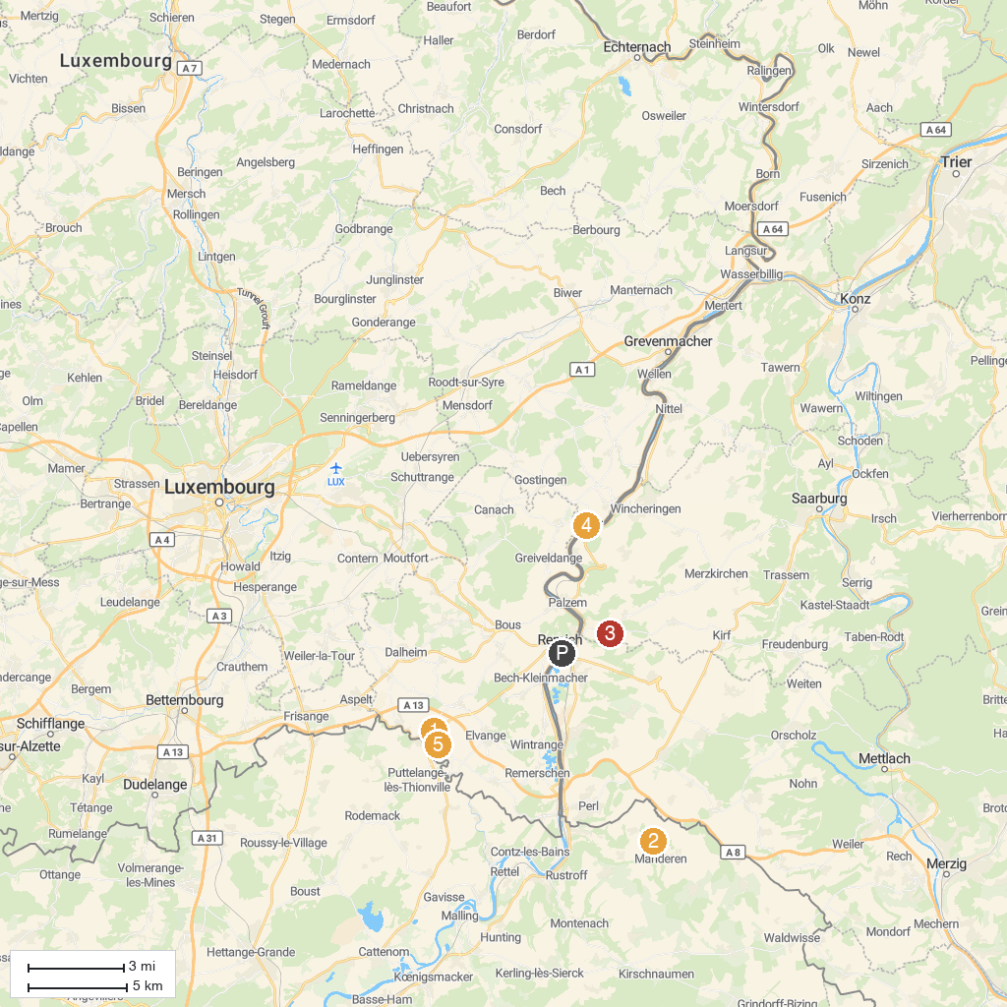
MAP KEY
1. Casino 2000 | 5. Luxembourgish Aviation Museum
2. Malbrouck Castle | 6. Treetop Walk Saarschleife
3. Bulldog- und Landmaschinenmuseum Robert Willkomm | 7. Réserve naturelle de Montenach
4. Wäinhaus - Maison et musée du vin
P. Cruise port / terminal
Map © MapTiler © OpenStreetMap contributors · cruiseports.org

