Remagen, Rhineland-Palatinate, Germany
Where the war turned: Remagen's famous bridge towers still stand on the Rhine, anchoring a compact, walkable town with Roman roots, Ahr valley Pinot Noir, and a hilltop pilgrimage church with sweeping river views.
⚓ Docked (Rhine pier) · 🕒 Typical call: 6–8 hrs · 💶 Currency: Euro (€) · 🗣️ Language: German · 🍷 Ahr Valley wine country
✍️ MY DAY IN PORT (FILL IN)
Ship / Date
In port | arrive ______ · all aboard ______
Booked excursion
Notes / meeting point
GETTING ASHORE
- Docking: Docked at KD Rhine pier, Rheinpromenade — no tender
- Walk to center: 3–5 min from pier to Marktplatz
- Best For: WWII history, river walks, Rhine cycling, Ahr wine
- Don't Miss: Peace Museum in the Ludendorff Bridge towers (€5)
GETTING AROUND
- 🚕 Taxi: €6–9 — Taxis are available near the landing stage. Base fare is €4.00 plus €2.50/km; the short port-to-center distance keeps fa
- 📱 Rideshare: ✅ Uber
TOP THINGS TO DO
- Peace Museum — Ludendorff Bridge Towers — Step inside the two surviving stone bridge towers that U.S.
- Apollinariskirche Hilltop Pilgrimage — A striking Neo-Gothic church perched on a hill above the Rhine, its twin towers visible from the pier.
- Roman Museum Remagen — Housed in a 15th-century chapel in the town center, this free museum displays excavated artifacts, tombstones, and tools from the…
- Rhine Cycle Path Day Ride — The flat, paved Rheinradweg runs right past the pier.
- Linz am Rhein Ferry Day Trip — From the Kripp district south of the town center, board the Rhine car/passenger ferry for a roughly 10-minute crossing to Linz am…
BEST WALKS
- Promenade & Peace Museum Walk: 1.5 km · ~25 min one way · Flat — Follow the Rhine promenade south from the pier past weeping willows and riverside sculptures to the…
- Church on the Hill: 2 km · ~35 min · Moderate uphill finish — Walk from the pier through the town center, then follow the wooded path up to the Apollinariskirche…
WEATHER · DAYLIGHT · MONEY
Month | High °F | Low °F | Rainy days
May | 65 | 49 | 13
Jul | 76 | 60 | 12
Sep | 69 | 54 | 10
Daylight: May 5:43AM–9:12PM · Jul 5:36AM–9:37PM · Sep 7:07AM–7:44PM
cruiseports.org/remagen · Confirm terminal & all-aboard time with your ship

Remagen, Rhineland-Palatinate, Germany — Port Map
Red = walkable sights · Amber = excursions farther out · P = cruise terminal
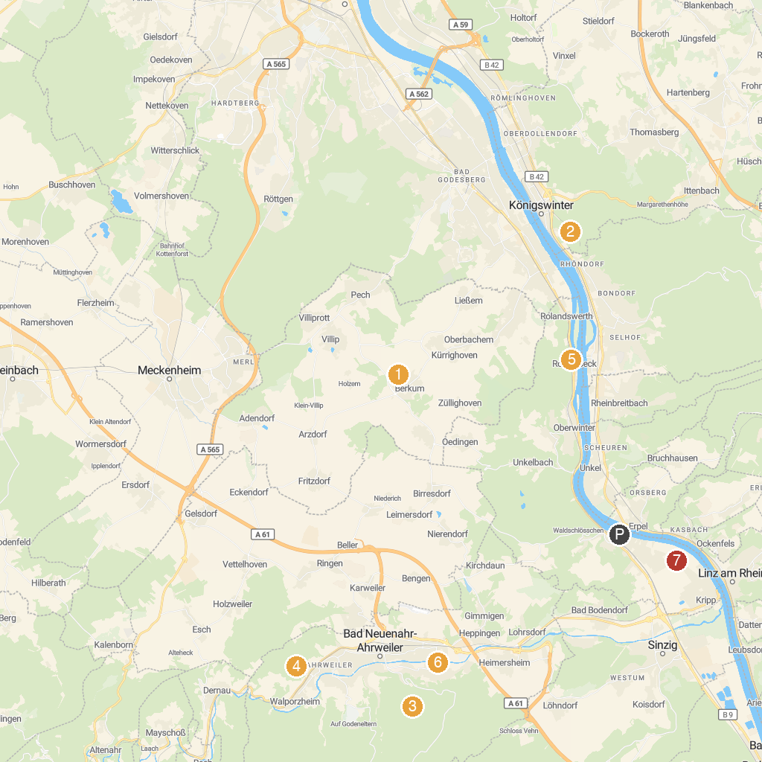
MAP KEY
1. Burg Odenhausen | 5. German Museum Bonn
2. Schloss Drachenburg | 6. Arp Museum Bahnhof Rolandseck
3. Forest Adventure Treeclimbing Park Bad Neuenahr | 7. Lenné Park
4. Dokumentationsstätte Regierungsbunker | 8. Friedenskapelle „Schwarze Madonna“
P. Cruise port / terminal
Map © MapTiler © OpenStreetMap contributors · cruiseports.org

