Reine, Lofoten, Norway
One of the world's most photographed villages, Reine sits at the foot of jagged granite peaks in Norway's Lofoten archipelago — a compact gem of red fishermen's cabins, turquoise fjords, and world-class hiking above the Arctic Circle.
⚓ Tender (no cruise pier) · 🕒 Typical call: 6–8 hrs · 💵 Norwegian Krone (NOK) — nearly cashless; cards everywhere · 🗣️ Norwegian (English widely spoken) · 🌅 Midnight Sun Jun–Jul; Northern Lights Oct–Mar
✍️ MY DAY IN PORT (FILL IN)
Ship / Date
In port | arrive ______ · all aboard ______
Booked excursion
Notes / meeting point
GETTING ASHORE
- Docking: Tender only — ships anchor in the fjord; tenders land at the small harbor pontoon in the village center
- Walk to Center: Steps off the tender — you arrive directly in the village
- Best For: Dramatic scenery photography, Reinebringen hike, fjord boat cruises, Arctic seafood
- Don't Miss: Reinebringen summit views, Sakrisøy yellow cabins, Anita's Sjømat fishburger
GETTING AROUND
- 🚕 Taxi: NOK 230–440 (~$22–$42) for short regional trips — Taxis serve the Lofoten area but are pricey and scarce. Pre-book in advance; same-day hailing is unreliable in this remo
- 📱 Rideshare: ❌ not available
TOP THINGS TO DO
- Reinebringen Hike — Lofoten's most iconic hike: roughly 1,970 Sherpa-built stone steps to a summit with sweeping views over Reine and the fjords.
- Reinefjord Boat Cruise — Classic or electric boat tour into the inner Reinefjord, gliding past sheer mountain walls to reach roadless hamlets like Vindstad.
- Sea Kayaking the Fjord — Guided kayak tours depart directly from Reine harbor, offering a water-level perspective of the soaring granite peaks and red…
- Bunes Beach via Ferry — Take a local ferry from Reine to roadless Vindstad (20 min), then hike 45 minutes over an easy pass to a vast white-sand Arctic…
- Norwegian Fishing Village Museum (Å) — The village of Å, 10 km south, is a preserved 19th-century fishing community with a cod-liver oil factory, a bakery dating to…
BEST WALKS
- Village Stroll & Sakrisøy: 3 km · ~45 min one-way · Easy — Walk from the tender pier through Reine's red rorbu cabins and across the bridges to Sakrisøy…
- Reinebringen Trailhead Walk: 1.5 km · ~20 min · Easy flat approach — From the tender pier, follow the path along the E10 (with a pedestrian tunnel bypass) to reach the…
WEATHER · DAYLIGHT · MONEY
Month | High °F | Low °F | Rainy days
May | 45 | 39 | 14
Jul | 58 | 51 | 11
Sep | 52 | 47 | 15
Daylight: Sep 6:25AM–7:38PM
cruiseports.org/reine · Confirm terminal & all-aboard time with your ship

Reine, Lofoten, Norway — Port Map
Red = walkable sights · Amber = excursions farther out · P = cruise terminal
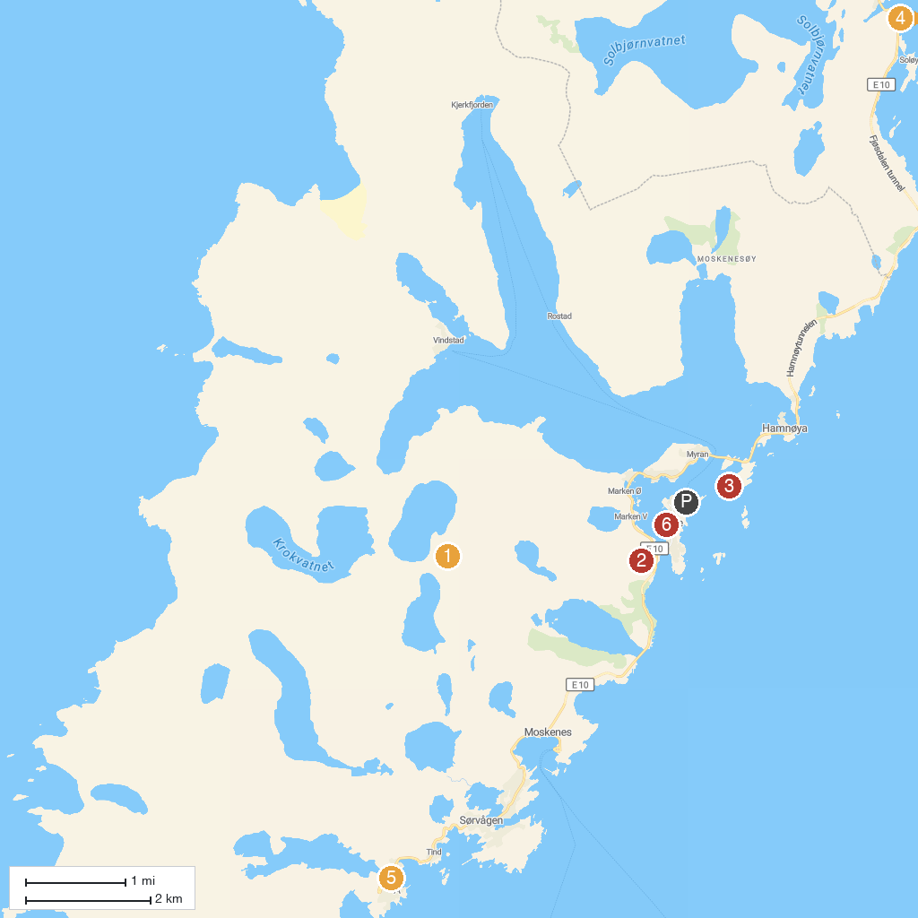
MAP KEY
1. Munkebu | 4. The Blacksmith at Sund and Fisherman Museum
2. Reinebringen | 5. Norwegian Fishing Village Museum Å
3. Olenilsøya Coastal Fort | 6. Visitor Centre Lofotodden National Park
P. Cruise port / terminal
Map © MapTiler © OpenStreetMap contributors · cruiseports.org

