Peso da Régua, Douro Valley, Portugal
Nestled in the oldest demarcated wine region on Earth, Régua is where rabelo boats once floated barrels of Port downriver — today it's the beating heart of Douro river cruises, a five-minute walk from everything worth seeing.
⚓ Docked (Cais da Régua pier) · 🕒 Typical call: 5–8 hrs · 💶 Currency: Euro (€) · 🗣️ Language: Portuguese · 🍷 Wine region: UNESCO World Heritage
✍️ MY DAY IN PORT (FILL IN)
Ship / Date
In port | arrive ______ · all aboard ______
Booked excursion
Notes / meeting point
GETTING ASHORE
- Docking: Direct pier — Cais da Régua; no tender
- Walk to center: 5–10 min flat along the riverfront promenade
- Best For: Port wine tastings, vineyard excursions, scenic train rides
- Don't Miss: Museu do Douro + the azulejo panels at Régua railway station
GETTING AROUND
- 🚕 Taxi: €5–€15 — Taxis are available near the pier and train station. Short in-town rides run €5–€8; transfers to nearby quintas or Pinhã
TOP THINGS TO DO
- Museu do Douro — The region's top museum sits steps from the pier in the historic Casa da Companhia.
- Quinta Wine Tasting — Several prestigious estates sit within a 10-minute taxi ride.
- Douro Historic Train to Tua — On select weekends (June–Oct), the restored Douro Historic Train runs from Régua along the river to Tua, hauled by a vintage…
- Lamego & the Sanctuary Staircase — Fifteen minutes by taxi, Lamego is a baroque gem crowned by the Sanctuary of Nossa Senhora dos Remédios with its famous 686-step…
- Miradouro de São Leonardo de Galafura — One of the finest viewpoints in the entire Douro Valley, about 20 minutes from town by taxi.
BEST WALKS
- Riverfront & Railway Station Walk: 1.5 km · 20–30 min · Flat · Free — From the pier, follow the Ecopista riverfront promenade east to the Régua railway station (10 min).
- Town Centre & Museu do Douro: 1 km · 15–20 min · Easy · ~€6 museum — Head directly from the pier to the Museu do Douro (5 min walk) for wine history and a riverside…
WEATHER · DAYLIGHT · MONEY
Month | High °F | Low °F | Rainy days
May | 75 | 55 | 8
Jul | 88 | 65 | 2
Sep | 81 | 62 | 6
Daylight: May 6:13AM–8:42PM · Jul 6:11AM–9:02PM · Sep 7:11AM–7:39PM
cruiseports.org/regua · Confirm terminal & all-aboard time with your ship

Peso da Régua, Douro Valley, Portugal — Port Map
Red = walkable sights · Amber = excursions farther out · P = cruise terminal
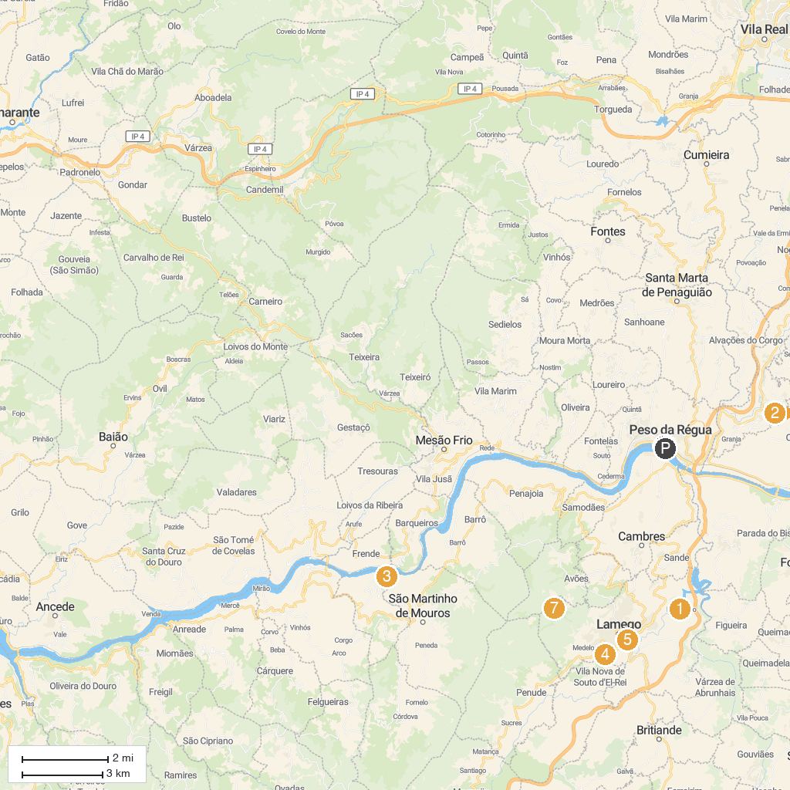
MAP KEY
1. Capela de São Pedro de Balsemão | 5. Lamego Cathedral
2. Miradouro São Leonardo de Galafura | 6. Douro Museum
3. Parque Fluvial de Porto de Rei | 7. Parque Biológico de Lamego
4. Santuário de Nossa Senhora dos Remédios
P. Cruise port / terminal
Map © MapTiler © OpenStreetMap contributors · cruiseports.org

