Reggio Calabria, Calabria, Italy
At the very tip of the Italian boot, Reggio Calabria looks across the narrow Strait of Messina to Sicily — a city of ancient Greek bronzes, a legendary seafront, and the world's only bergamot coast.
⚓ Pier (docked) · 🕒 Typical call: 6-8 hrs · 💶 Euro (EUR) · 🗣️ Italian
✍️ MY DAY IN PORT (FILL IN)
Ship / Date
In port | arrive ______ · all aboard ______
Booked excursion
Notes / meeting point
GETTING ASHORE
- Docking: Pier — Porto di Reggio Calabria, western dock
- Walk to center: 15–20 min (1.2 km) to Lungomare & museum
- Best For: Ancient Greek art, scenic promenade, local food
- Don't Miss: Riace Bronzes at the National Archaeological Museum
GETTING AROUND
- 🚕 Taxi: €5–€15 — Licensed taxis are available at the port. The short distance to Piazza Garibaldi and the city center keeps fares low; al
TOP THINGS TO DO
- Riace Bronzes & National Archaeological Museum — The MArRC houses the Riace Bronzes — two life-sized 5th-century BC Greek bronze warriors discovered by a diver in 1972.
- Lungomare Falcomatà Stroll — Gabriele D'Annunzio called it 'the most beautiful kilometer in Italy.' Walk the botanical-lined seafront past giant ficus trees…
- Day Trip to Scilla — Take the train about 20-30 min north to one of Italy's most beautiful fishing villages.
- Bergamot & Calabrian Food Tasting — Reggio Calabria is the only place on earth where bergamot citrus grows commercially.
- Castello Aragonese & Old Town — The Aragonese Castle survived earthquakes and centuries of history.
BEST WALKS
- Pier to Riace Bronzes Walk: 1.2 km · 15-20 min · Flat — Walk from the port gates south along the seafront to the National Archaeological Museum.
- Lungomare Full Stroll: 2 km · 30-40 min · Flat — Walk the full length of the Lungomare from the museum end to Piazza Indipendenza, passing ancient…
WEATHER · DAYLIGHT · MONEY
Month | High °F | Low °F | Rainy days
May | 71 | 58 | 10
Jul | 86 | 71 | 5
Sep | 79 | 67 | 11
Daylight: May 5:46AM–8:01PM · Jul 5:46AM–8:19PM · Sep 6:39AM–7:05PM
cruiseports.org/reggio-calabria · Confirm terminal & all-aboard time with your ship

Reggio Calabria, Calabria, Italy — Port Map
Red = walkable sights · Amber = excursions farther out · P = cruise terminal
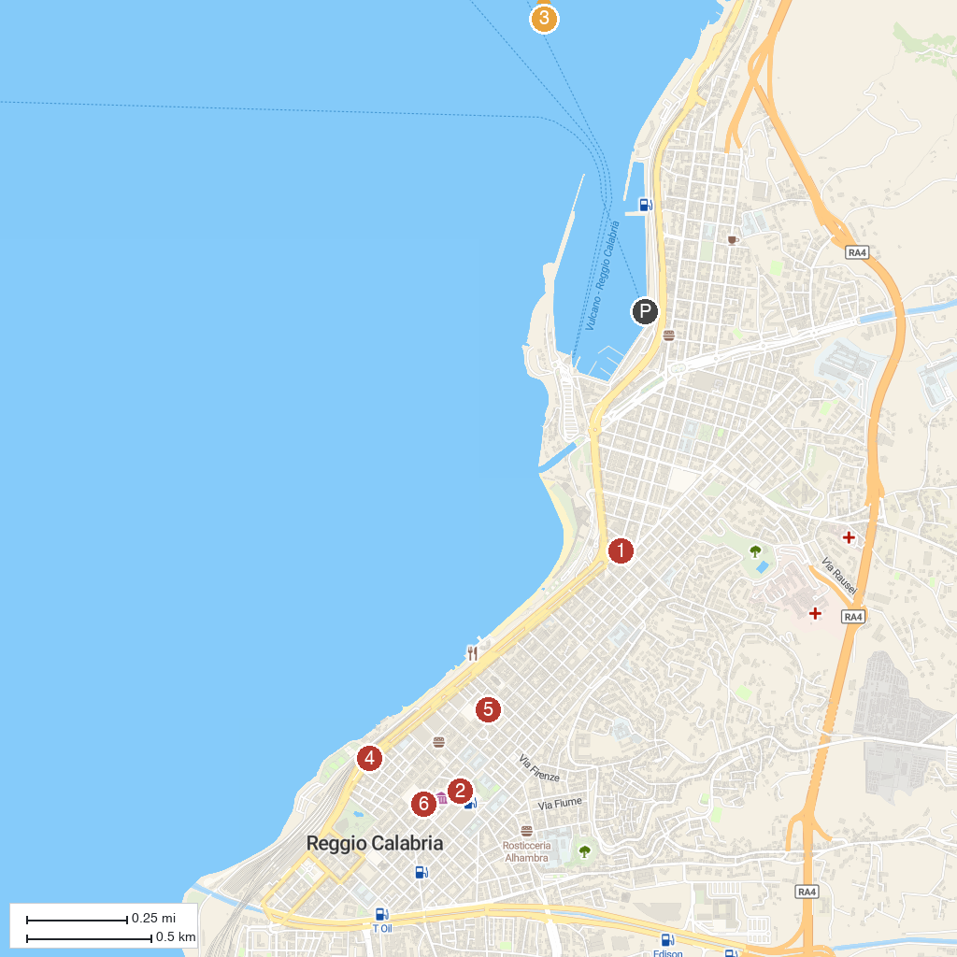
MAP KEY
1. Palazzo del Monte di Pietà | 5. Roman Baths
2. Museo Archeologico Nazionale di Reggio Calabria | 6. Pinacoteca Civica
3. Church of Saint Mary of the Announcement 'degli Ottimati' | 7. Basilica Cattedrale di Maria Santissima Assunta in Cielo
4. Sanctuary of Saint Francis of Paola
P. Cruise port / terminal
Map © MapTiler © OpenStreetMap contributors · cruiseports.org

