Regensburg, Bavaria, Germany
One of Germany's best-preserved medieval cities, Regensburg rises from the Danube bank with Gothic spires, Roman ruins, and a 12th-century stone bridge — and your ship docks minutes from all of it.
⚓ Docked (river pier) · 🕒 Typical call: 8-10 hrs · 💶 Euro (€) · 🗣️ German · 🏰 UNESCO World Heritage
✍️ MY DAY IN PORT (FILL IN)
Ship / Date
In port | arrive ______ · all aboard ______
Booked excursion
Notes / meeting point
GETTING ASHORE
- Docking: River pier at Marc-Aurel-Ufer / Donaulände — steps from the Old Town
- Walk to center: 2-7 min to Stone Bridge; 10 min to Cathedral
- Best For: Medieval architecture, Roman history, Bavarian food and beer
- Don't Miss: Historische Wurstküche — world's oldest sausage kitchen, open since the 12th century
GETTING AROUND
- 🚕 Taxi: €5–€12 — Taxis available near the port and city center. Fares are short given proximity; useful for reaching the train station or
TOP THINGS TO DO
- Old Town Walk: Stone Bridge to Cathedral — Cross the 12th-century Steinerne Brücke (Stone Bridge), walk to the magnificent Dom St.
- Old Town Hall & Reichstag Museum — Guided tour of the 14th-century Altes Rathaus, including the Imperial Hall where the Holy Roman Empire's Perpetual Diet met from…
- Thurn und Taxis Palace (Schloss St. Emmeram) — Tour the opulent state rooms and medieval cloister of this private palace with over 500 rooms — still home to the aristocratic…
- Museum of Bavarian History — Ultramodern interactive museum right on the riverbank, tracing how Bavaria became Bavaria from 1800 to today.
- Walhalla Day Trip — A scenic Danube boat cruise (about an hour each way) or a 20-minute drive east to Donaustauf brings you to the Walhalla — a…
BEST WALKS
- Riverside to Cathedral Loop: 3 km · 45-60 min · Easy — Walk east from the dock along the Donaulände, cross the Steinerne Brücke, detour into the Old Town…
- Stadtamhof & Spitalgarten: 1.5 km · 20-30 min · Easy — Cross the Stone Bridge to the historic island district of Stadtamhof, then wind down to the…
WEATHER · DAYLIGHT · MONEY
Month | High °F | Low °F | Rainy days
May | 65 | 47 | 14
Jul | 77 | 59 | 11
Sep | 68 | 51 | 10
Daylight: May 5:29AM–8:47PM · Jul 5:23AM–9:10PM · Sep 6:48AM–7:24PM
cruiseports.org/regensburg · Confirm terminal & all-aboard time with your ship

Regensburg, Bavaria, Germany — Port Map
Red = walkable sights · Amber = excursions farther out · P = cruise terminal
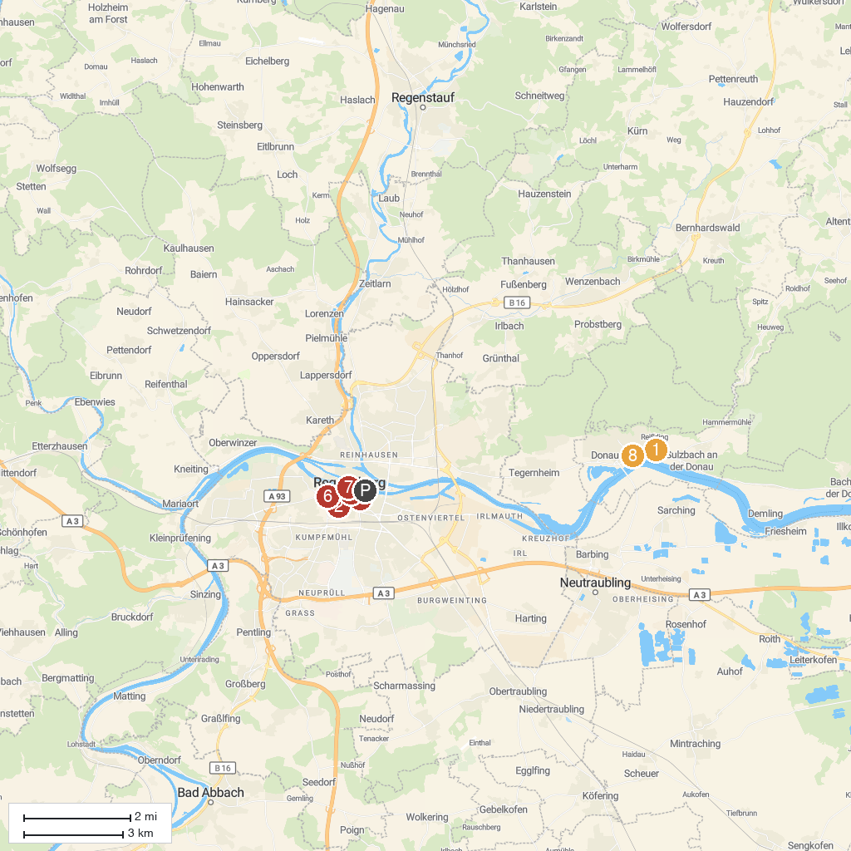
MAP KEY
1. Walhalla | 5. St. Peter Cathedral
2. St. Emmeram's Abbey | 6. Scots Monastery
3. Donaumarkt | 7. Brückturm-Museum
4. Historisches Museum Regensburg | 8. Fürstengarten
P. Cruise port / terminal
Map © MapTiler © OpenStreetMap contributors · cruiseports.org

