Red Bay, Labrador, Canada
An impossibly remote Labrador fishing village that was once the whale-oil capital of the world. Red Bay's UNESCO-listed Basque whaling ruins and icy strait scenery make for one of Canada's most memorable port calls.
⚓ Tender (no pier) · 🕒 Typical call: 6-8 hrs · 💵 Canadian Dollar (CAD) · 🗣️ English · 🧊 Iceberg & whale season: Jun–Aug
✍️ MY DAY IN PORT (FILL IN)
Ship / Date
In port | arrive ______ · all aboard ______
Booked excursion
Notes / meeting point
GETTING ASHORE
- Docking: Tender — ships anchor in harbor; boats ferry to village dock
- Walk to center: 2 min from tender dock to Parks Canada Visitor Centre
- Best For: History, hiking, wildlife, icebergs, off-the-beaten-path
- Don't Miss: Saddle Island boat trip — the heart of the UNESCO whaling site
GETTING AROUND
TOP THINGS TO DO
- Basque Whaling Station & Saddle Island — The centerpiece of Red Bay.
- Iceberg & Whale Watching Boat Tour — In June and July, icebergs drift down the Strait of Belle Isle in stunning numbers.
- Tracey Hill Hike — Climb 689 wooden steps to the summit of Tracey Hill for panoramic views over Red Bay harbor, the Strait of Belle Isle, and on…
- Point Amour Lighthouse Drive — A short drive along the Labrador Coastal Drive brings you to Point Amour Lighthouse, the tallest lighthouse in Atlantic Canada…
- Boney Shore & Labrador Wildflowers Walk — Walk the Boney Shore Trail along the water's edge where centuries-old whale bones still surface from the sediment.
BEST WALKS
- Village & Visitor Centre Loop: 0.5 km | 15–20 min | Easy — From the tender dock, walk to the Parks Canada Visitor Centre, browse the exhibits and chalupa…
- Tracey Hill Trail: 2 km return | 1–1.5 hrs | Moderate (689 steps) — Begins near the Visitor Centre.
WEATHER · DAYLIGHT · MONEY
Month | High °F | Low °F | Rainy days
May | 47 | 34 | 11
Jul | 63 | 48 | 11
Sep | 56 | 44 | 11
Daylight: May 5:33AM–8:58PM · Jul 5:16AM–9:16PM · Sep 7:04AM–7:27PM
cruiseports.org/red-bay-nl · Confirm terminal & all-aboard time with your ship

Red Bay, Labrador, Canada — Port Map
Red = walkable sights · Amber = excursions farther out · P = cruise terminal
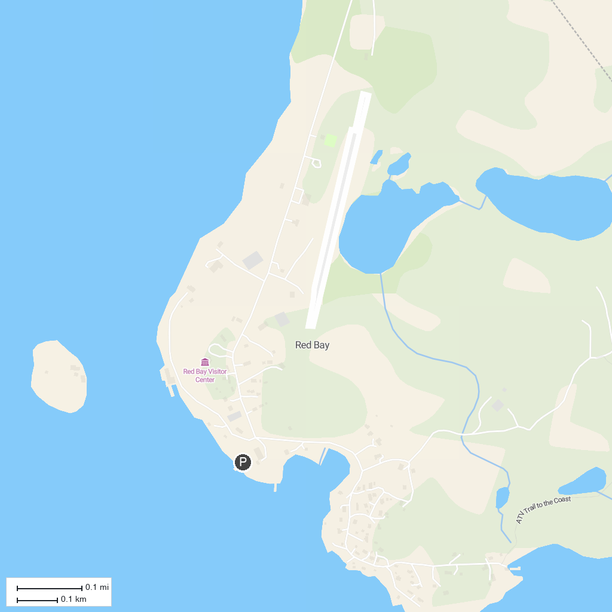
MAP KEY
1. Red Bay National Historic Site & World Heritage Site | 2. Pinware River Provincial Park
P. Cruise port / terminal
Map © MapTiler © OpenStreetMap contributors · cruiseports.org

