Rauma, Satakunta, Finland
Rauma is Finland's best-kept secret — a UNESCO-listed medieval wooden town where 600 colorful timber buildings line cobblestone lanes, lace-makers work in open doorways, and two World Heritage sites await within a short drive.
⚓ Pier (docked) · 🕒 Typical call: 8-10 hrs · 💶 Currency: Euro (€) · 🗣️ Language: Finnish / English widely spoken · 🏛️ 2 UNESCO World Heritage Sites
✍️ MY DAY IN PORT (FILL IN)
Ship / Date
In port | arrive ______ · all aboard ______
Booked excursion
Notes / meeting point
GETTING ASHORE
- Docking: Pier at the Port of Rauma — shuttle required to town
- Walk to center: 4 km / 2.5 mi — shuttle bus (10-15 min) provided by cruise line; no walking through industrial port
- Best For: History, wandering a UNESCO wooden old town, Scandinavian culture
- Don't Miss: Old Rauma's cobblestone lanes, Church of the Holy Cross frescoes, and Lapskoussi stew
GETTING AROUND
- 🚕 Taxi: €10–13 — Metered taxis are available at the cruise terminal. The ~4.5 km ride to the Old Town costs roughly €10–13 based on curre
- 📱 Rideshare: ✅ Uber
TOP THINGS TO DO
- Old Rauma Walking Tour — Wander over 600 colorful 18th–19th century wooden buildings in one of Scandinavia's best-preserved medieval town cores.
- Sammallahdenmäki Bronze Age UNESCO Site — Finland's other World Heritage site in Rauma's backyard — 36 granite burial cairns dating back over 3,000 years, set in a…
- Rauma Lace-Making Experience — Rauma has been famous for bobbin lace since the 1700s.
- Rauma Maritime Museum — Housed in the former Navigation School, this is one of Finland's best maritime museums.
- Poroholma Archipelago & Beach — A short taxi or 25-minute walk from the center, Poroholma is a recreation peninsula with a sandy beach, beach volleyball, a…
BEST WALKS
- Old Rauma Highlights Loop: 2 km · 1-1.5 hrs · Easy (cobblestones) — Start at the Kauppatori (Market Square), grab a coffee at Café Sali, then head into the medieval…
- Canal & Poroholma Stroll: 3 km one-way · 45 min · Easy — From the shuttle drop-off near the canal, follow the waterfront path south toward Poroholma…
WEATHER · DAYLIGHT · MONEY
Month | High °F | Low °F | Rainy days
May | 55 | 42 | 8
Jul | 68 | 57 | 12
Sep | 59 | 50 | 10
Daylight: May 4:47AM–10:14PM · Jul 4:27AM–10:51PM · Sep 7:01AM–7:55PM
cruiseports.org/rauma · Confirm terminal & all-aboard time with your ship

Rauma, Satakunta, Finland — Port Map
Red = walkable sights · Amber = excursions farther out · P = cruise terminal
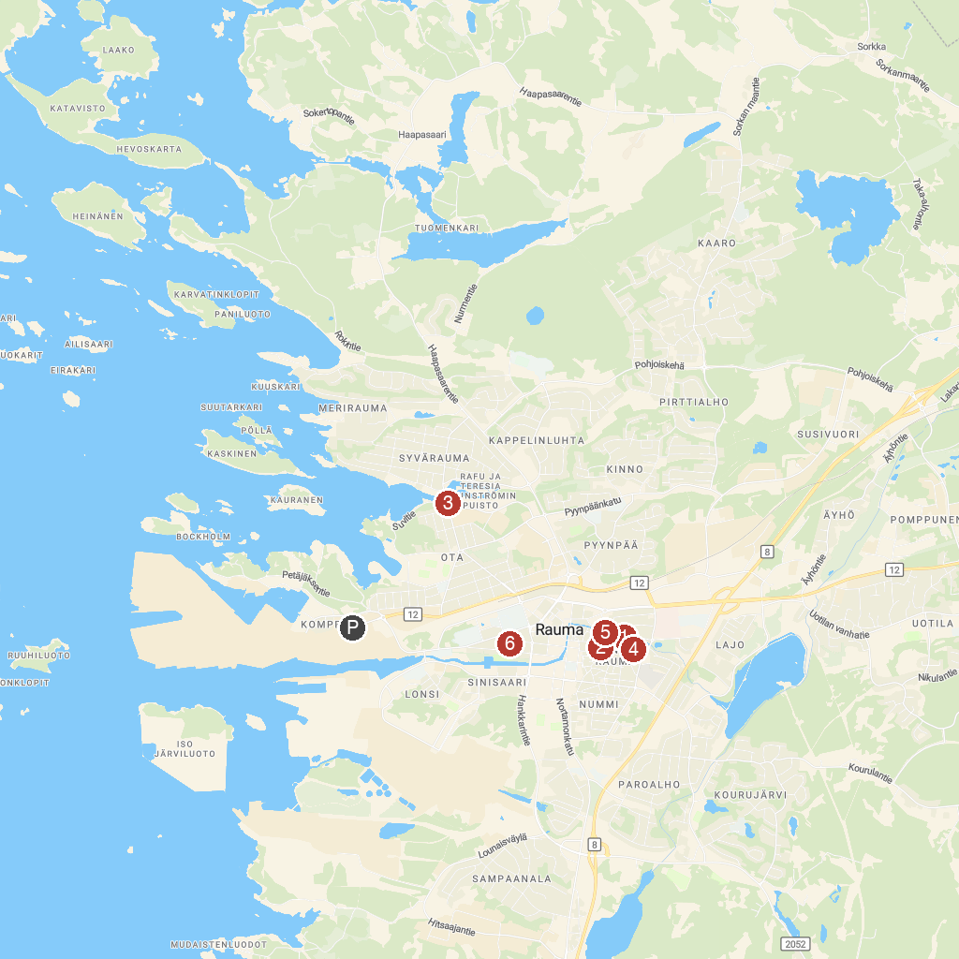
MAP KEY
1. Rauma Museum, Home Museum Kirsti | 5. Rauma Art Museum
2. Old Rauma | 6. Church of the Holy Cross
3. Teresia and Rafael Lönnström House Museum | 7. Rauma Maritime Museum
4. Sammallahdenmäki – UNESCO World Heritage Site
P. Cruise port / terminal
Map © MapTiler © OpenStreetMap contributors · cruiseports.org

