Rathlin Island, County Antrim, Northern Ireland
Six miles off the Antrim coast, this L-shaped island of 150 souls hosts tens of thousands of nesting seabirds and one of Ireland's most unusual lighthouses — a wild, genuine escape that rewards every expedition ship call.
⚓ Tender port (Church Bay anchor) · 🕒 Typical call: 5–7 hrs · 💷 GBP — no ATM on island · 🗣️ English · 🐦 Best Apr–Jul for puffins
✍️ MY DAY IN PORT (FILL IN)
Ship / Date
In port | arrive ______ · all aboard ______
Booked excursion
Notes / meeting point
GETTING ASHORE
- Docking: Tender only — ships anchor in Church Bay; tenders land at the harbour pontoon in the village
- Walk to centre: 0 min — village, pub, café & visitor centre are right at the pier
- Best For: Seabird watching, walking, cycling, wildlife, off-the-beaten-path scenery
- Don't Miss: RSPB West Light Seabird Centre (puffins + upside-down lighthouse) — book the Puffin Bus at the pier
GETTING AROUND
- 📱 Rideshare: ❌ not available
TOP THINGS TO DO
- RSPB West Light Seabird Centre — Northern Ireland's largest seabird colony clings to the cliffs at the island's western tip.
- Mill Bay Seal Spotting — A flat 10–15 minute walk south from the harbour brings you to Mill Bay slipway, where harbour and grey seals haul out on the…
- Boathouse Visitor Centre & Marconi Heritage — Right at the harbour, the Boathouse Museum tells the island's story through artefacts, photos, and tales of over 40 shipwrecks.
- Cycling the Island Loop — Hire bikes at the harbour — electric bikes recommended given the hills — and explore Rathlin's narrow roads past dramatic coastal…
- Robert the Bruce's Cave (Boat/Zodiac) — According to legend, the Scottish king sheltered in a sea cave on Rathlin's rugged northeast cliffs (below the East Lighthouse)…
BEST WALKS
- Harbour Village Stroll: 0.5 miles • Easy • 20 min — From the tender pontoon, walk to the Boathouse Visitor Centre, find the Marconi Memorial, peek into…
- Mill Bay Seal Walk: 1.2 miles • Easy • 30–40 min return — Head south along the flat coastal path from the harbour to Mill Bay slipway for near-certain seal…
WEATHER · DAYLIGHT · MONEY
Month | High °F | Low °F | Rainy days
May | 55 | 46 | 17
Jul | 61 | 53 | 19
Sep | 59 | 52 | 16
Daylight: May 5:15AM–9:27PM · Jul 5:04AM–9:55PM · Sep 6:57AM–7:41PM
cruiseports.org/rathlin-island · Confirm terminal & all-aboard time with your ship

Rathlin Island, County Antrim, Northern Ireland — Port Map
Red = walkable sights · Amber = excursions farther out · P = cruise terminal
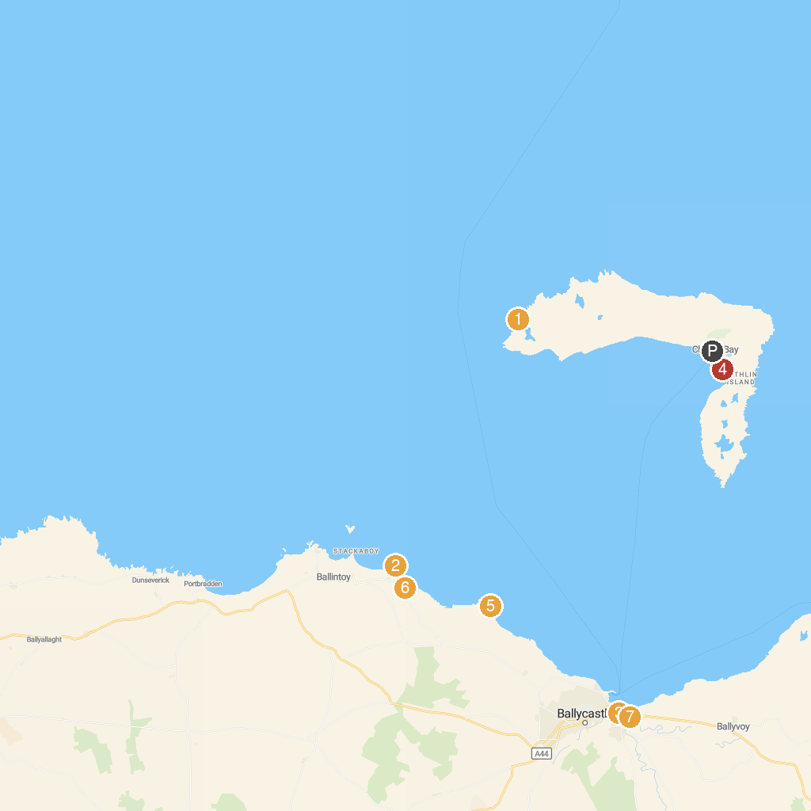
MAP KEY
1. RSPB Rathlin West Light Seabird Centre | 5. Kelp House
2. Carrick-a-Rede - National Trust | 6. Kinbane Castle
3. National Trust - White Park Bay | 7. Portaneevy Car Park & Viewpoint
4. Ballycastle Golf Club | 8. Bonamargy Friary (State Care Monument)
P. Cruise port / terminal
Map © MapTiler © OpenStreetMap contributors · cruiseports.org

