Ras Al Khaimah, UAE
The UAE's 'Nature Emirate' trades skyscrapers for the Hajar Mountains, red dunes, and a 7,000-year history — with the world's longest zipline thrown in for good measure.
⚓ Pier (dedicated cruise terminal) · 🕒 Typical call: 8-10 hrs · 💵 UAE Dirham (AED) — 1 USD ≈ 3.67 AED · 🗣️ Arabic (English widely spoken) · ☀️ Hot & sunny; bring water & sunscreen
✍️ MY DAY IN PORT (FILL IN)
Ship / Date
In port | arrive ______ · all aboard ______
Booked excursion
Notes / meeting point
GETTING ASHORE
- Docking: Pier — dedicated boutique cruise terminal at Ras Al Khaimah Port (RAK Port), next to the Old Town; no tendering
- Walk to center: Cruise terminal sits beside RAK Old Town; short shuttle/taxi to the main city center (~10-20 min drive)
- Best For: Adventure (zipline, hiking), UAE heritage, beaches, desert safaris
- Don't Miss: The Jais Flight zipline on Jebel Jais (world's longest) or Dhayah Fort views
GETTING AROUND
- 🚕 Taxi: AED 6–15 — RAKTA-regulated metered taxis are available outside the terminal. The short hop to the city center costs roughly AED 6–1
- 📱 Rideshare: ✅ Uber, Careem
TOP THINGS TO DO
- Jais Flight — World's Longest Zipline — Soar at up to 160 km/h across the Hajar Mountains on the Jais Flight zipline at 1,680 m above sea level.
- Dhayah Fort & Palm Valley — The only intact hilltop fort in the UAE, perched on a rocky outcrop with 360-degree views over date palm groves, mountains, and…
- Al Jazirah Al Hamra Ghost Town — The best-preserved pre-oil town in the UAE — an entire 17th-century pearling village abandoned in the 1970s.
- National Museum of Ras Al Khaimah — Housed in a historic fort (16th-century origins, much rebuilt in the 18th-19th centuries) that served as the ruling Al Qawasim…
- Suwaidi Pearl Farm Dhow Tour — The UAE's only working cultured pearl farm, reached by traditional dhow from the fishing village of Al Rams.
BEST WALKS
- Corniche Al Qawasim Waterfront Walk: 3 km · Flat · 45-60 min — RAK's main waterfront promenade runs along the creek past cafes, mangroves, and the towering UAE…
WEATHER · DAYLIGHT · MONEY
Month | High °F | Low °F | Rainy days
May | 98 | 82 | 0
Jul | 103 | 89 | 0
Sep | 99 | 84 | 0
Daylight: May 5:30AM–6:54PM · Jul 5:34AM–7:09PM · Sep 6:02AM–6:20PM
cruiseports.org/ras-al-khaimah · Confirm terminal & all-aboard time with your ship

Ras Al Khaimah, UAE — Port Map
Red = walkable sights · Amber = excursions farther out · P = cruise terminal
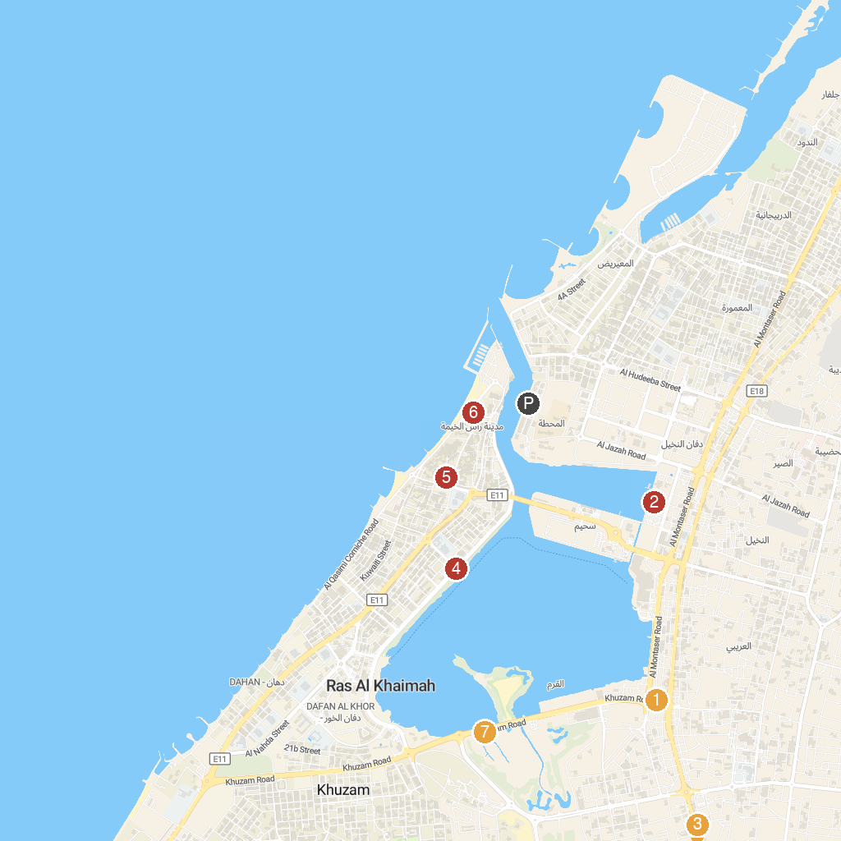
MAP KEY
1. AL SAQR TRAVEL AND TOURISM | 5. National Museum of Ras Al Khaimah
2. Cheeky Monkeys | 6. RAK Old Corniche Sea View
3. Saqr Park | 7. Mangroves
4. Corniche Al Qawasim كورنيش القواسم
P. Cruise port / terminal
Map © MapTiler © OpenStreetMap contributors · cruiseports.org

