Rarotonga, Cook Islands, South Pacific
A volcanic jewel ringed by a turquoise reef lagoon, Rarotonga blends South Pacific paradise with Polynesian warmth — no traffic lights, no skyscrapers, just one perfect island day.
⚓ Tender port (no pier for large ships) · 🕒 Typical call: 6-8 hrs · 💵 New Zealand Dollar (NZD) · 🗣️ English & Cook Islands Māori
✍️ MY DAY IN PORT (FILL IN)
Ship / Date
In port | arrive ______ · all aboard ______
Booked excursion
Notes / meeting point
GETTING ASHORE
- Docking: Tender to Avatiu Harbour — sea conditions sometimes cancel calls
- Walk to centre: 5-15 min flat walk east to Avarua town
- Best For: Lagoon snorkelling, beaches, Polynesian culture, black pearls
- Don't Miss: Muri Lagoon cruise or Titikaveka Beach snorkelling
GETTING AROUND
- 🚕 Taxi: NZ$15 per person — CITA-operated green taxis offer fixed fares from the port to Avarua. Up to 4 passengers can share; arrange fare with dri
- 📱 Rideshare: ❌ not available
TOP THINGS TO DO
- Muri Lagoon Cruise & Snorkel — The island's signature excursion: glass-bottom boat over the marine reserve, snorkelling in crystal waters, beach BBQ lunch on a…
- Raro Buggy Mountain Safari — Drive open-cockpit buggies through the island's lush interior, past ancient marae sacred sites and ridge-top viewpoints with…
- The Needle (Te Rua Manga) Hike — A challenging trail to Rarotonga's iconic stone pinnacle, rewarding fit hikers with dramatic views over the island and lagoon.
- Highland Paradise Cultural Centre — Set high in the mountains, this historic site explores the lost village of the Tinomana tribe, featuring ancient marae…
- Titikaveka Beach Snorkel Day — Arguably the island's best beach for swimming and snorkelling — deep enough at low tide with abundant coral heads and blue…
BEST WALKS
- Avatiu Harbour to Avarua Town: 0.8 km | ~12 min | Flat | Free — Walk east along the waterfront from the tender pier to Avarua, the Cook Islands' capital.
- Avarua to Maire Nui Botanical Gardens: ~5 km by bus | Easy | Small donation — Take the clockwise ring-road bus from the harbour to the Maire Nui Botanical Gardens on the south…
WEATHER · DAYLIGHT · MONEY
Month | High °F | Low °F | Rainy days
May | 78 | 75 | 16
Jul | 75 | 72 | 12
Sep | 74 | 72 | 10
Daylight: May 7:02AM–6:08PM · Jul 7:16AM–6:14PM · Sep 6:35AM–6:33PM
cruiseports.org/rarotonga-island · Confirm terminal & all-aboard time with your ship

Rarotonga, Cook Islands, South Pacific — Port Map
Red = walkable sights · Amber = excursions farther out · P = cruise terminal
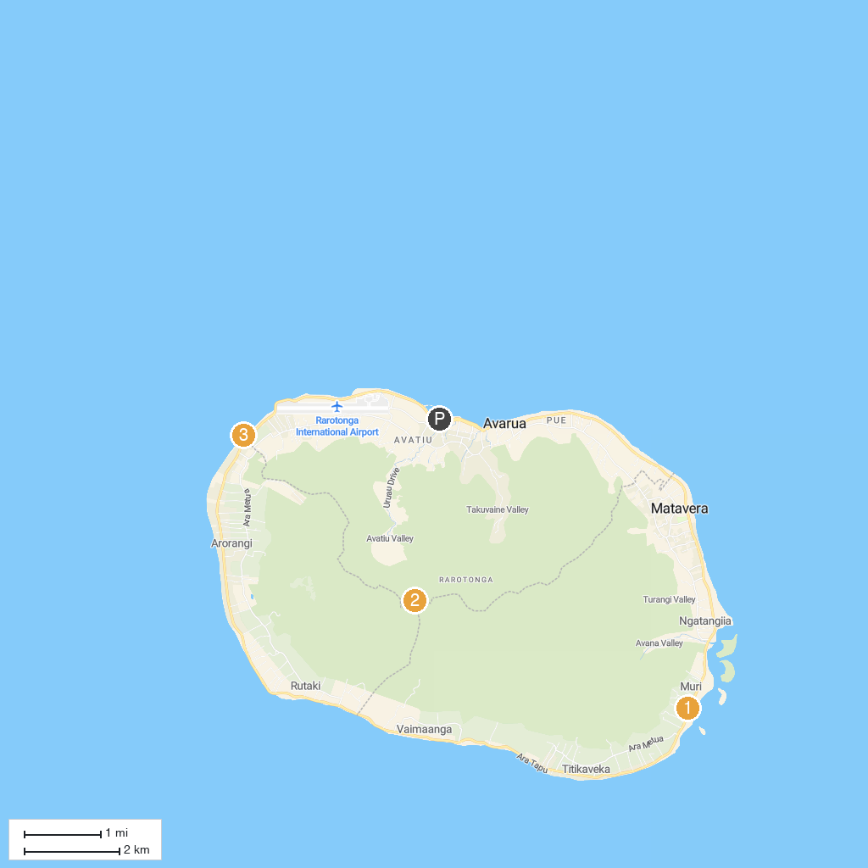
MAP KEY
1. Te Ara Cook Islands Museum of Cultural Enterprise | 3. Black Rock
2. Te Rua Manga (The Needle)
P. Cruise port / terminal
Map © MapTiler © OpenStreetMap contributors · cruiseports.org

