Rangiroa, Tuamotu Archipelago, French Polynesia
The second-largest atoll on Earth, Rangiroa is a diver's paradise where wild dolphins surf the passes, black pearls are harvested offshore, and a turquoise lagoon big enough to swallow the entire island of Tahiti glows at every horizon.
⚓ Tender (no pier) · 🕒 Typical call: 6-8 hrs · 💵 XPF (French Pacific Franc) · 🗣️ French / Tuamotuan · 🤿 World-class diving & snorkeling
✍️ MY DAY IN PORT (FILL IN)
Ship / Date
In port | arrive ______ · all aboard ______
Booked excursion
Notes / meeting point
GETTING ASHORE
- Docking: Tender — ships anchor in the lagoon; tenders land at Ohotu Wharf, Avatoru Islet
- Walk to center: Avatoru village is ~10 km west; Tiputa Pass dolphin spot is 10 min on foot from pier
- Best For: Scuba diving, lagoon snorkeling, dolphin watching, pearl farms, blue lagoon boat trips
- Don't Miss: Dolphins surfing Tiputa Pass at outgoing tide; a Blue Lagoon excursion to swim with baby reef sharks
GETTING AROUND
- 🚕 Taxi: ~500 XPF/person (short trips); from 1,500 XPF + 130 XPF/km — Taxis are available but scarce — book in advance. Short village transfers cost around 500 XPF per person; longer private
- 📱 Rideshare: ❌ not available
TOP THINGS TO DO
- Tiputa Pass Drift Dive — Drop into the open ocean side of Tiputa Pass and ride the incoming current through the pass into the lagoon.
- Blue Lagoon Boat Excursion — A 1-hour boat ride across the lagoon leads to the Lagon Bleu — a lagoon within the lagoon, ringed by tiny coconut-fringed motus.
- Dolphin Watching at Tiputa Pass — A resident pod of bottlenose dolphins lives permanently in the pass and loves to surf the standing waves created by rushing tides.
- The Aquarium Snorkel Tour — A short boat ride from the tender pier to the shallow lagoon edge known as 'The Aquarium' (Motu Nuhi).
- Gauguin's Pearl Farm Visit — Gauguin's Pearl Farm sits in the Avatoru village area, several km west of the Tiputa-side tender wharf.
BEST WALKS
- Pier to Tiputa Pass Dolphin Viewpoint: 10 min walk | Flat | Free — The easiest walk on the atoll.
- Pier to Kia Ora Resort: 20–25 min walk (or 5 min by bike) | Flat — Walk or bike west along the main road from Ohotu Wharf to the Hotel Kia Ora Resort & Spa.
WEATHER · DAYLIGHT · MONEY
Month | High °F | Low °F | Rainy days
May | 82 | 79 | 18
Jul | 80 | 78 | 13
Sep | 79 | 77 | 13
Daylight: May 6:04AM–5:29PM · Jul 6:17AM–5:36PM · Sep 5:45AM–5:46PM
cruiseports.org/rangiroa-atoll-tuamotus · Confirm terminal & all-aboard time with your ship

Rangiroa, Tuamotu Archipelago, French Polynesia — Port Map
Red = walkable sights · Amber = excursions farther out · P = cruise terminal
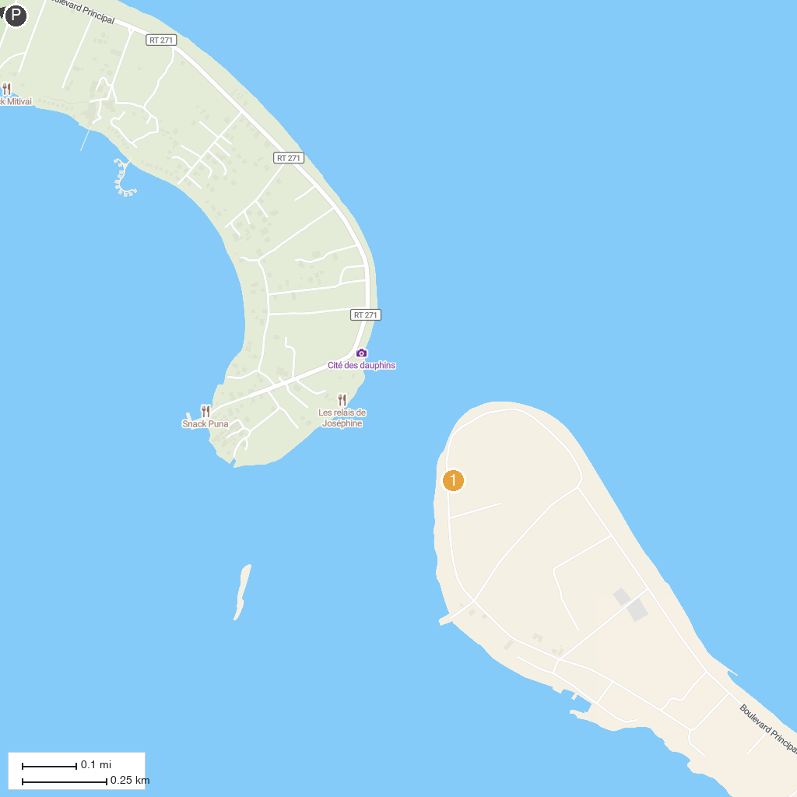
MAP KEY
1. Rairoa Fishing And Tours | 2. Lagon Bleu - Blue Lagoon
P. Cruise port / terminal
Map © MapTiler © OpenStreetMap contributors · cruiseports.org

