Ralswiek, Rügen, Germany
A tucked-away lagoon village on Germany's largest island, Ralswiek delivers a fairy-tale castle, legendary pirate theater, and easy access to Rügen's chalk-cliff coast.
⚓ Pier (small ships only) · 🕒 Typical call: 6–8 hrs · 💶 Euro (€) · 🗣️ German
✍️ MY DAY IN PORT (FILL IN)
Ship / Date
In port | arrive ______ · all aboard ______
Booked excursion
Notes / meeting point
GETTING ASHORE
- Docking: Marina pier (small & expedition ships only; large ships use Sassnitz/Mukran)
- Walk to center: 2 min to village; 10 min to Ralswiek Castle
- Best For: History, open-air theater (summer), nature day-trips
- Don't Miss: Störtebeker Festspiele (Jun–Aug) and the Königsstuhl chalk cliffs in Jasmund NP
GETTING AROUND
- 🚕 Taxi: €17–€21 — Regulated taxi fares to Bergen auf Rügen (~8 km, ~8 min). Several local companies serve the Rügen area including Taxiunt
TOP THINGS TO DO
- Störtebeker Festspiele — One of Europe's largest open-air theater events, the Störtebeker Festival stages the legend of Germany's most famous pirate on a…
- Jasmund National Park & Königsstuhl Chalk Cliffs — Rügen's showpiece: a UNESCO-listed stretch of brilliant white chalk cliffs rising 118 m above the Baltic, immortalized by painter…
- Cape Arkona & Slavic Fortress — The dramatic northern tip of Rügen features chalk cliffs, two lighthouses, and the remnants of a Slavic fortress (Jaromarsburg).
- Rasender Roland Steam Railway — The 'Racing Roland' narrow-gauge steam train has served Rügen since 1895, rattling through beach resorts and forest between…
- Binz & Baltic Beach — Rügen's most elegant resort town, with ornate 19th-century spa villas, a long sandy Baltic beach, and iconic wicker Strandkörbe…
BEST WALKS
- Village & Castle Park Loop: ~1.5 km · 30 min · Easy — From the marina, stroll through the small village past the Swedish Wooden Chapel (relocated from a…
WEATHER · DAYLIGHT · MONEY
Month | High °F | Low °F | Rainy days
May | 60 | 48 | 10
Jul | 70 | 59 | 14
Sep | 65 | 55 | 10
Daylight: May 5:01AM–9:04PM · Jul 4:51AM–9:32PM · Sep 6:39AM–7:22PM
cruiseports.org/ralswiek-rugen · Confirm terminal & all-aboard time with your ship

Ralswiek, Rügen, Germany — Port Map
Red = walkable sights · Amber = excursions farther out · P = cruise terminal
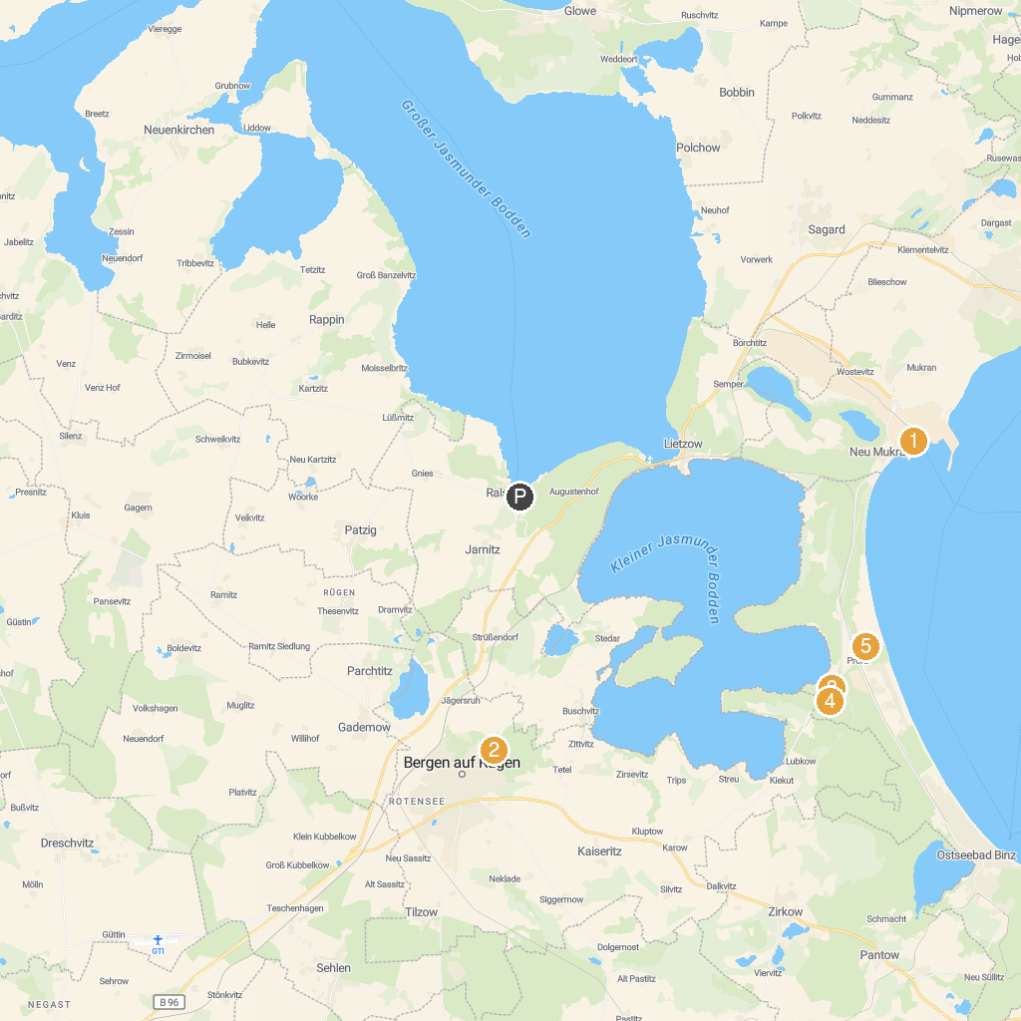
MAP KEY
1. Sassnitz Ferry Port GmbH | 5. Baumwipfelpfad im Naturerbe Zentrum Rügen
2. Rügenpark | 6. Aussichtplattform Adlerhorst - Baumwipfelpfad Rügen Naturerbezentrum Rügen
3. Erlebniswelt U-Boot | 7. Sand sculpture festival in Binz
4. Inselrodelbahn | 8. Uhren- und Musikgerätemuseum
P. Cruise port / terminal
Map © MapTiler © OpenStreetMap contributors · cruiseports.org

